

**GROUP ASSIGNMENT**

**TECHNOLOGY PARK MALAYSIA**

**AAPP006-4-2-SDP**

**SOFTWARE DEVELOPMENT PROJECT**

**UCDF1905ICT(SE)**

**HAND OUT DATE: 7 DECEMBER 2020**

**HAND IN DATE: 2021**

**WEIGHTAGE:** **100%**

**LECTURER: NIK SAKINAH NIK AB AZIZ**

**INSTRUCTIONS TO CANDIDATES:**

**1. Submit your assignment at the administrative counter.**

**2. Students are advised to underpin their answers with the use of references (cited using the Harvard Name System of Referencing).**

**3. Late submission will be awarded zero (0) unless Extenuating Circumstances (EC) are upheld.**

**4. Cases of plagiarism will be penalized.**

**5. The assignment should be bound in an appropriate style (comb bound or stapled).**

**6. Where the assignment should be submitted in both hardcopy and softcopy, the softcopy of the written assignment and source code (where appropriate) should be on a CD in an envelope / CD cover and attached to the hardcopy.**

**7. You must obtain 50% overall to pass this module.**

**Name: MUHAMMAD DANISH BIN MANSOR TP: TP055704**

**KISHEN SHANTHAN A/L JEGATHES TP055296**

**MUHAMMAD FUAD BIN ABDULLAH TP055684**

**JOHARI IDZMAN BIN DZULKARNAIN TP055683**

Table of Contents

2.0 Acknowledgement 6

3.0 Abstract 7

4.0 Introduction 8

4.1 Project Background 8

4.2 Problem Context 9

4.2.1 Inability to View Borrowing Status Easily [Muhammad Danish Bin Mansor (TP055704)] 9

4.2.2 Manual Process of Managing Information About Books and Clients [Kishen Shanthan A/L Jegathes (TP055296)] 9

4.2.3 Librarians Facing Difficulties While Attending to Clients’ Requests due to Human Natural Limitation [Muhammad Fuad Bin Abdullah (TP055684)] 10

4.2.4 Data Redundancy [Johari Idzman Bin Dzulkarnain (TP055683)] 10

4.3 Proposed Solution 11

4.3.1 Status-Checker System for Both Librarian and Client [Muhammad Danish Bin Mansor (TP055296)] 11

4.3.2 Digitize the Processes with Features such as Book Inventory and Client Profile Management Feature [Kishen Shanthan A/L Jegathes (TP055296)] 11

4.3.3 Self-Service Book Catalogue Viewer System for Clients to Use [Muhammad Fuad Bin Abdullah (TP055704)] 12

4.3.4 Usage of Database Management Software (DBMS) prevents data duplication and data validation methods will reduce chances of human error. [Johari Idzman Bin Dzulkarnain (TP055683)] 13

4.4 Project Objectives 14

4.5 Project Scope 14

5.0 Project Plan 15

5.1 System Development Methodology 15

5.2 Project Gantt Chart 19

6.0 System Hierarchy Chart 20

6.1 Feature Hierarchy Chart 20

6.2 Admin Hierarchy Chart 21

6.3 Librarian Hierarchy Chart 22

6.4 Client Hierarchy Chart 23

7.0 Context Diagram 24

8.0 Data Flow Diagram Level 0 25

9.0 Data Flow Diagram Level 1 26

9.1 Muhammad Danish Bin Mansor [TP055704] 26

9.2 Kishen Shanthan A/L Jegathes [TP055296] 28

9.3 Muhammad Fuad Bin Abdullah [TP055684] 29

9.4 Johari Idzman Bin Dzulkarnain [TP055683] 30

10.0 Data Dictionary 31

10.1 Muhammad Danish Bin Mansor [TP055704] 31

10.2 Kishen Shanthan A/L Jegathes [TP055296] 32

10.3 Muhammad Fuad Bin Abdullah [TP055684] 33

10.4 Johari Idzman Bin Dzulkarnain [TP055683] 34

11.0 Entity Relationship Diagram (ERD) 35

12.0 Flowcharts 36

12.1 Muhammad Danish Bin Mansor [TP055704] 36

12.2 Kishen Shanthan A/L Jegathes [TP055296] 38

12.3 Muhammad Fuad Bin Abdullah [TP055684] 42

12.4 Johari Idzman Bin Dzulkarnain [TP055683] 44

13.0 Screen Design & User Manual 48

13.1 Registration Page 48

13.2 Login Page 53

13.3 Homepage 57

13.4 Team Page 58

13.5 Catalogue 59

13.6 Edit Profile Details 61

13.7 Client User Role 63

13.7.1 View Borrowing Status 63

13.8 Librarian User Role 64

13.8.1 Add New Book 64

13.8.2 Edit Book 65

13.8.3 Delete Book 67

13.8.4 Add New Borrowing 68

13.8.5 View Borrowing Details 70

13.9 Admin User Role 73

13.9.1 View User Information 73

13.9.2 Register New User 74

13.9.3 Edit User Information 75

13.9.4 Delete User Information 76

14.0 Report Design & User Manual 77

14.1 Report Design 77

14.2 User Manual 79

15.0 Test Plan 82

15.1 Muhammad Danish Bin Mansor [TP055704] 82

15.2 Kishen Shanthan A/L Jegathes [TP055296] 85

15.3 Muhammad Fuad Bin Abdullah [TP055684] 89

15.4 Johari Idzman Bin Dzulkarnain [TP055683] 98

16.0 Significant Source Codes 103

16.1 Displaying data on the home page 103

16.2 Deleting a Book 105

16.3 Updating Client Profile Information 106

16.4 Creating Client Profile 107

17.0 Conclusion 108

17.1 Assumptions 111

17.2 Limitations 111

17.3 Enhancements 111

18.0 References 113

19.0 Appendix 114

19.1 Installation Guide 114

19.1.1 Prerequisite 114

19.1.2 Downloading and Installing WAMP 115

19.1.3 Downloading and Extracting LibSys Files 128

19.1.4 Setting up LibSys in WAMP Directory 133

19.1.5 Setting up Database and Testing the Website 136

19.1.6 Conclusion 154

# Acknowledgement

The group would like to thank Miss Nik Sakinah Nik Ab Aziz for the guidance in the process of making this assignment a successful one. All the knowledges that she shared to us have helped us in getting better understanding on how the system and the documentation of the project should look like. As the group leader of the team, I, Muhammad Danish Bin Mansor would like to say thank you to all of the group members for cooperating and diligently working in making this project a success. Everyone worked hard in ensuring that this project could be completed within the timeframe given and according to the plan as stated in the Gantt Chart of this project. If there are more projects in the future, the current team consisting of Muhammad Fuad Bin Abdullah, Johari Idzman Bin Dzulkarnain, Kishen Shanthan A/L Jegathes, and Muhammad Danish Bin Mansor should be working together again as the group is efficient in getting the work done.

# Abstract

This document covers the Library Management System developed by Group 9 which consists of the following members: Muhammad Danish Bin Mansor TP055704, Kishen Shanthan A/L Jegathes TP055296, Muhammad Fuad bin Abdullah TP055684 and Johari Idzman Bin Dzulkarnain TP055683. The Library Management System was developed because the one of the members of the group was a librarian in high school and he expressed the difficulty in keeping track of all the different components that he needs to keep track of as part of his duties as a librarian. For example, the librarian will have to write in the borrowing logbook whenever a student makes a borrowing then the librarian will also need to write into a separate logbook to register new students into the system. This decentralized method leads to confusion and may lead to duplicate data or out of date information to be stored. Hence, the group has decided to create a digital library system that will manage all the processes in the library to make it more efficient and effective to be used. The main objective of this system is to have a centralized system where the librarian can access many of the different functions to save time and increase the productivity of a single librarian. Among the features that is present in the system is a book management system, borrowing management system and user management system. All these systems are incorporated together and work together seamlessly to provide an easy experience for the Librarian. Diagrams and flowcharts of the systems are also included as it provides insightful information on how the system is planned out and operates. The Entity Relationship Diagram has been normalized and the flowchart represents the flow of a particular process. This document also contains the User manual for each of the user roles which are Client, Librarian and Admin. The user manual serves as a guide to the different functions present in the different user roles. Included in the document is also an installation guide on how to install and use the system including other related software’s such as WAMP to host the system locally.

# Introduction

## Project Background

Victoria Institution Public Library has provided the residents its services since 1964. It contains the local town archive and has a collection of thousands of books acquired throughout the years. The books kept on several dozen rows of shelves and are organized by categories such as genre, book title and publishing date. The library uses a traditional method of managing their operations through a file-based approach where each book is painstakingly catalogued in a physical card or paper slip manually (Brick, 2018). This process is not only time consuming, but also labour and resource intensive as well. The files used to store the records also take up space and becomes more complex to navigate effectively the larger the library becomes. These records and card catalogues are also prone to damage and misplacement meaning resources need to be spent on maintaining the records alone. This system of cataloguing with library cards as reference has worked well in the past, but as the library’s collection of books increases, it becomes increasingly challenging and cumbersome to keep the catalogue up to date. Recently, books have been misplaced or improperly recorded which affects the accuracy and disrupts the inventory numbers. The library also allows books to be borrowed which further complicates the management operations of the library.

It is with this problem in mind that the Victoria Institution Public Library management has decided to develop a Library Book Management System to simplify the operations of the Library and make it more efficient and effective. Using an Information System to manage the books and borrowing process will increase the productivity of the library as the librarians are able to get work done at a significantly faster time and accuracy compared to the traditional method of a pen and paper or file-based approach. The new system will also incorporate a database system to have a centralised method of storing and retrieving data which can increase data integrity and reduce data redundancy. The project will be web-based as it is seen as the most accessible option as it allows any user with an internet browser to use the system. The system will provide benefits to all its users such as more efficient way of managing the books and borrowing process by the librarians as well as providing a better customer experience for the clients and book burrowers as they can browse the catalogue remotely and track their borrowing status. The project also aims to reduce the operational cost of the library by reducing the cost of resources such as logbooks, files and hiring of professional transcribers to update the book catalogue as these will be replaced by the Library Book Management Software.

## Problem Context

### Inability to View Borrowing Status Easily [Muhammad Danish Bin Mansor (TP055704)]

Current library system utilizes the usage of pen and paper to maintain and record the borrowing status for books borrowed by clients. This status includes the number of books borrowed by a client, the borrowing period of the client, the start date and end date for the books borrowed by the client depending on the book type, and fine amount if the client exceeds the allowed borrowing period. Clients will be given a small card as a way for the clients to know the information required, and the librarian will also have a book to record the borrowing status. As for the client, the card provided is small in size and can be lost easily if a proper care is not being done by the client. In addition to that, the information stated on the card is small and hard to read which make it harder for the client to view his/her borrowing status. Any water spillage on the card will also ruin the writings on the card and clients need to bring along the card for borrowing purposes. As for librarians, they need to use the logbook containing the borrowing status of client which requires a physical book. Librarians would need to find the book first in order to view the status which led to longer process time for each client and make it harder to view the status.

### Manual Process of Managing Information About Books and Clients [Kishen Shanthan A/L Jegathes (TP055296)]

Information about books such as the description, author, publisher, genre, title, rack location at Victoria Institution Public Library is handwritten on paper with no order of name or serial number whatsoever. The same goes to the client’s personal information which are filled up by the client on a piece of paper when registering for a library card. The document is then stored in a file cabinet to be used for future reference. Being a library with hundreds of books and clients, the library has a lot of documents that are stored in many file cabinets and shelves that end up occupying space in the library which is already lacking space. Furthermore, the physical documents cannot last and are more prone to damage as compared to digital softcopies. The storing of client’s information without any form of protection also poses a security threat as the librarian can have unfiltered access to all of the client’s personal information. The information about books also becomes harder to look for as they are just added along the way when a new stock of books arrives. As such, there is no quick way for a librarian to search for a specific book as they would have to look line-by-line for a hundred or more lines to get to the record that they want. This is time-consuming and slow especially when they would have to update information about a certain book such as the quantity which would also require having to erase the information and updating it with the latest information.

### Librarians Facing Difficulties While Attending to Clients’ Requests due to Human Natural Limitation [Muhammad Fuad Bin Abdullah (TP055684)]

As with any physical libraries, Victoria Institution Public Library employs human workers as librarians. A librarian is tasked to not only manage books and observe client’s behaviour, but they are also required to answer any question or enquiries described mostly about location or availability of books by the clients. Often, librarians will need to spend a portion of their precious time available to answer precisely the questions asked by the clients. When the time taken is longer than expected and considering the limited number of librarians working at the time, managerial work will definitely start to pile up and other clients with similar questions have to wait in an ever-continuing line of queue. When compared to pre-programmed robots or machines, librarians are bound to human natural limitations particularly where they are only capable of processing and transforming small amount of information at one time into practical output. In the case of a librarian’s daily routine, a librarian can only focus to one task at a time. Otherwise, mishaps such as books misplacement, chaotic workflow, growing queue of clients, librarian’s own mental distress due to immense pressure and irregular work routine can occur which may result in unsatisfactory overall performance of the library management procedure. Effects due to the mishaps can tremendously affect Victoria Institution Public Library’s external image and further disrupt the internal affairs of the organisation. If the situation came to the worst, the library would have to face higher rate of worker turnovers as the library is inefficient at handling automatable tasks and insensible about their workers’ mental and physical health.

### Data Redundancy [Johari Idzman Bin Dzulkarnain (TP055683)]

The traditional file-based approach may lead to the same data being stored in the same logbook or file because of human oversight or error. It is also hard to update new data as it needs to be changed in multiple locations of the record. For example, if a client changed their address, it must be updated in their library card and the borrowing logbook. The librarian also must manually update the details in each of the logbooks and records which is time consuming. The librarian may get tired and make a mistake which will further disrupt the accuracy of the data. If some of the data is not updated, then it will create data inconsistency where the data used may not be accurate. Inaccurate data may lead to many problems such as accounting error and incorrect data to be extracted which may affect decision making.  File based management also rely on physical copies of the data which is prone to damage and is difficult to backup and store.

## Proposed Solution

### Status-Checker System for Both Librarian and Client [Muhammad Danish Bin Mansor (TP055296)]

Status checker system is a solution that can be implemented by the library as way to solve the viewing status problem. The proposed system will allow clients and librarians to keep track and view the borrowing status easily as it has better representation. For example, the user can view just click on the view button to see the list of total books he or she has borrowed. Apart from that, they can also view the each of the book’s status to know the dateline or returning date for each book. Users can access this feature system through their laptop or smartphone which most of the time people carry it with them as those devices are compact and part of basic necessity. This system also has better graphics and text sizes for better viewing compare to the library borrowing card which make it less of a hassle to view and reduce eyestrain and view the borrowing status.

### Digitize the Processes with Features such as Book Inventory and Client Profile Management Feature [Kishen Shanthan A/L Jegathes (TP055296)]

By creating a digital system to complement the business processes, the information about the books and clients can be better managed. Client registration would be seamless as clients can register on the website from anywhere with just an internet connection. Their account would already qualify as a library card, thus not require having to carry a physical card around. The client data would also be more secure as it will be encrypted, and only authorized people would be allowed to access it. Adding a new book will be made much simpler using the Book Inventory Management feature as it can be done digitally with a few clicks without requiring paper. Furthermore, the system will allow for books to be searched with a search key and also easily sorted using filters such as genre, publisher, author and more that can be done within the blink of an eye. This also allows librarians to easily edit the book details as they can then select a book from the search query or the filtered list to update or change information about the book which would then be instantly saved. As physical documents will no longer be needed, the system would eliminate the need for file cabinets or shelves for library-related documents. As such, these spaces can be used for more books or to store a server that hosts the website which requires much less space. Furthermore, the move to a digital system is much more reliable as the data is everlasting and does not get damaged overtime unlike physical documents.

### Self-Service Book Catalogue Viewer System for Clients to Use [Muhammad Fuad Bin Abdullah (TP055704)]

A solution is proposed to address the issue faced by librarians while working where they are required to juggle between completing library’s managerial tasks and attending to clients’ demand. The solution is the creation of a cataloguing system that displays list of books along with relevant information like title, author, genre, shelf number and most importantly, availability status. Although it sounds like a traditional approach where a thick, laminated book is used to display important details of each book, this system is going to be programmed instead and integrated along with the rest of the proposed solutions which is in a web client view. The solution is brought forward tackle the most frequently asked questions and that is about the location and availability of the book however, verbal questions that are unrelated to books will still need to be addressed by the librarians. Besides that, the system should allow the clients to perform specific look-up by having a string input section to accept title or author name and filtration settings that can sort or exclude details to produce the most desirable search result. This system is planned to use basic website development tools and that includes CSS, JavaScript, HTML, PHP, and a central database to tabulate information of all books in the library.

### Usage of Database Management Software (DBMS) prevents data duplication and data validation methods will reduce chances of human error. [Johari Idzman Bin Dzulkarnain (TP055683)]

The solution to reduce data redundancy is to implement a system that uses a centralized database to synchronize the data being inserted and extracted. A centralized database will allow data to be inserted and extracted in only one location which will eliminate data redundancy. Data validation implemented by the system will ensure that the data inserted is accurate and of the correct type. An example would be a feature in the system where the user must fill in a form to register their details and is unable to proceed if some of the fields are empty or of the wrong data type. This increases data integrity and reduces the number of errors encountered in the system. Good data integrity also increases the accuracy of the data being extracted which means it can be better processed into information to be used in better decision making. The system being an information system also means that the data is stored virtually which will save space and prevent physical damage.

## Project Objectives

* To make it more accurate and easier for both client and librarian to check the borrowing status
* To make it easier for librarians to add, delete, and update information about books
* To reduce workload of a librarian by introducing a computerised book catalogue
* To reduce the chances of repeating data and strengthen data integrity.

## Project Scope

The project will cover a library book management system which covers 4 main features, Catalogue, Borrowing & Returning, Registration and account management, and Book Inventory Management with 3 users which are Admin, Librarian and Client. The estimated number of simultaneous users that the system can handle is a 100. The system will be used to replace the current manual business process and keep track all the operation in the library. The new library book management system will provide the following features to the users. It will allow the Client to search for the books and be able to track the books they borrow. The Librarian will be able to manage the library book inventory and process borrowing and returning of books. The admin will be responsible for managing the database and user accounts. Other than the features listed above, the system will also come with a user manual, instruction, and installation manual to guide the users on how to operate and maintain the system. The project documentation can also be used by the user to better understand the system and provide insights into its features. The milestones will be discussed in section 3.2 (Gantt Chart) which shows the timeline and important dates of the project. The system will be developed as a website using programming languages such as HTML, CSS, Javascript and PHP. The limits of the project will be discussed in section 5.2 (Limitation).

# Project Plan

## System Development Methodology

The methodology that was chosen for LibSys Library Management System project is the waterfall methodology whereby each phase in the methodology is conducted separately however requiring the preceding phase to be completed before continuing. There are five phases in the methodology comprising of requirement analysis, designing, implementation, testing, and maintenance as shown in the Figure 1 below (IONOS, 2019). Each of the phases will be implemented during the construction of LibSys Library Management System. The purpose of the usage of this methodology is due to the advantages that it offers, and it is very suitable for the development of LibSys Library Management System. As development of LibSys Library Management System is a project with well-defined requirements for both functional requirement and non-functional requirement which make it suitable with waterfall methodology that is very to be used and to be understand. Even though this methodology does not allow any reversion or turning back to the previous phase that has been completed and once the following phase has been started, as the project will be analysed and all the requirements, activities and process being identified, there will be no need for any reversion to happen. In addition to that, the project will also in short time period as the timeline of the project will be defined during the requirement analysis phase and there will be no last-minute changes that might delay the project which in return will extend the development period and clients need to wait longer before the system can be completed, deployed and used.

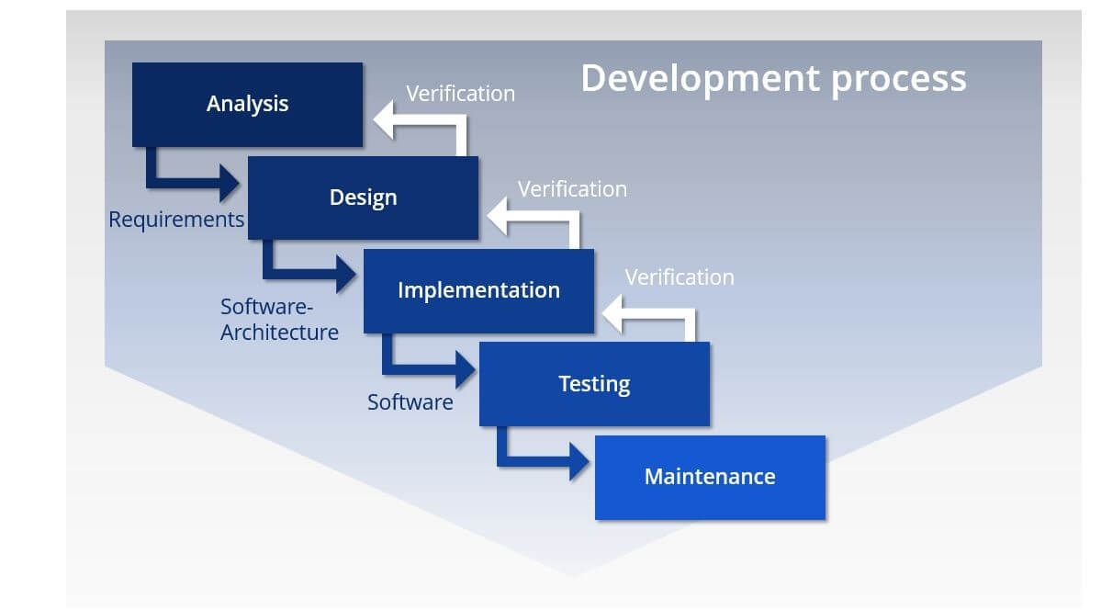

Figure 1; Waterfall Methodology Model (IONOS, 2019)

In the requirement analysis phase, all the problems related to the current system will be identified by each team member and solution will be proposed to overcome the issues. Apart from that, the scope of the project and its objective including all the requirements needed by the clients to solve current system’s issue will also be identified. This allows the system to be created effectively and efficiently as the scope and objectives have been identified to fit the managerial use by replacing the current pen and paper system of the library. After all the requirements have been identified, a proposal report will be documented to include the requirements of the proposed system to the manager of the library as a black and white agreement with the manager about how the system will be used in solving the problems that are being encountered and to be check by the manager in case of any missing or left out requirements. Apart from that, Gantt chart will also be produced as an outline to the activities that will be performed during the entire lifecycle of the project and the duration including estimation of system completion.

Upon the completion and agreement of the requirements during the requirement analysis phase, a following phase which is the designing phase will start to commence. Designing phase is a phase that will cover up the process of designing the proposed system before implementation phase can take phase. Things that are required such as the layout of the system, flow of the system, database tables, will be identified and being turned into a documented form in a report. The procedure on how the system will be processing the users input and interpret it or change it to produce output will be defined first during this phase. Following with the production of storyboard for the layout of the system including the interface of the system on how the system should look like before coding the system during the implementation phase. All the database tables that will used for the system will then be conceptualised in order for a proper data management of the system. All of the things that have been created and defined will then be documented in a report in order to be used as reference during the implementation phase to ensure that all the requirements will be implement and smooth implementation phase can be conducted.

Implementation phase will then be conducted after the designing phase has been completed, finalised and verified. In this phase, the system will be coded according to the design phase and programmers will decide on the usage of the best programming language suited for the project depending on the medium or platform the system requires. In the project of LibSys Library Management System, the team has decided that the system will work best through a web-based system. Thus, languages such as Hypertext Markup Language 5 (HTML 5), PHP, Cascading Style Sheets (CSS), and JavaScript will be used for the development of the system. While Structured Query Language (SQL) will be used on the database management and usage of the system. Apart from that, the team will also be following coding standards such as keep it short and simple (KISS), Do not Repeat Yourself (DRY), minimise coupling and maximise cohesion as a way to make sure that the system has a code that easily understandable and easier bug fixes that might be needed in the future. In addition to that, any new features that might be required can be added into the system more efficiently due to the proper coding standards that hae been used during the development of the system. The back end of the system will be developed before the front-end compromising the interface of the system. Each unit and component will the be integrated with each other to form a fully functional system.

Testing phase is the succeeding phase to the implementation phase which the system will be tested out for any possible error that might result in the system failure to compute or process the user input and produce the correct output. Apart from that, any bugs in the system could also lead to the system to be glitchy, poor performance or even crashes might happen. Thus, testing is required to be conducted to ensure that the system can be fully-operate before being delivered to the client which in this case is the manager of the library. Various types of testing such as interface testing, validation testing, user acceptance testing, and etc, will be conducted by the team and the results will be documented for management and reference in case any suspected error or bugs must be debugged. Debugging process will then take place if there is any bugs or error found in the system.

Once the system has been tested out during the testing phase, the system will then be delivered to the client and deployed for client’s usage. A maintenance phase will take place to help the client in maintaining the system. A support team will be there to help fix any error or bugs that might be encountered in the future by the users of the system. Therefore, the client of this project can be worry-free in case of any unprecedented situation or incident happen as the team will be there to help.

## Project Gantt Chart

[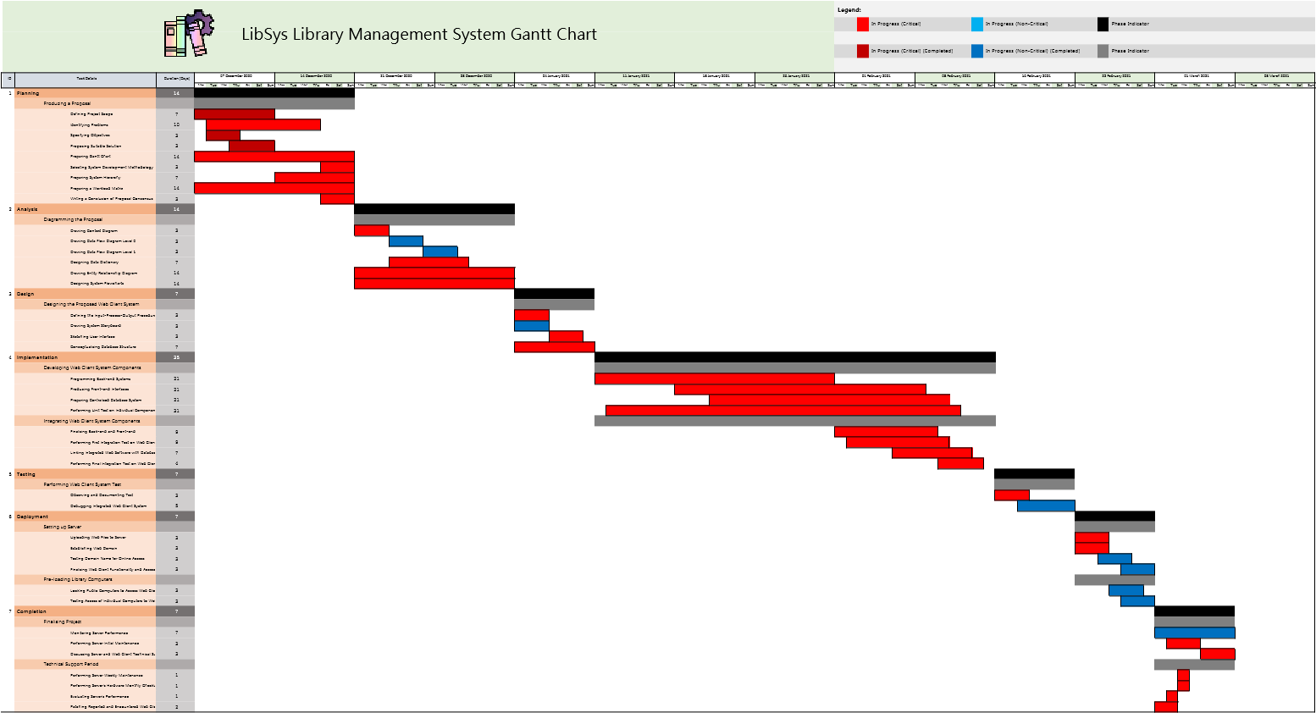](https://cloudmails-my.sharepoint.com/personal/tp055684_mail_apu_edu_my/Documents/Diploma%201905ICT(SE)/Semester%205/SDP/ganttchart.xlsx?web=1)

Figure 2: Gantt Chart for LibSys Library Book Management System

# System Hierarchy Chart

## Feature Hierarchy Chart

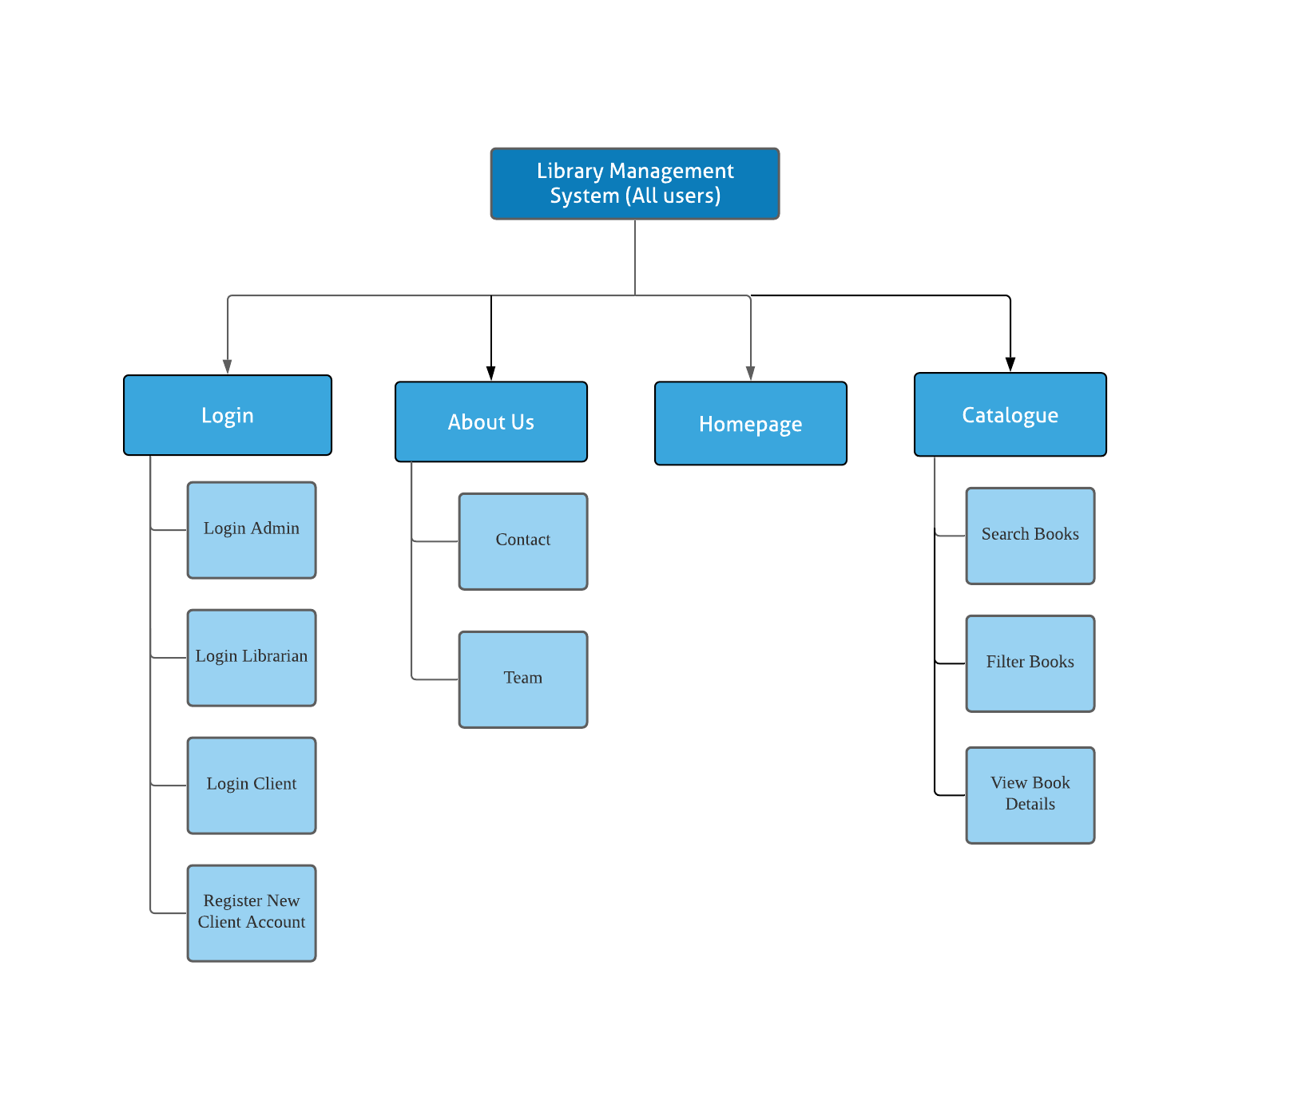

Figure 3: Feature Hierarchy Chart of LibSys Library Management System.

## Admin Hierarchy Chart

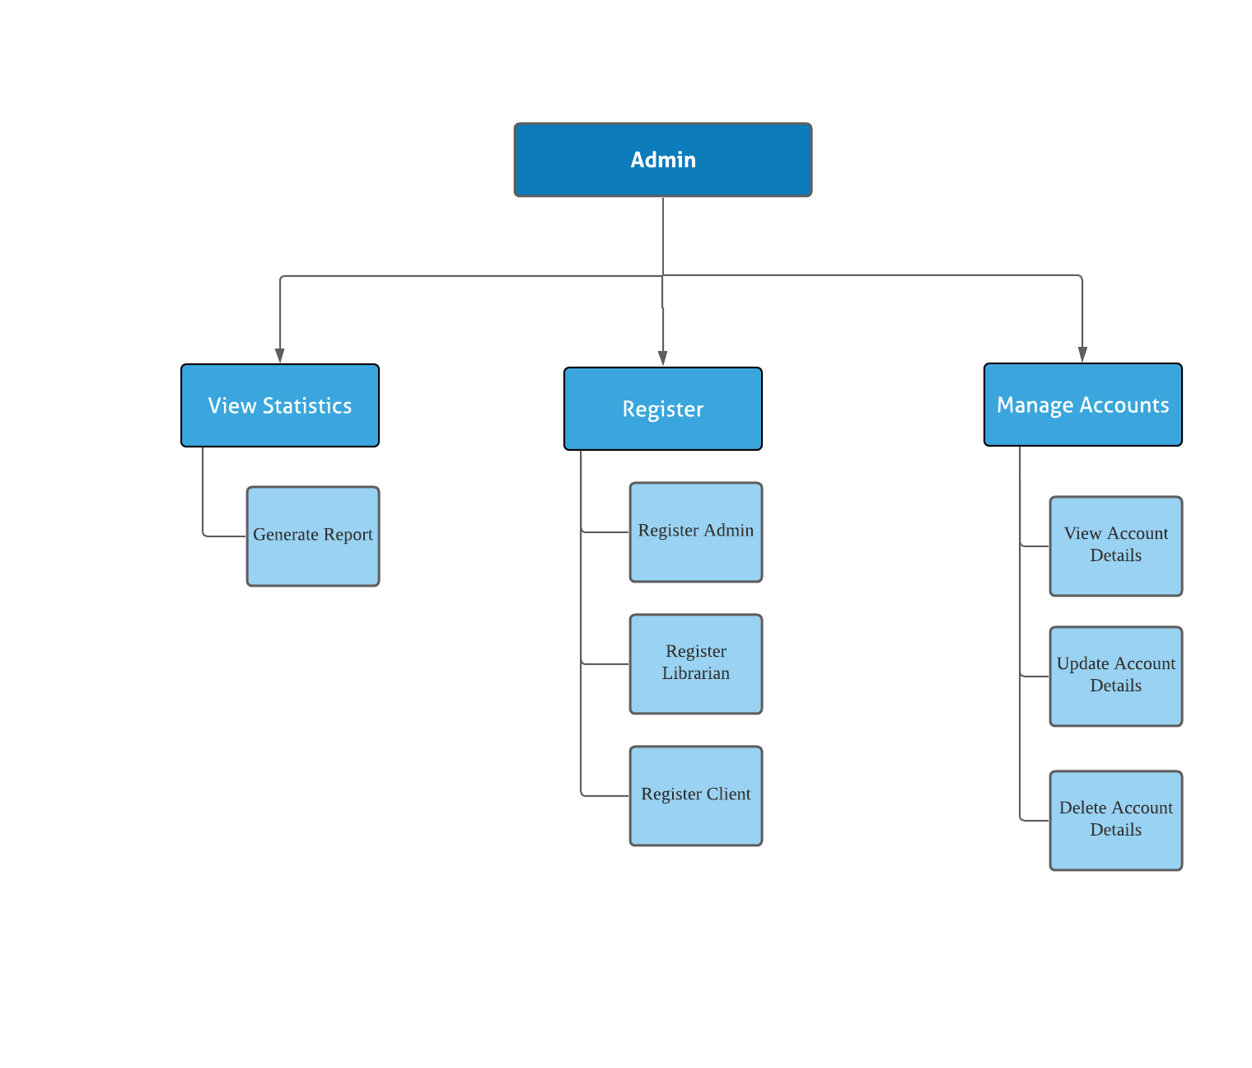

Figure 4: Admin User Role Hierarchy Chart of LibSys Library Management System.

## Librarian Hierarchy Chart

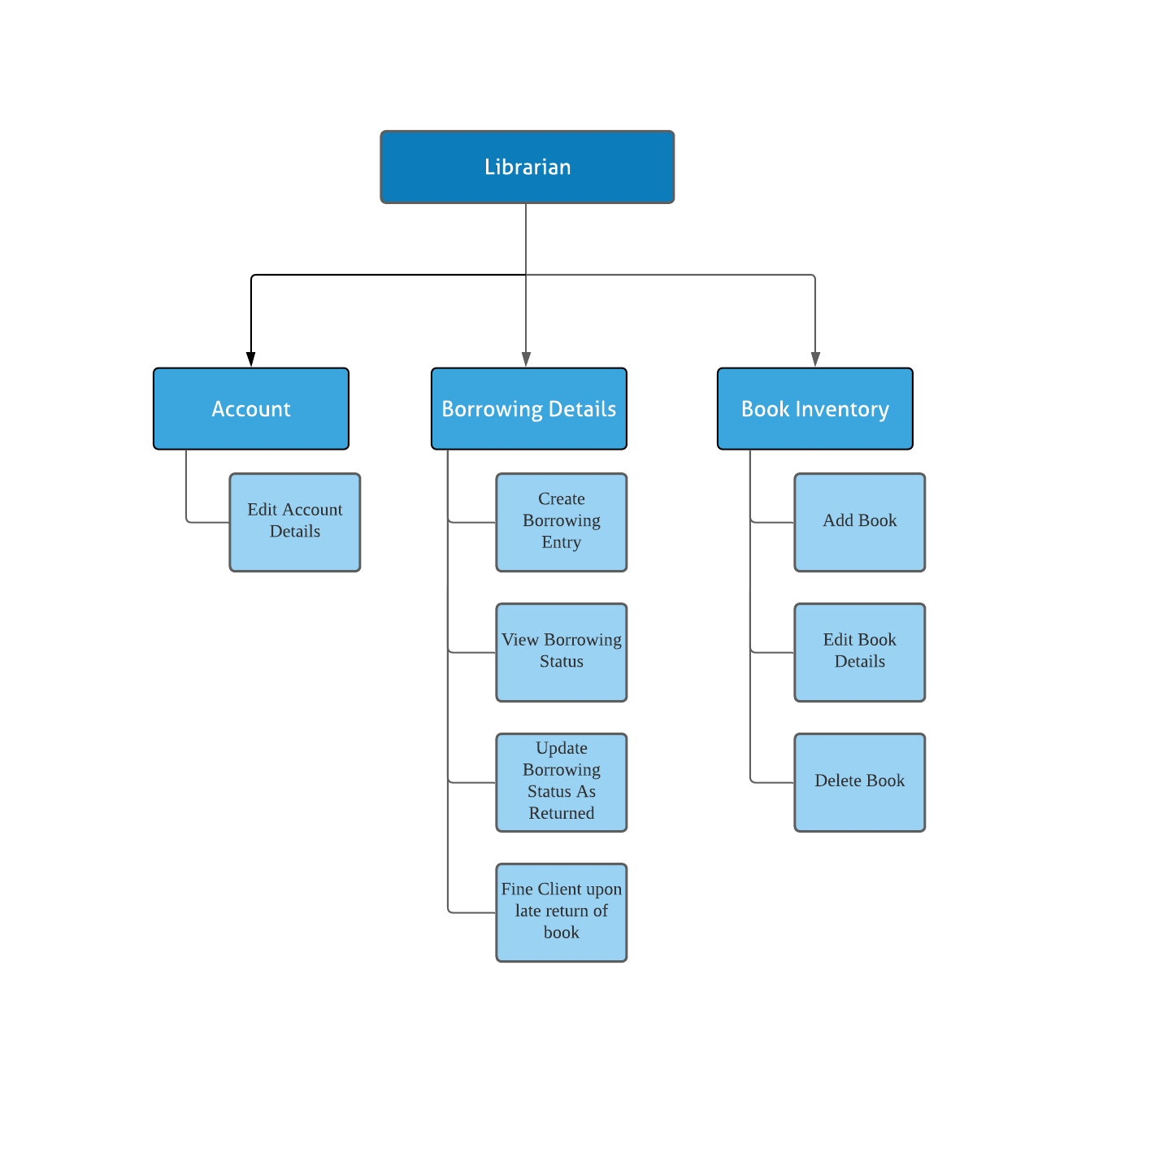

Figure 5: Librarian User Role Hierarchy Chart of LibSys Library Management System.

## Client Hierarchy Chart

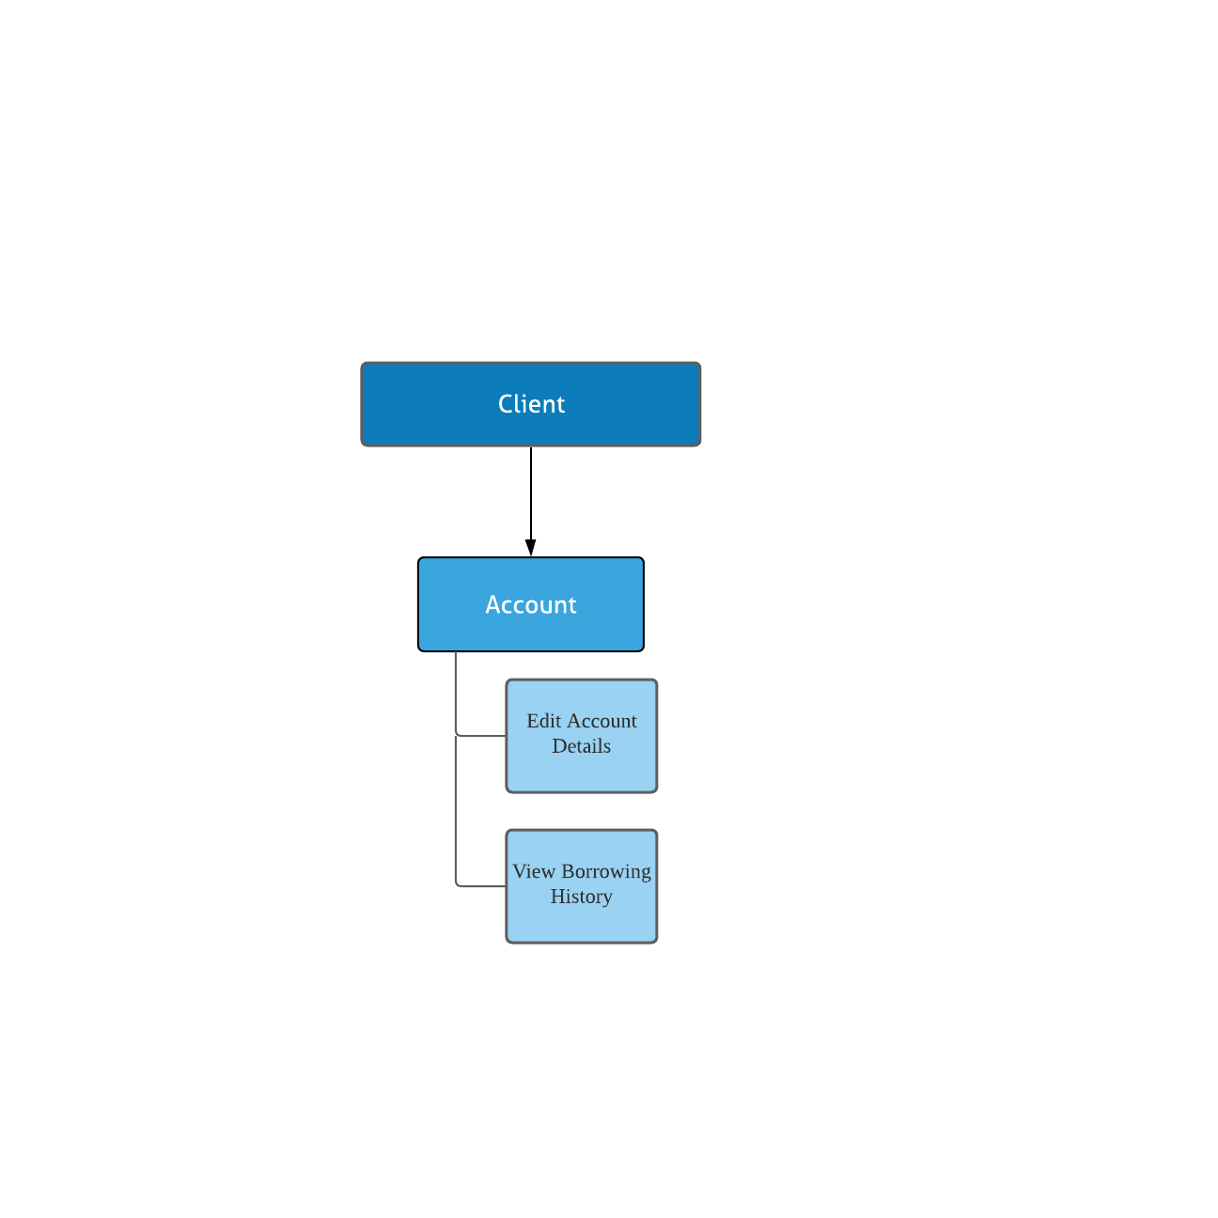

Figure 6: Client User Role Hierarchy Chart of LibSys Library Management System.

# Context Diagram

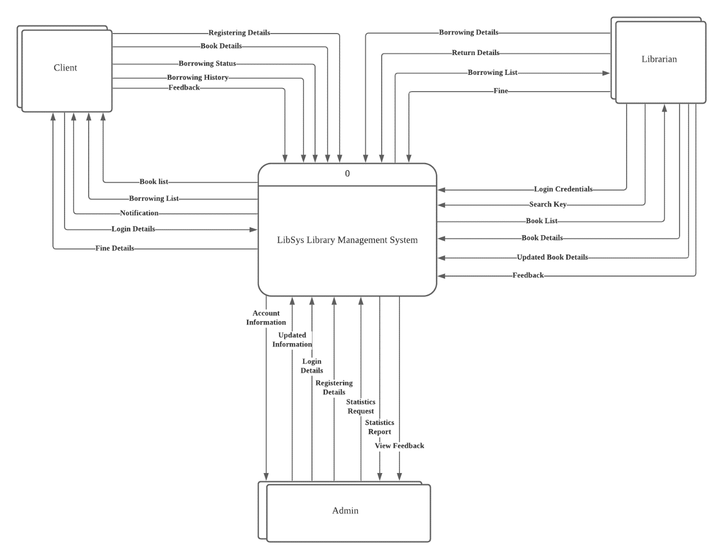

Figure 7: Context Diagram of LibSys Library Management System

# Data Flow Diagram Level 0

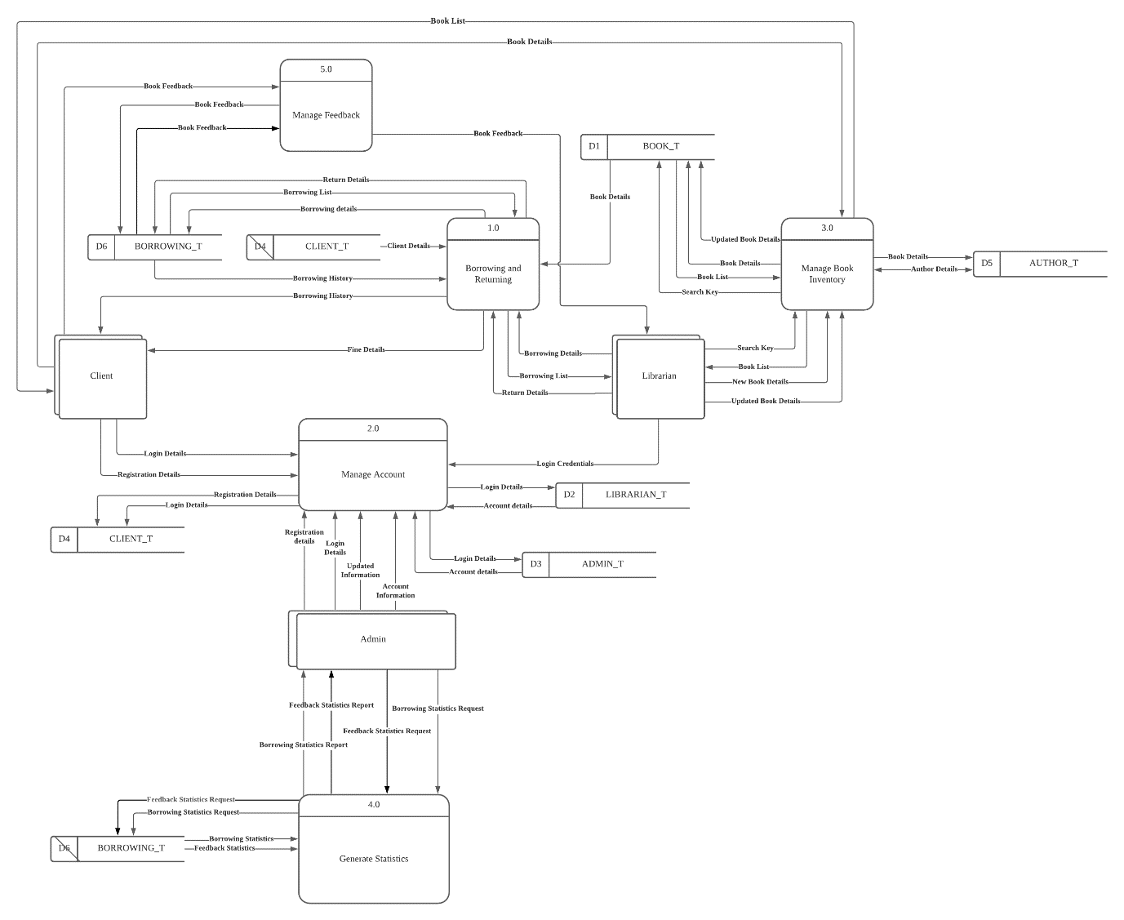

Figure 8: Data Flow Diagram Level 0 of LibSys Library Management System

# Data Flow Diagram Level 1

## Muhammad Danish Bin Mansor [TP055704]

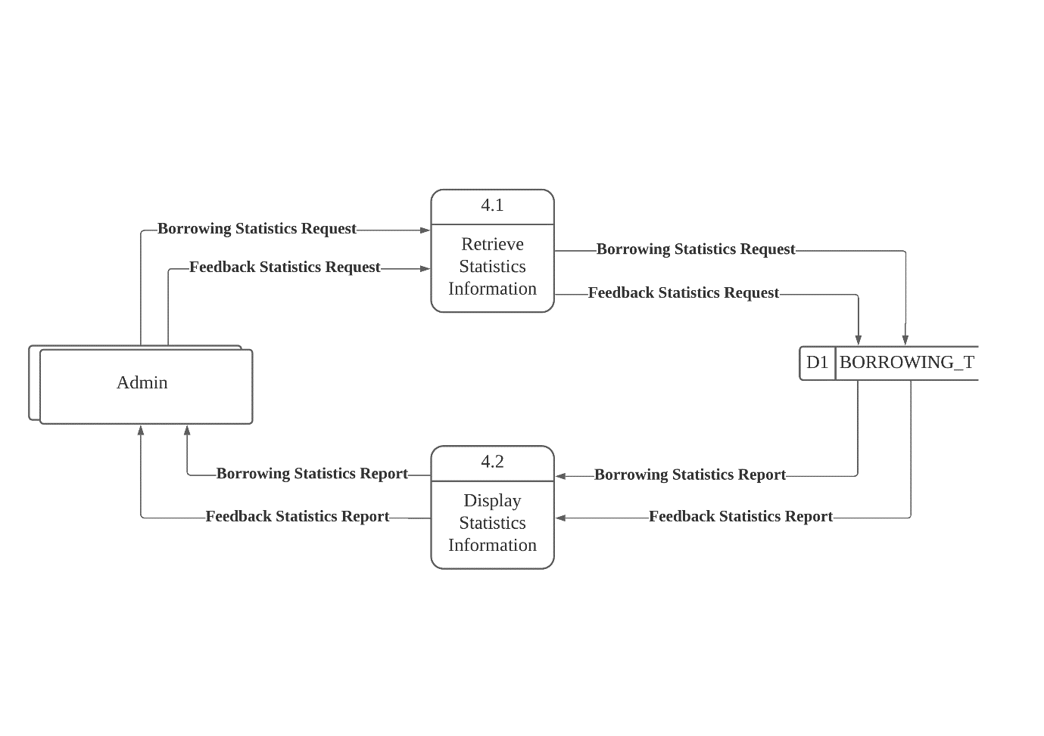

Figure 9: Data Flow Diagram Level 1 for View Statistics process

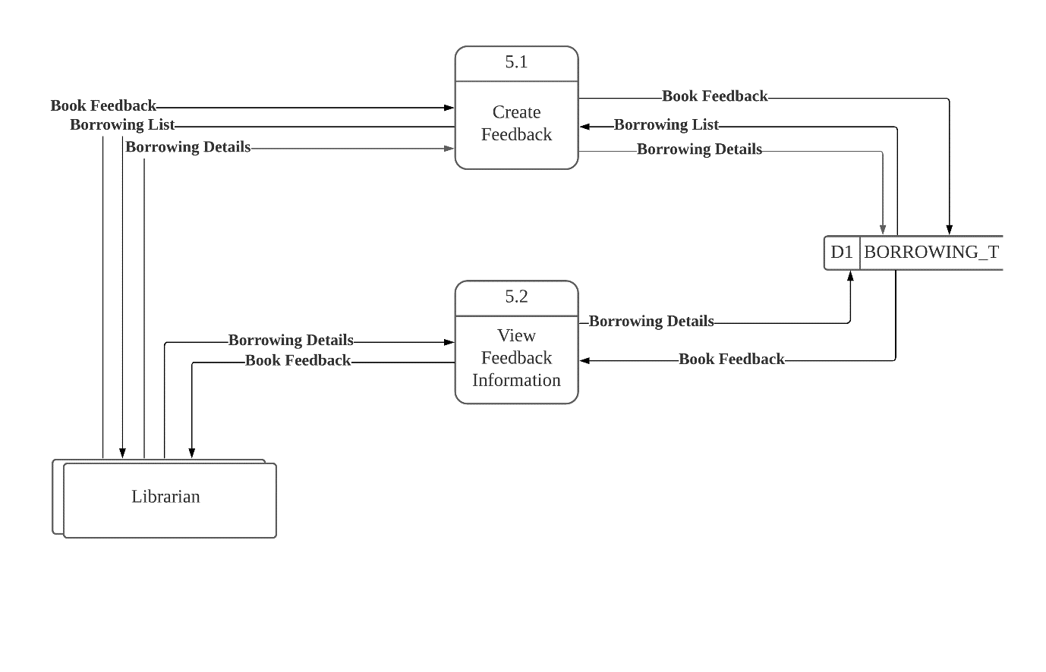

Figure 10: Data Flow Diagram Level 1 Manage Feedback Process

## Kishen Shanthan A/L Jegathes [TP055296]

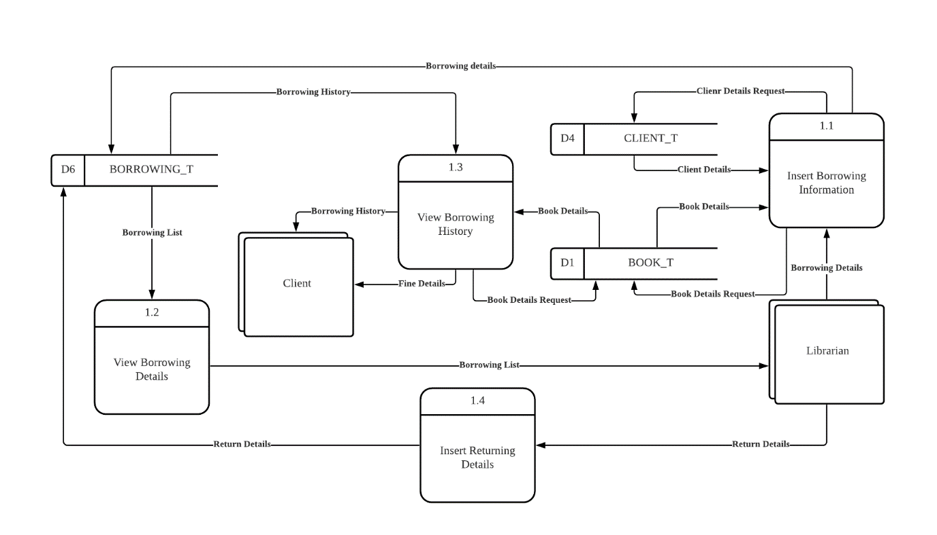

Figure 11: Data Flow Diagram Level-1 for Borrowing and Returning process.

## Muhammad Fuad Bin Abdullah [TP055684]

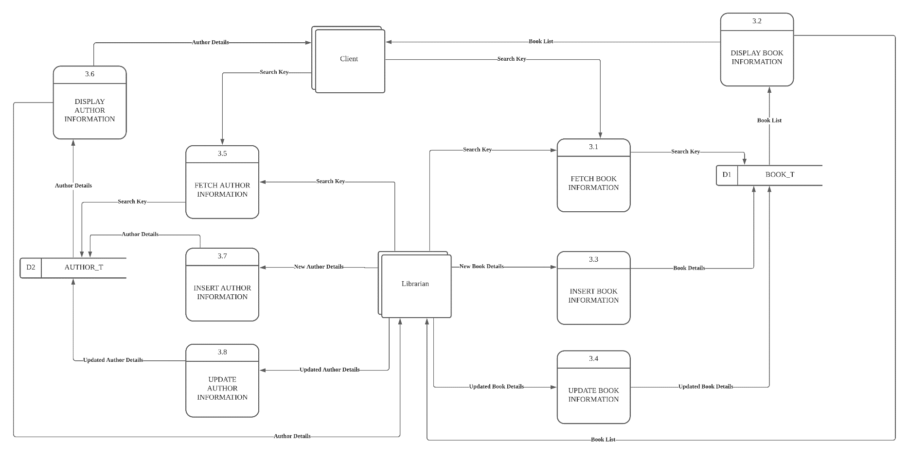

Figure 12: Data Flow Diagram Level 1 for Manage Book Inventory process

## Johari Idzman Bin Dzulkarnain [TP055683]

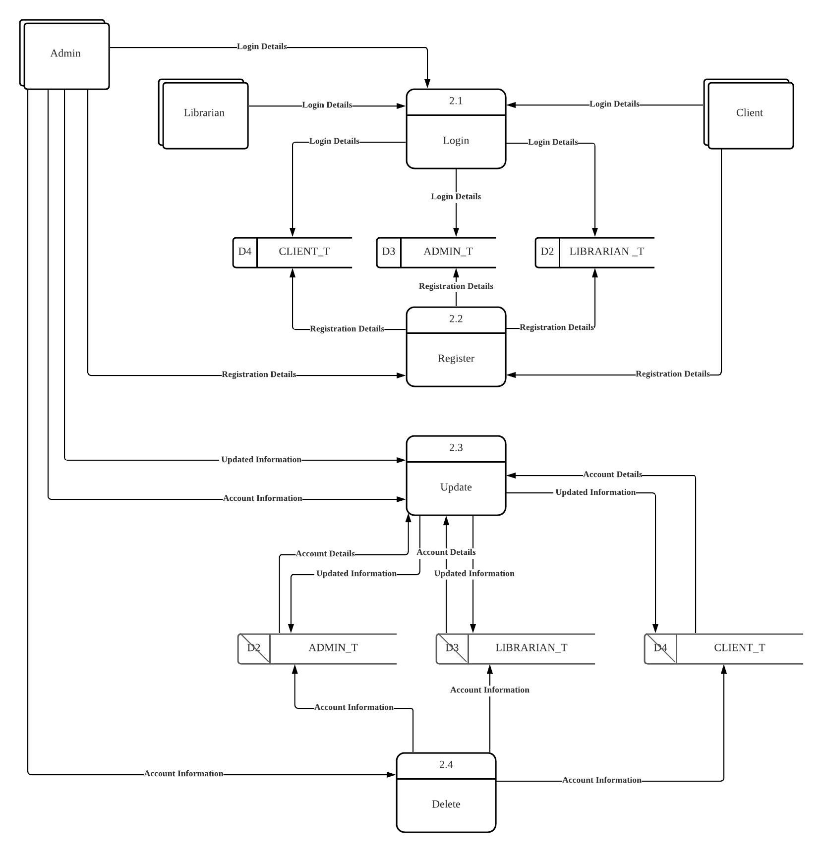

Figure 13: Data Flow Diagram Level 1 for Manage Accounts process

# Data Dictionary

## Muhammad Danish Bin Mansor [TP055704]

**Data dictionary:**

Process:

|  |  |
| --- | --- |
| Name | 4.0 Generate Statistics |
| Description | 1. The process will retrieve the statistics for both borrowing and feedback from BORROWING_T and display it in table form for Librarian. |
| Input data flows | 1. Borrowing Statistics Request 2. Feedback Statistics Request |
| Output data flows | 1. Feedback Statistics Report 2. Borrowing Statistics Report |

Process:

|  |  |
| --- | --- |
| Name | 5.0 Manage Feedback |
| Description | 1. The process will retrieve borrowing details by requesting from BORROWING_T, before receiving the book feedback from Librarian and inserting it to BORROWING_T. 2. The process will retrieve borrowing list that contains the book feedback from the BORROWING_T table and display to the Librarian in a table format. |
| Input data flows | 1. Book Feedback 2. Book Feedback |
| Output data flows | 1. Book Feedback 2. Book Feedback |

## Kishen Shanthan A/L Jegathes [TP055296]

**Data dictionary:**

Process:

|  |  |
| --- | --- |
| Name | 1.0 Borrowing and Returning |
| Description | 1. The process will retrieve book details from the BOOK_T table and the retrieve client details from CLIENT_T table before receiving the borrowing details from the Librarian and inserting into the BORROWING_T table. 2. The process will retrieve borrowing list from the BORROWING_T table and display to the Librarian in a table format. 3. The process will retrieve the borrowing history of the client from the BORROWING_T table, retrieve the book details of the book borrowed by the client from the BOOK_T table and then calculate the fine amount for the client if the borrowing is overdue before displaying the borrowing history to the client. 4. The process will receive the return details from the Librarian and update the borrowing information in the BORROWING_T table to include the return date and the fine amount (if the book is overdue). |
| Input data flows | 1. Borrowing Details 2. Return Details 3. Book Details 4. Client Details 5. Borrowing List 6. Borrowing History |
| Output data flows | 1. Borrowing Details 2. Return Details 3. Borrowing History 4. Borrowing List 5. Fine Details |

## Muhammad Fuad Bin Abdullah [TP055684]

**Data dictionary:**

Process:

|  |  |
| --- | --- |
| Name | 3.0 Manage Book Inventory |
| Description | 1. The process will accept search key of book from Client, query the data store BOOK_T and AUTHOR_T for specific book and author record, and return to the Client with searched book list. 2. The process will accept search key of book from Librarian, query the data store BOOK_T and AUTHOR_T for specific book and author record, and return to the Librarian with searched book list. 3. The process will accept new book and author information from Librarian and query the data store BOOK_T and AUTHOR_T for new record insertion with the new book information. 4. The process will accept new information of existing book and author from Librarian and query the data store BOOK_T and AUTHOR_T for existing record update with the new information. |
| Input data flows | 1. Search Key 2. New Book Details 3. Updated Book Details 4. Book Details 5. Book List 6. Author Details |
| Output data flows | 1. Book List 2. Search Key 3. Book Details 4. Updated Book Details 5. Author Details |

## Johari Idzman Bin Dzulkarnain [TP055683]

**Data dictionary:**

Process:

|  |  |
| --- | --- |
| Name | 2.0 Manage Account Process |
| Description | 1. The process will accept user input for email and password and will query the datastore CLIENT_T, LIBRARIAN_T or ADMIN_T for matching credentials. If the credentials match, then the user will be redirected to the index page. 2. The process will accept registration details from the users and query the datastore CLIENT_T, LIBRARIAN_T or ADMIN_T for new record insertion for new users. 3. The process will accept new information of existing users and query the datastore CLIENT_T, LIBRARIAN_T or ADMIN_T for existing record update with the new information. |
| Input data flows | 1. Login Details 2. Registration Details 3. Account Details 4. Updated Information 5. Account Information |
| Output data flows | 1. Login Details 2. Registration Details |

# Entity Relationship Diagram (ERD)

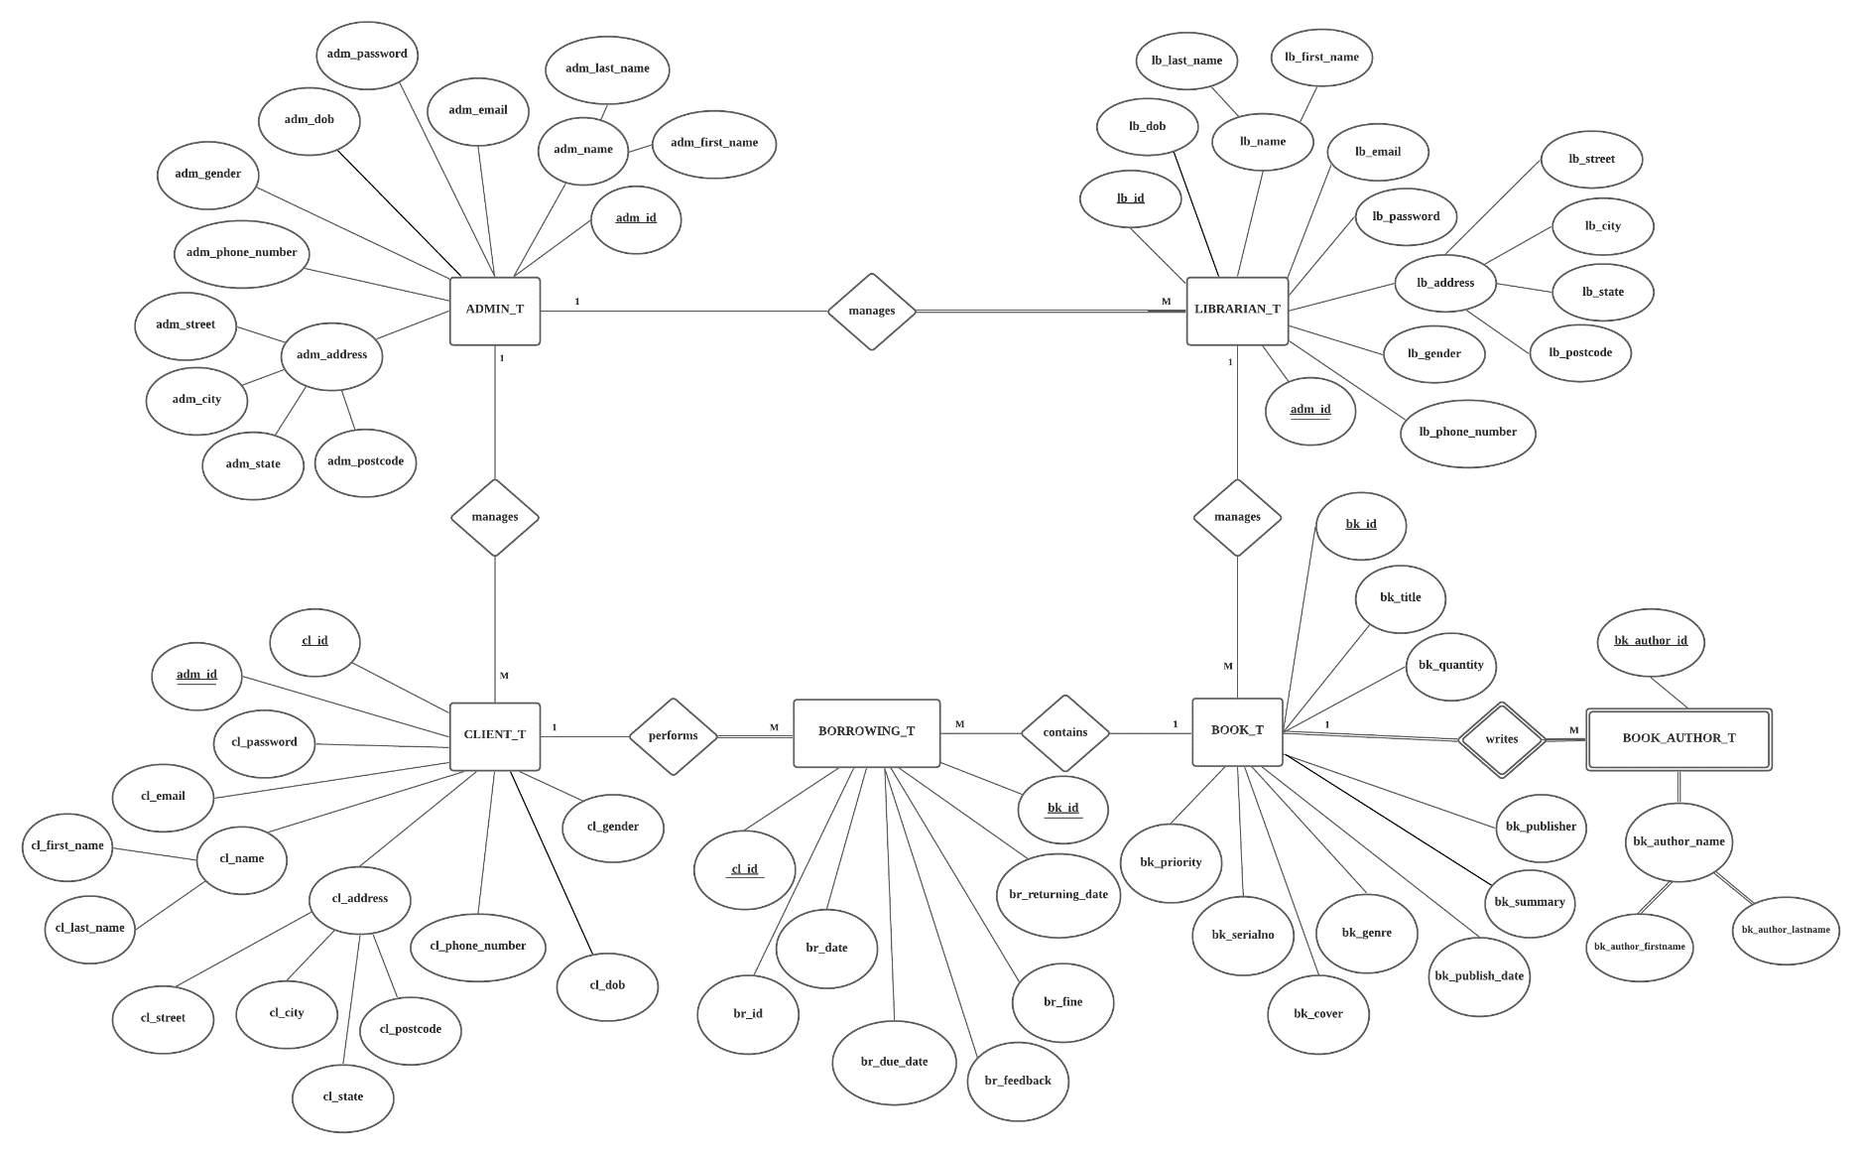

Figure 14: Entity Relationship Diagram of LibSys Library Management System

# Flowcharts

## Muhammad Danish Bin Mansor [TP055704]

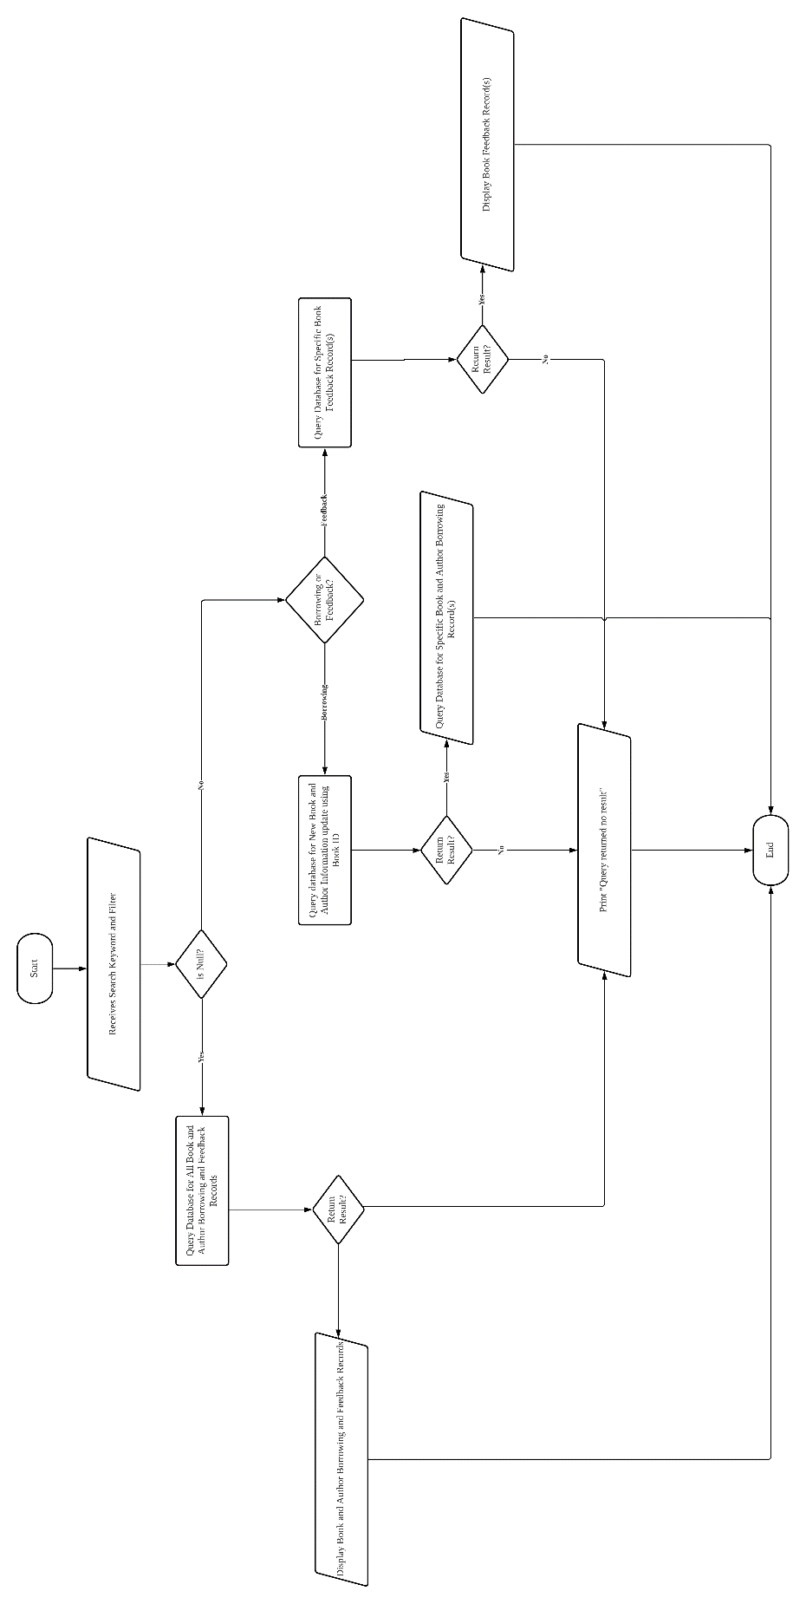

Figure 15: Flow chart for Fetch and Display Statistics Information process

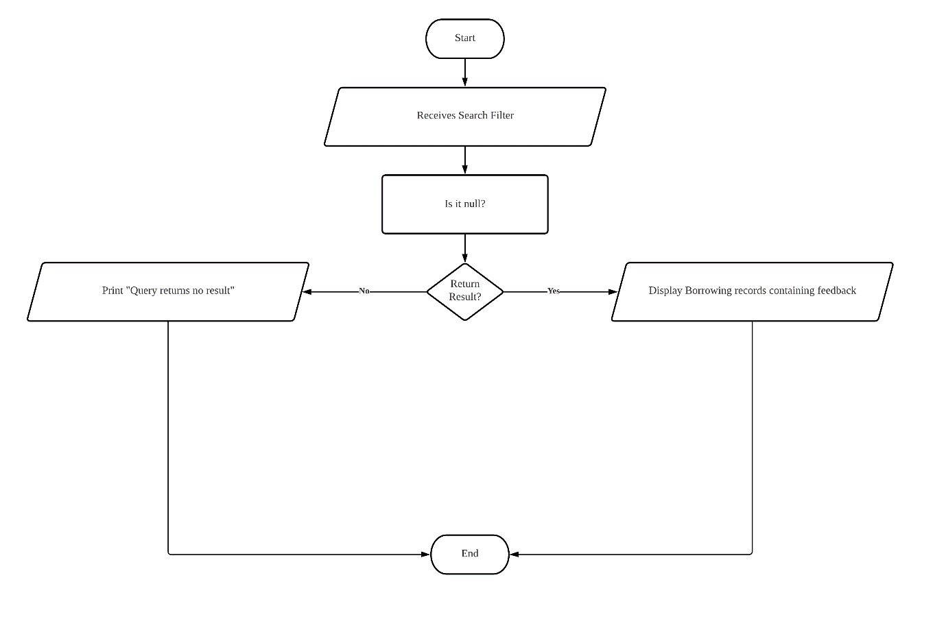

Figure 16: View Feedback Process’s Flowchart

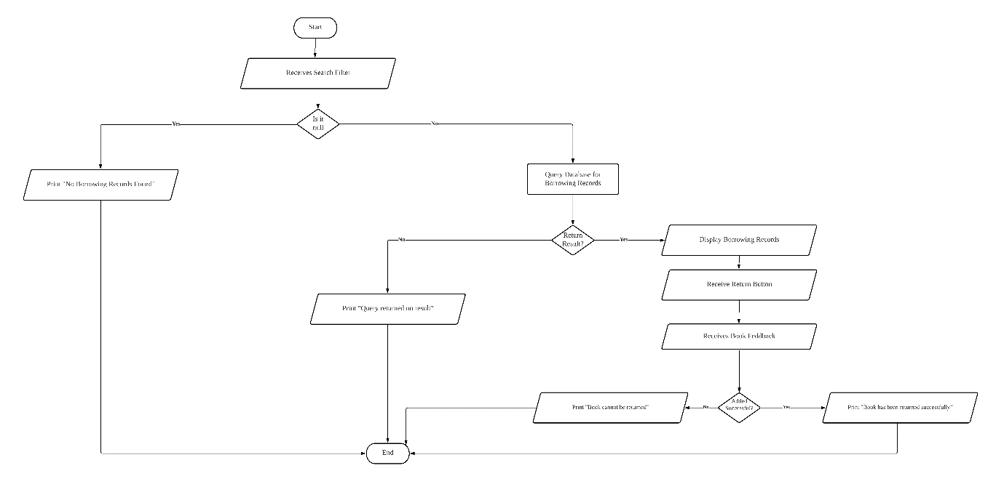

Figure 17: Flowchart for Create Feedback process

## Kishen Shanthan A/L Jegathes [TP055296]

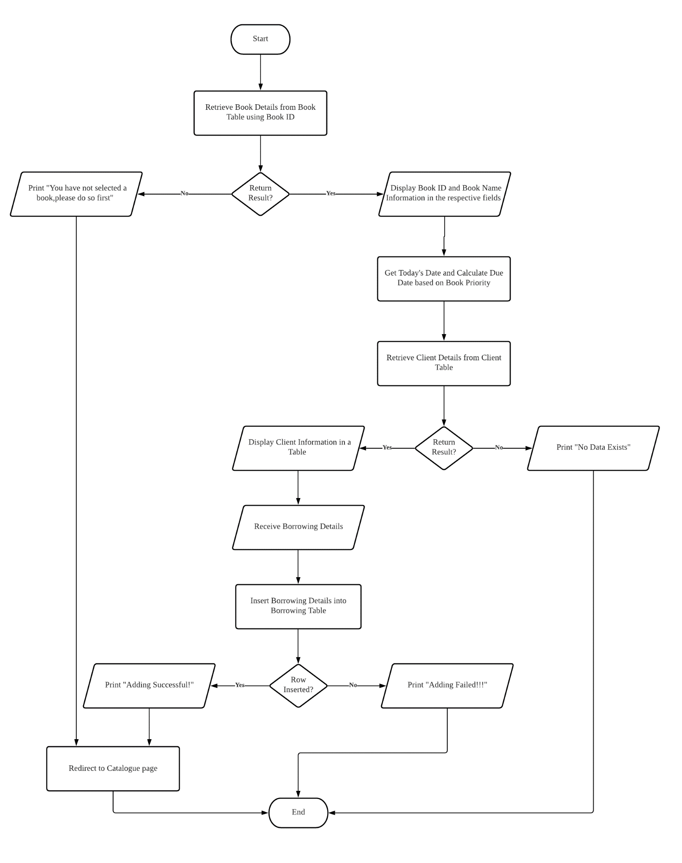

Figure 18: Flowchart for Insert Borrowing Information process.

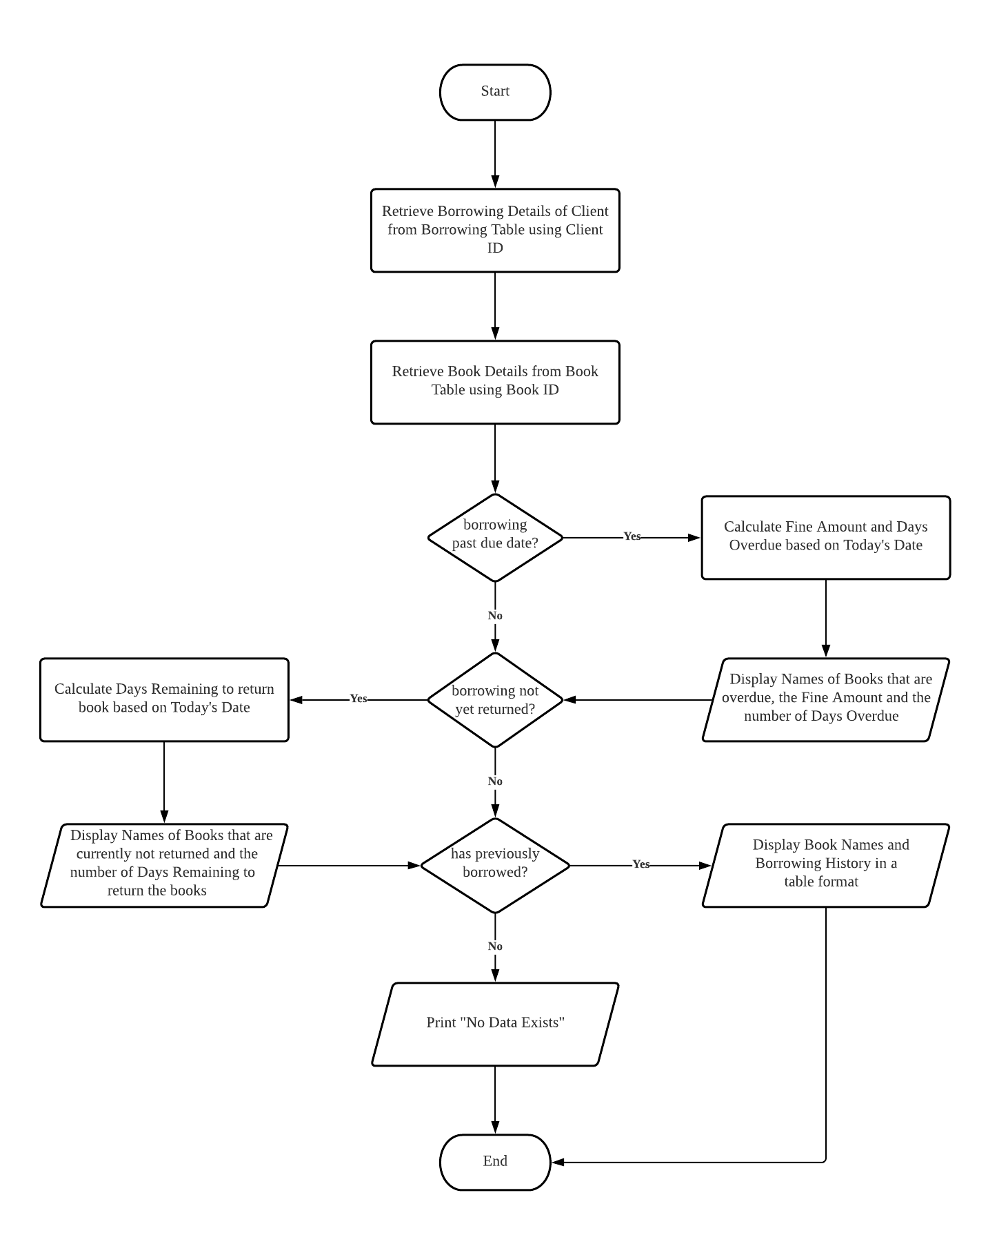

Figure 19: Flowchart for View Borrowing Details process.

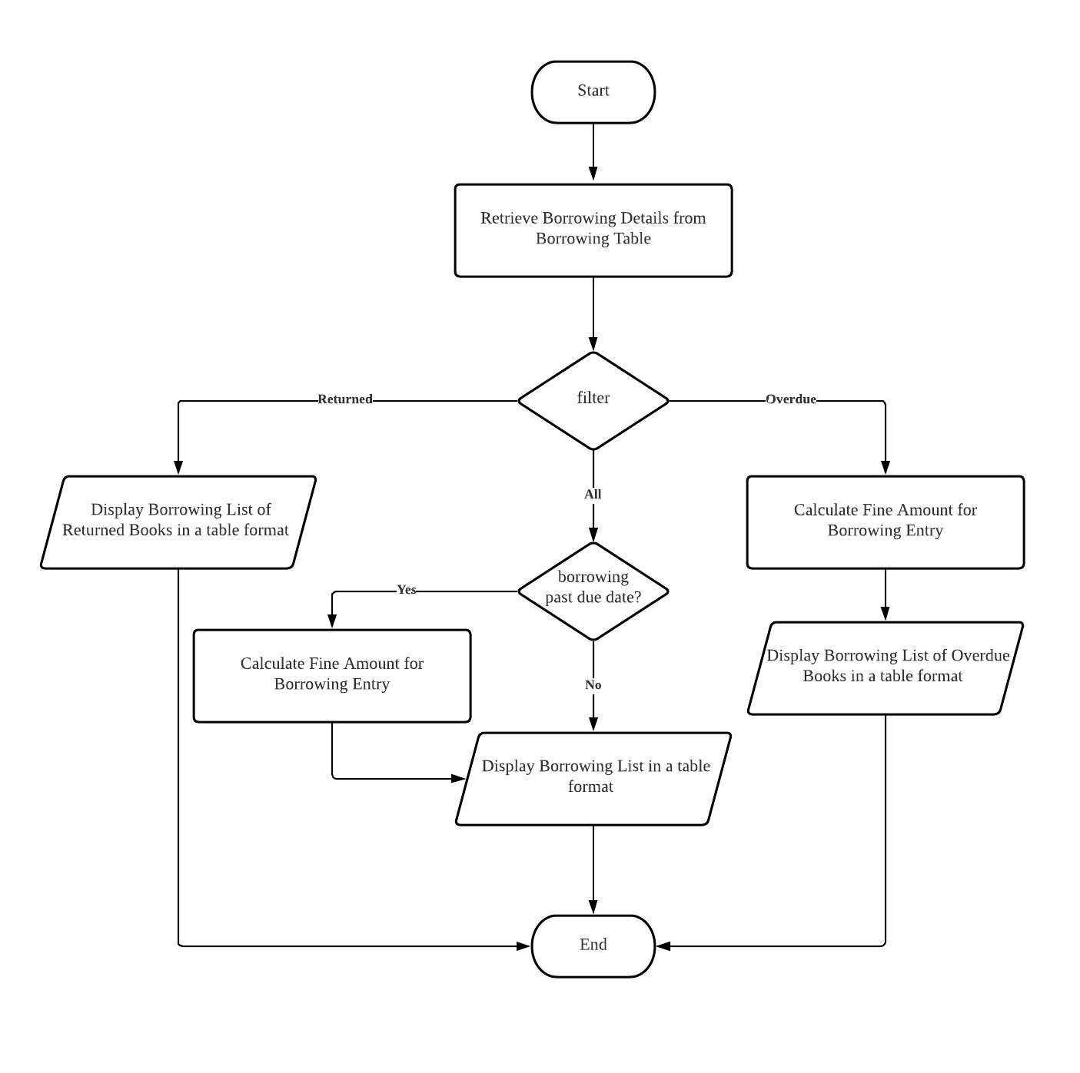

Figure 20: Flowchart for View Borrowing History process.

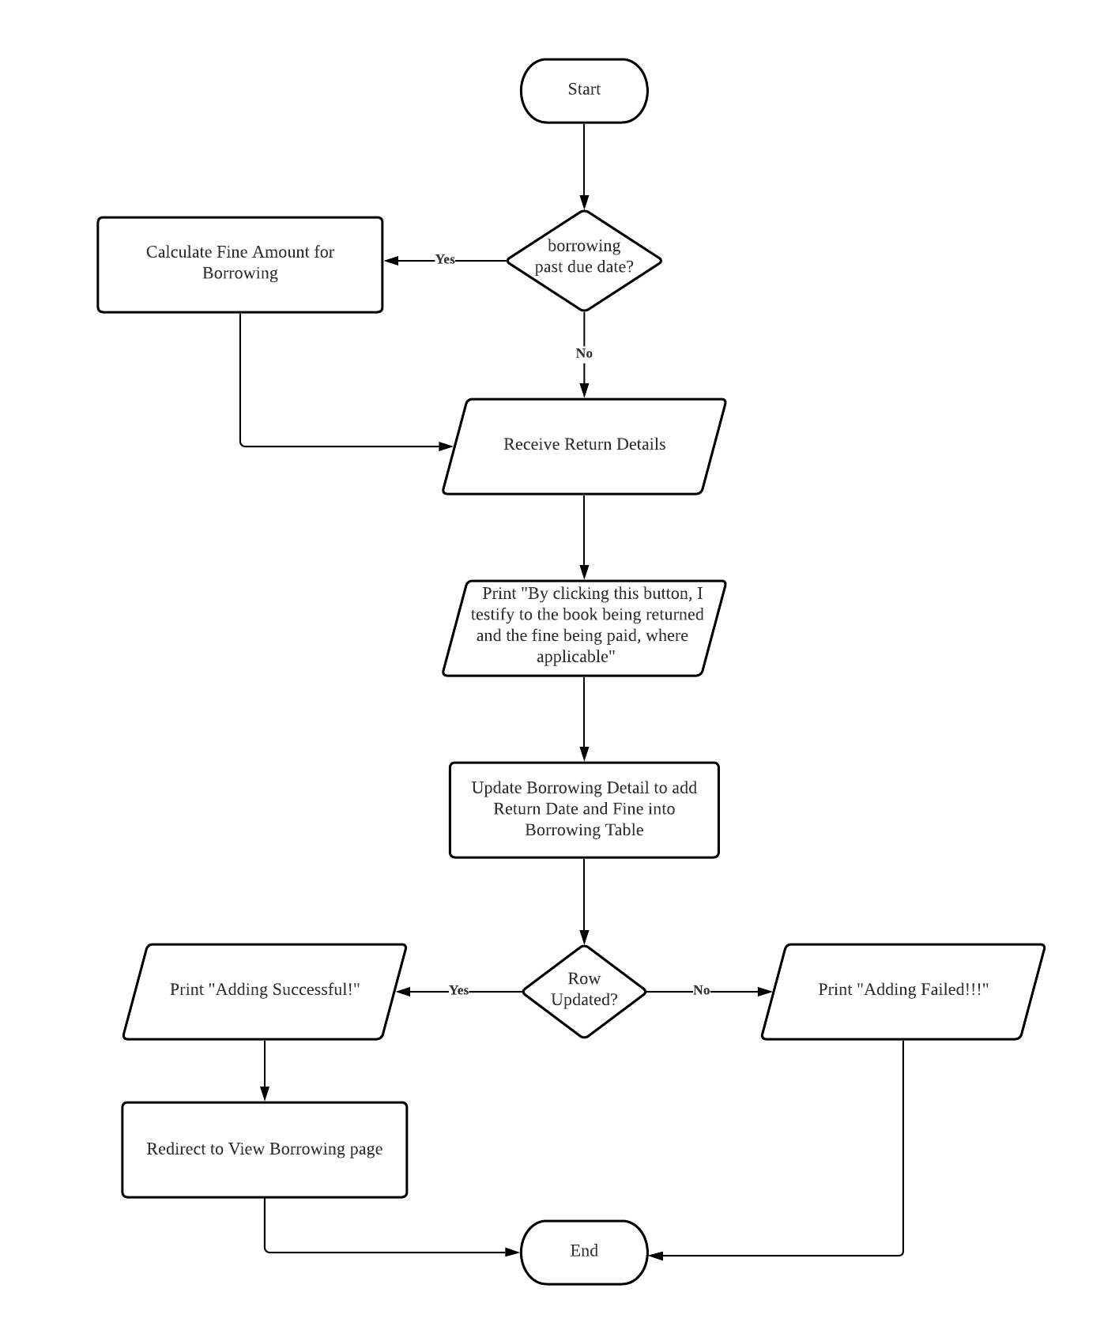

Figure 21: Flowchart for Insert Returning Details process.

## Muhammad Fuad Bin Abdullah [TP055684]

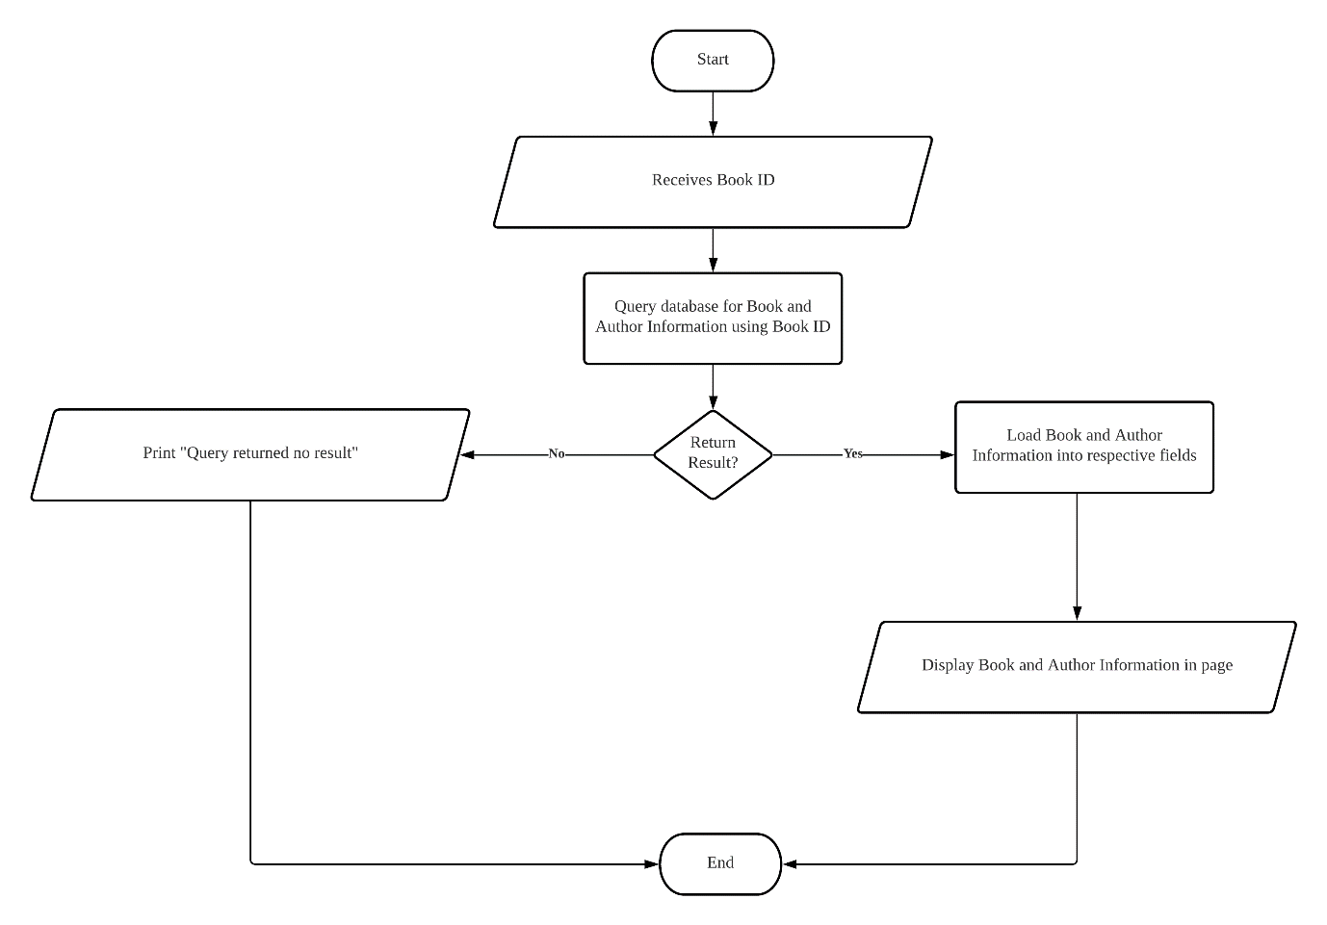

Figure 22: Flow chart for Fetch Book/Author Information process

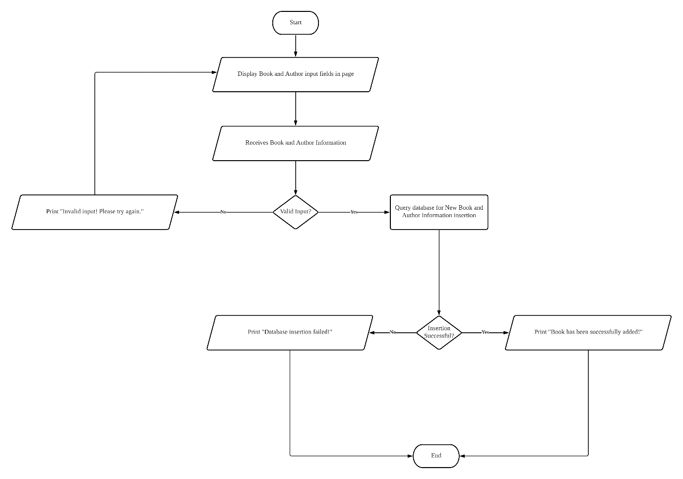

Figure 23: Flow chart for Insert Book/Author Information process

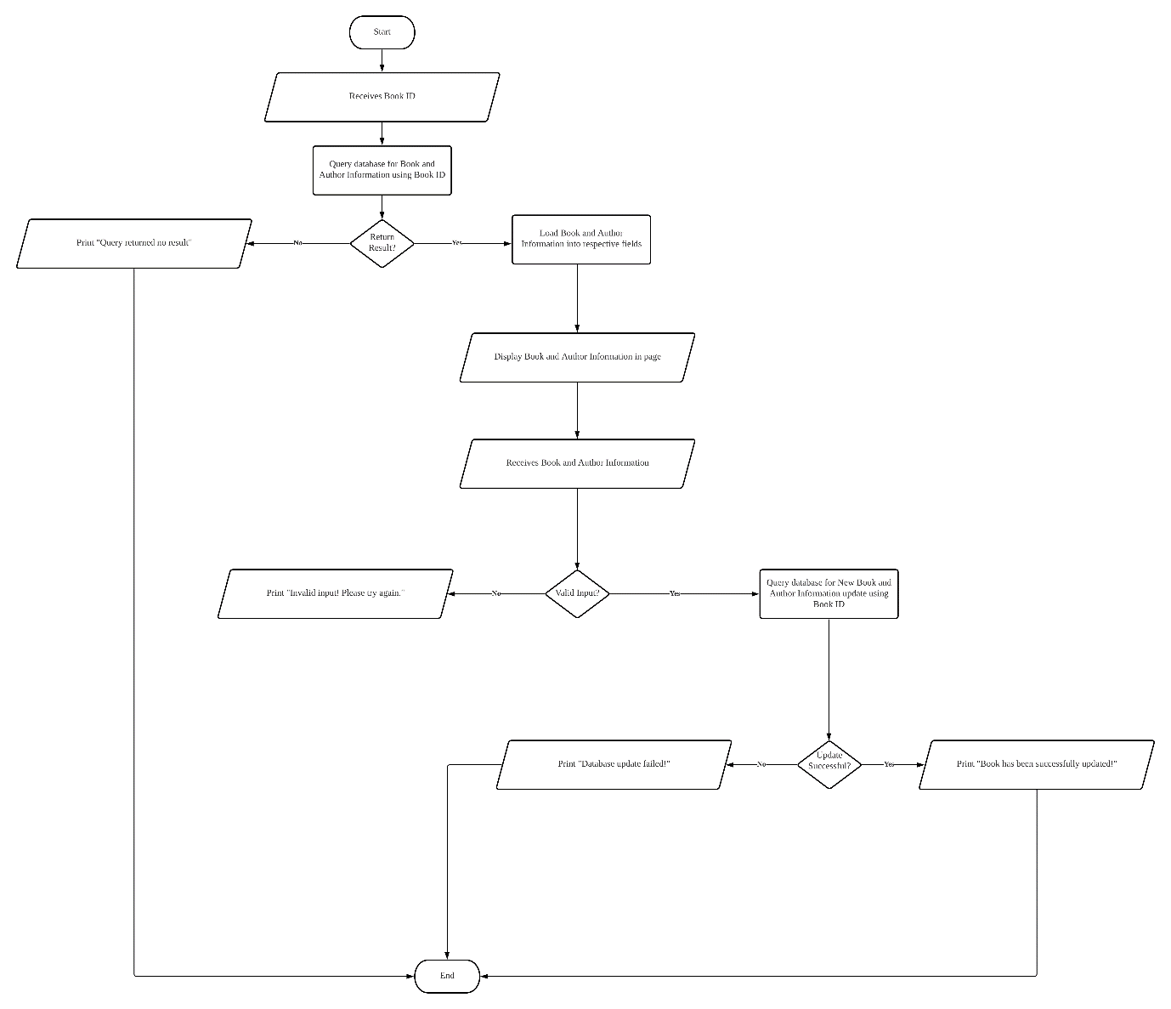

Figure 24: Flow chart for Update Book/Author Information process

## Johari Idzman Bin Dzulkarnain [TP055683]

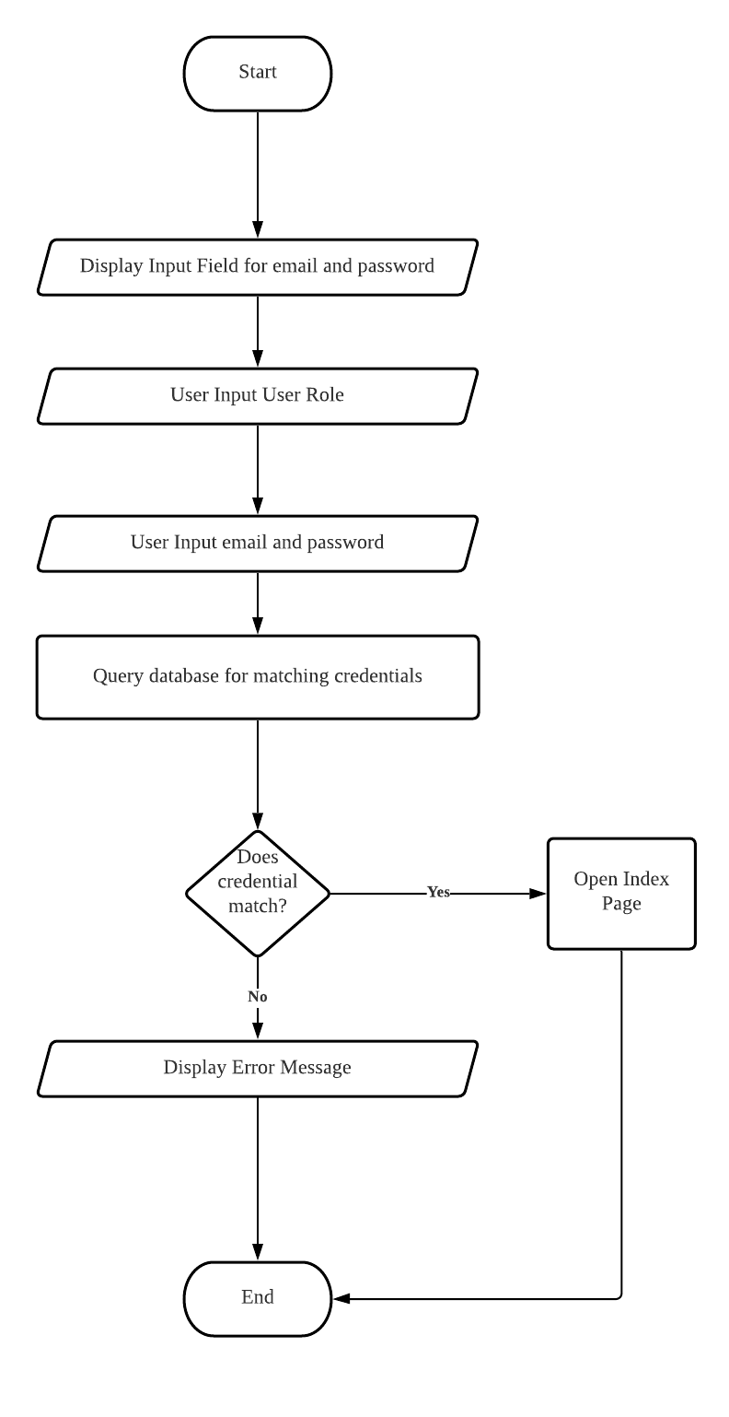

Figure 25: Flow chart for Login process

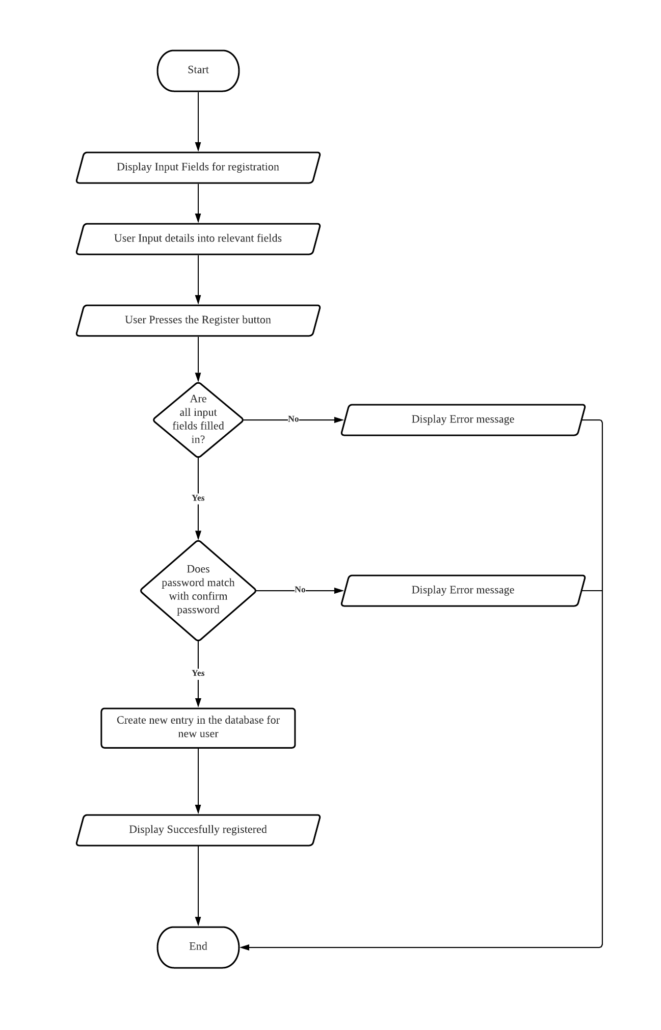

Figure 26: Flow chart for Register User process

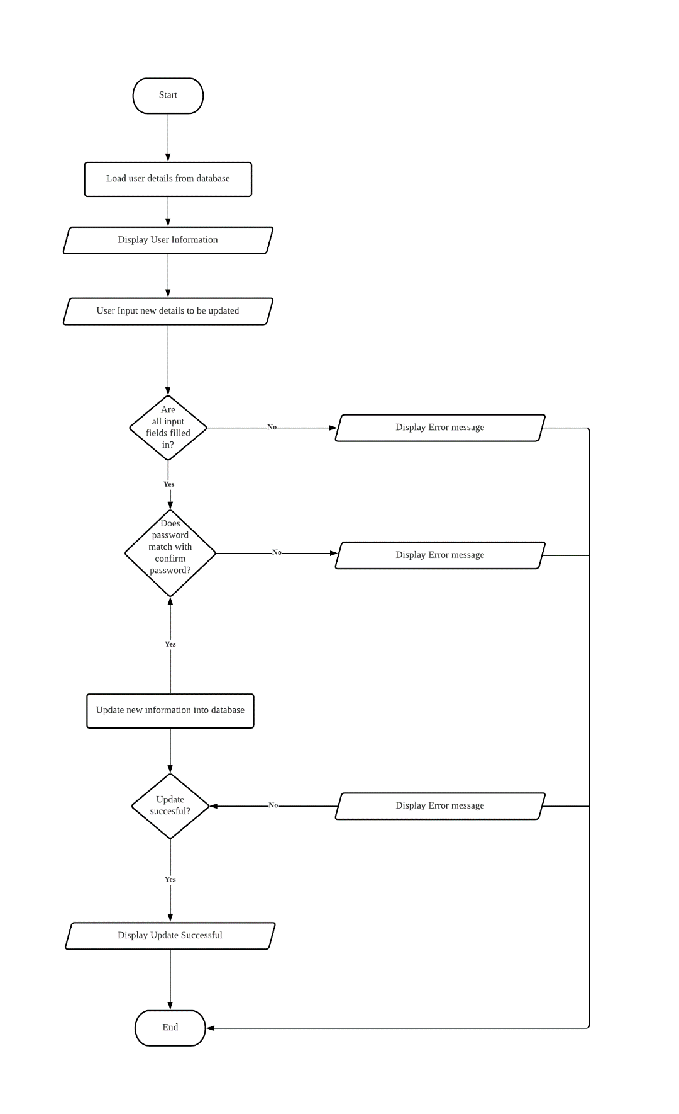

Figure 27: Flow chart for Update User Information process

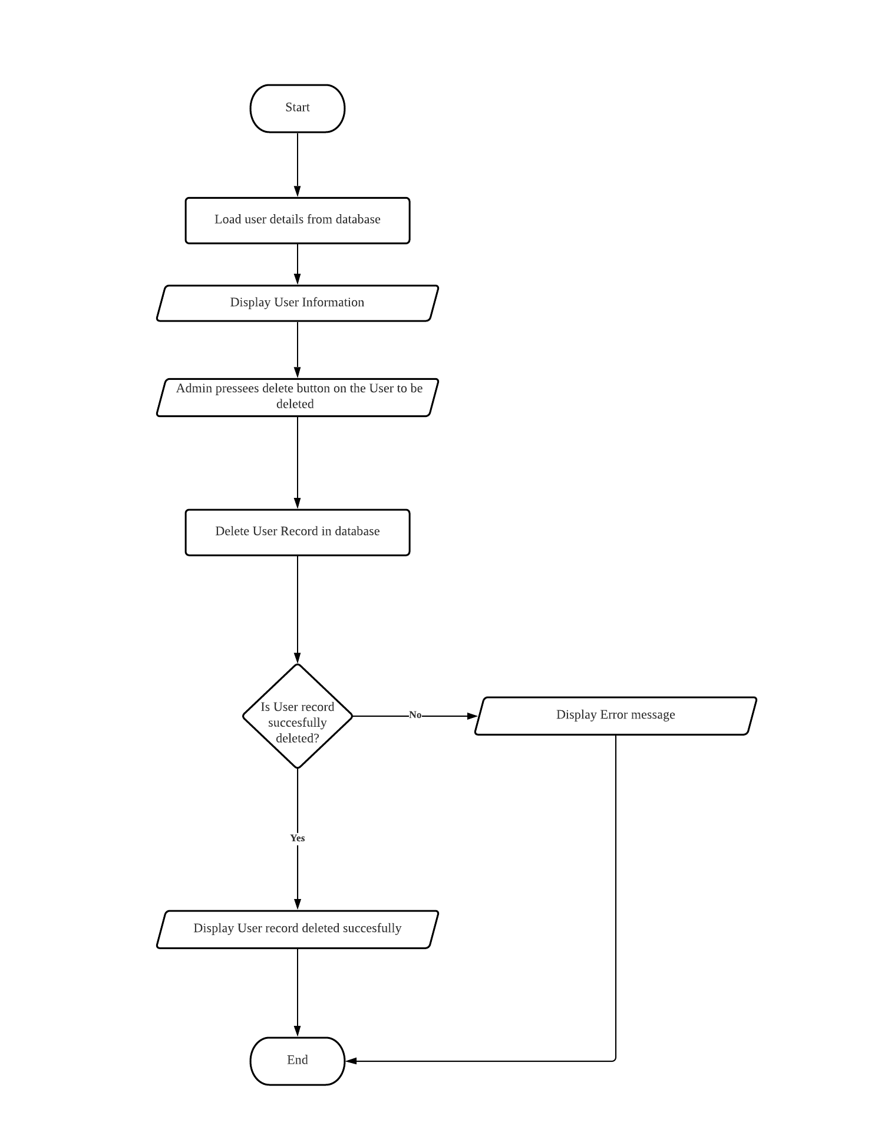

Figure 28: Flow chart for Delete User Information process

# Screen Design & User Manual

## Registration Page

Registration page is one of the security implementations inside the system that handles pre-authorization for users before assuming specific user roles’ privilege. There are three user roles available within the system which are client, librarian, and admin. Despite the differences in accessibilities and roles, they are required to register using the same registration form with slight differences to denote their specialty for the role.

In a registration page, a user of the system, regardless of role, shall be able to perform common information insertion into fields which represents first name, last name, date of birth, gender, phone number, email address, password, and repeat password as confirmation. As for home address, a user of the system shall be able to insert their street, city, postcode number and state of living details into the respective fields.

The user of the system may differentiate the fields by the title written at the top of the input field before performing information insertion. At the bottom of the page, two buttons are available for the user of the system to reset the form to its empty state and for registration submission after fields validation are conducted by the system.

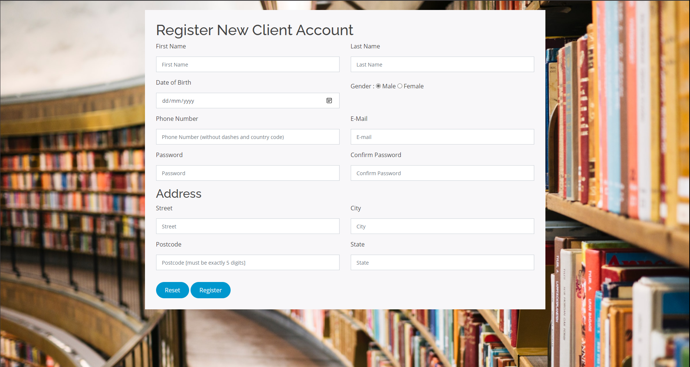

Figure 29: Empty client registration form for clients to fill-in before registering

A client may register an account at LibSys Library Management System by clicking on “Register new account” hyperlink at the bottom of the login card. Afterward, the registration form loads with titled fields to inform the client which input field is accepting which input string and buttons to reset the form to its original empty state or register the client with the information inserted. Now, the client is required to fill in the form with their personal details before they are allowed to finalise their registration.

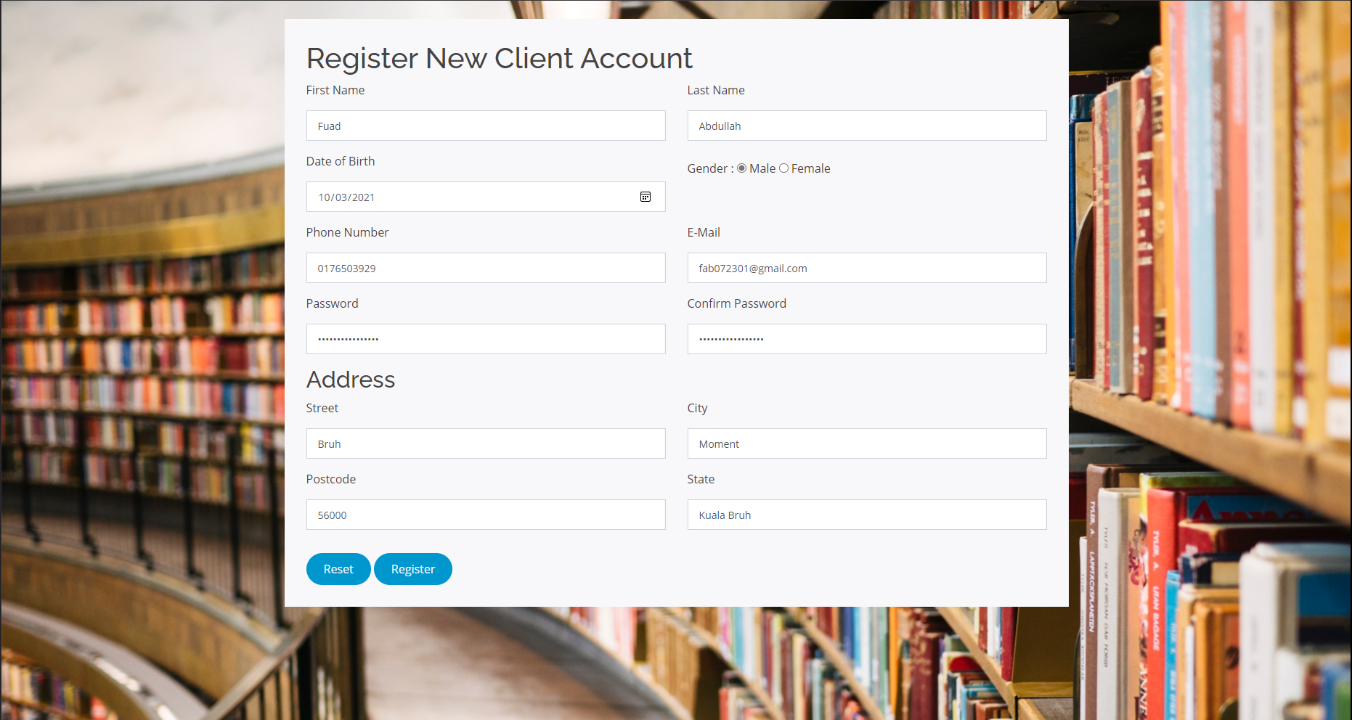

Figure 30: Registration form filled-in with valid client personal details

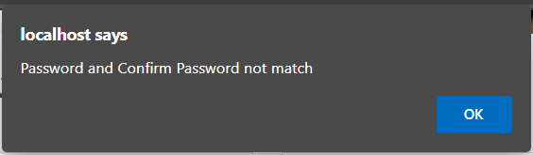 For the client registration form, all fields are required to be filled in with relevant information, meaning that no fields should be left empty before registration can take place. In the example above, all fields have been inserted with accepted details. For instance, the full name of the client registering for an account is “Fuad Abdullah”, but it is split into “Fuad” as first name and “Abdullah” for the last name. Reference can be done via the example screenshot above to know more about the requirement for the rest of the fields. As of now, the client’s registration form is completed and they can press the button to proceed with account finalisation.

Figure 31: Alert to notify client of password mismatch

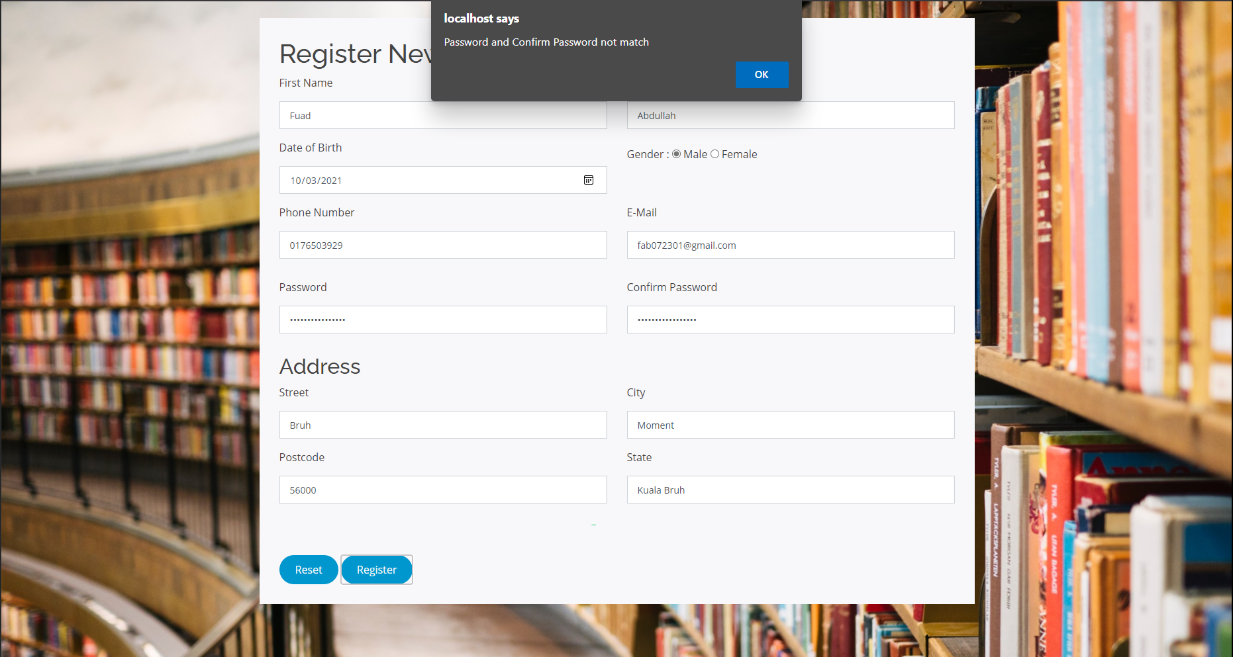

Figure 32: Alert to notify client of password mismatch in overall view

There would be a situation where a client accidentally inserted a mismatched pair of passwords when keying-in the “Password” and “Confirm Password” fields after “Register” button is pressed. To shed lights on why two password inputs are compulsory, it was set up to ensure client remembers their desired password as it will be used to login to their account after the registration is done. When the password mismatch exception is triggered, an alert will pop into the screen to notify the client of the wrong passwords and the client should address the notification straightaway in order to continue with the registration.

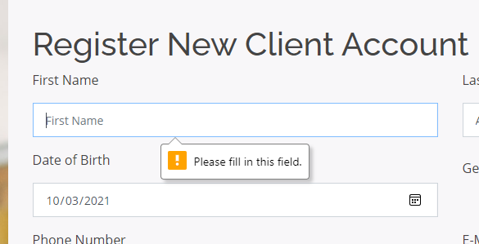

Figure 33: Hover pop-up to notify client of empty fields

In an event where a client forgot to fill in one of the required fields after pressing on “Register” button, a hover pop-up is displayed above or below the empty input field with remarks about the field being empty. This pop-up is helpful at times especially when the client is using mobile version of the website where the screen dimension is a lot smaller than conventional desktop monitor. A smaller screen creates a problem for the client to navigate through the form but when the pop-up is activated, the form will be scrolled to where it appeared, directing the client to the empty field instantly.

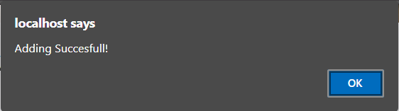

Figure 34: Alert to notify client of successful registration

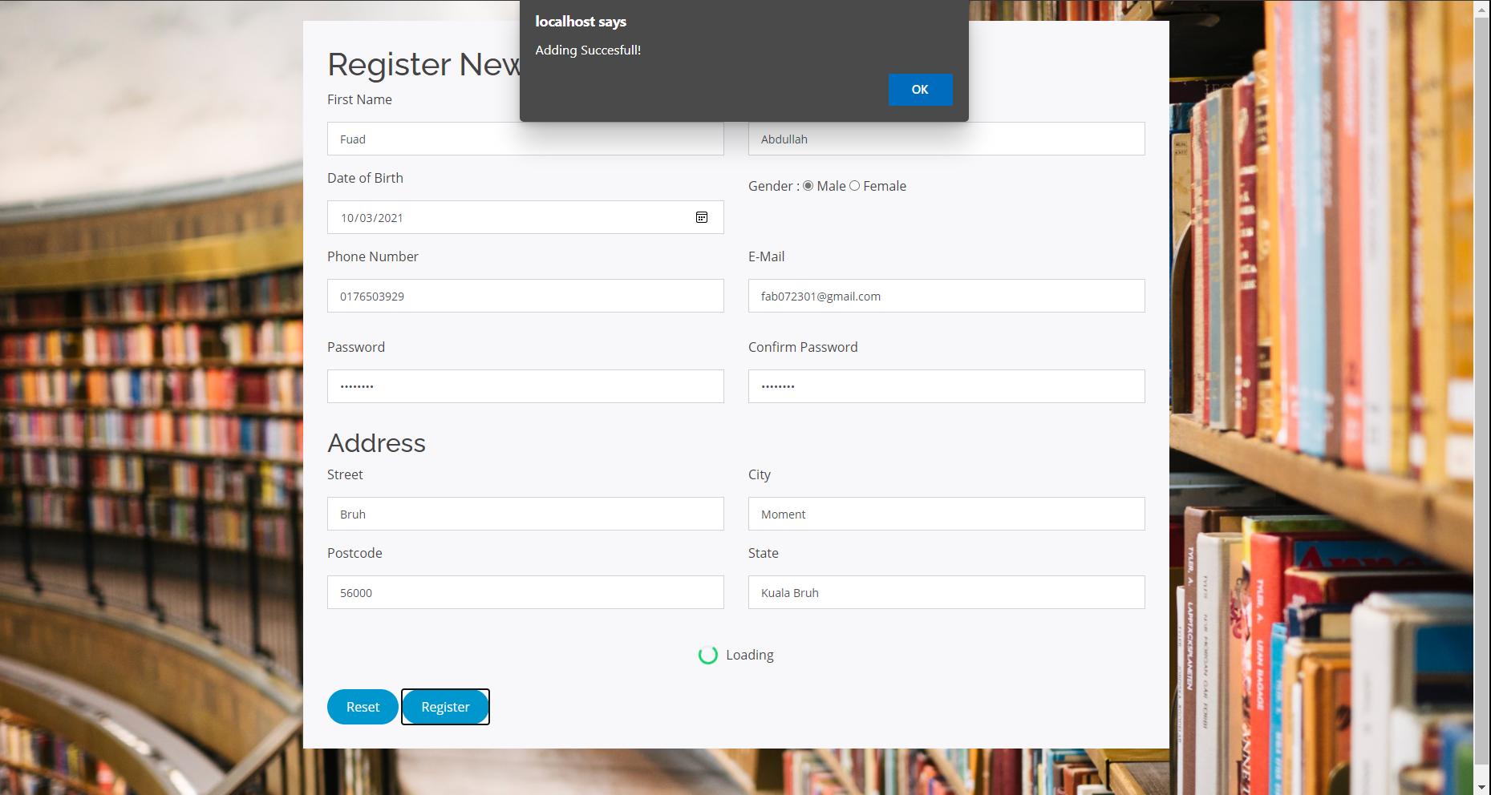

Figure 35: Alert to notify client of successful registration in overall view

Finally, if the client performed the personal details insertion without triggering any validation or exception errors, the client will be notified of successful registration once the “Register” button is pressed. As the pop-up is displayed, it indicates of a successful account creation and insertion into the database. To put it simply, the client has been registered as part of LibSys Library Management System users and is now able to perform borrowing and returning of books if they wish to do so. Before doing any of those, they are required to login to the system using the credentials comprised of their username and password through the login page. Note that similar procedure is applicable to the registration of librarian and admin with slight difference to the access to the registration form, which is exclusively available through admin user role.

## Login Page

Login page is another level of security implementation inside the system that handles authorization for users to assume specific user roles’ privilege after login. There are three user roles available within the system which are client, librarian, and admin.

In order to allow a single login page to be used by different user roles, a drop-down box was set in place to handle the role selection by the user of the system, regardless of role, before keying-in their credentials. For the user of the system to insert their credentials, two input fields are prepared to accept their email address as username and password, respectively.

At the bottom part of the login card, a button to authorise the inserted credentials and a hyperlink to redirect the user of the system to client registration form is present.

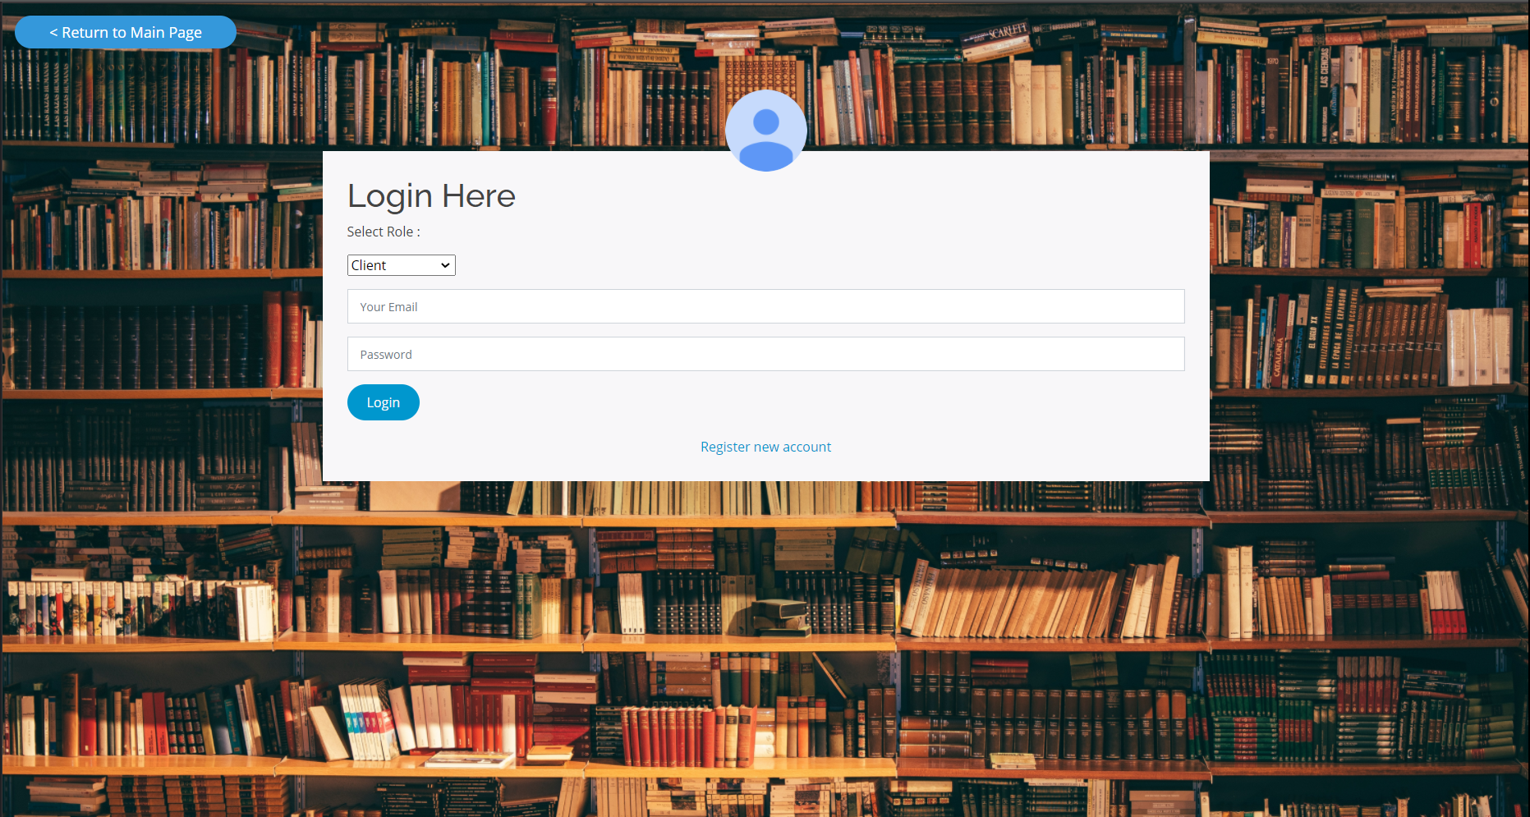

Figure 36: Empty email address and password fields with client user role selected

To demonstrate login sequence, account of client type is used. However, the exact same procedure is valid for librarian and admin user role. To start off and by default, the drop-down box to select user role is set to client and in this case, no changes in selection should be made. Then, the client may start inserting their valid credentials into the input fields accordingly.

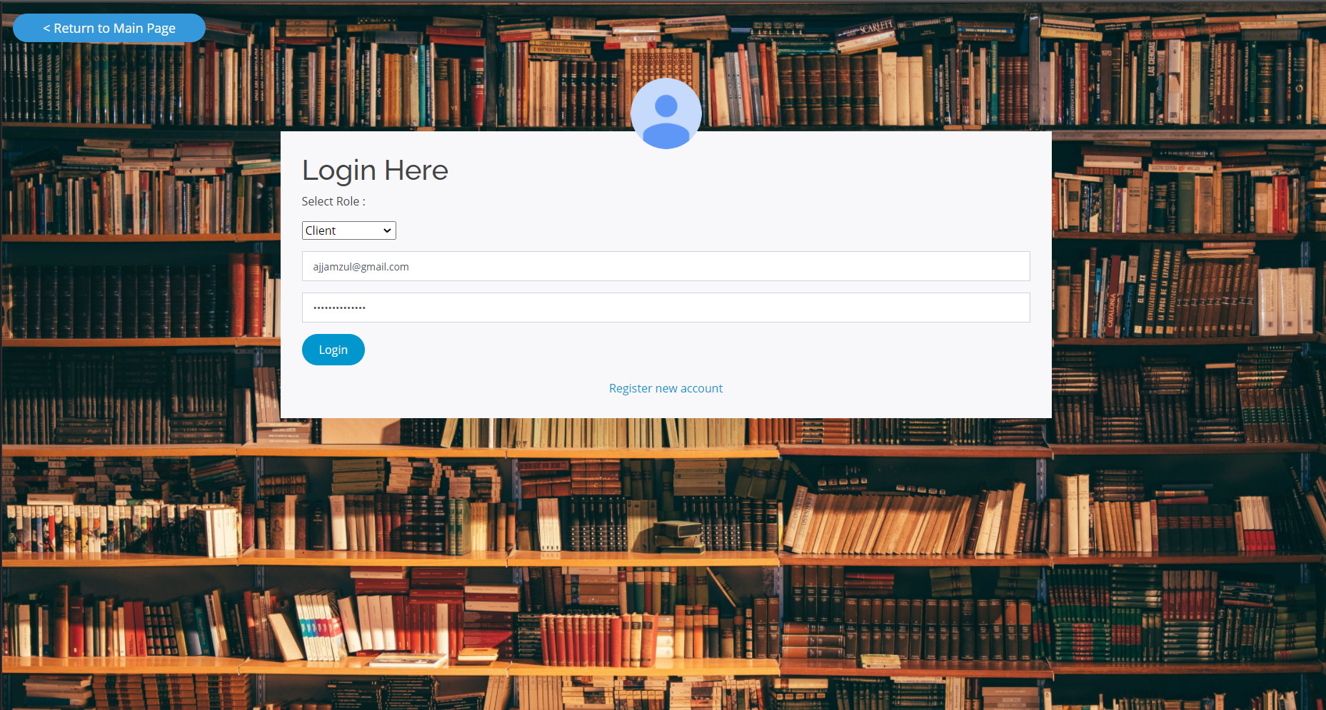

Figure 37: Input fields filled-in with credentials

Above is an example of client user with filled-in email address and password fields. Once “Login” button is pressed, authorization will be made based on the credentials inserted through a series of communications between the system and the database handling user accounts. In the case where no client account of the credentials inserted is found, an alert message will appear to tell the client of invalid credentials inserted, thus barring the client from logging in. Nonetheless, if an account of the credentials matched exactly an entry in the database, then the authorization is completed, and the user may now access the website as client.

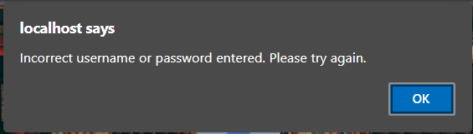

Figure 38: Alert to notify client of invalid credentials

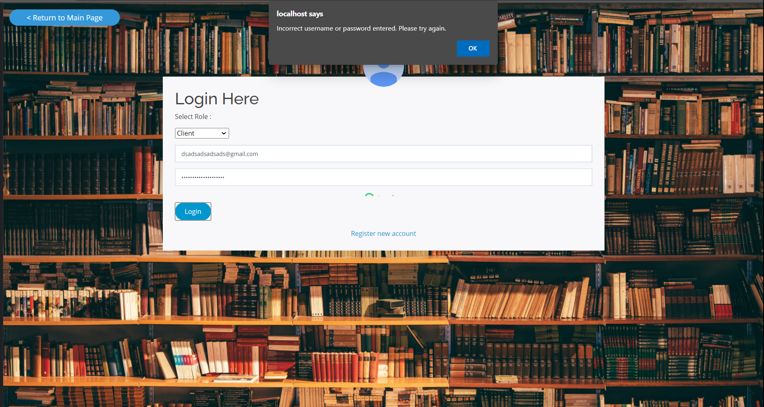

Figure n: Alert

Figure 39: Alert to notify client of invalid credentials in overall view

As mentioned previously, the two screenshots above display the alert of when a client’s credentials are not matching any of the entries found in the database. The client will need to dismiss the notification and retry with corrected credentials. Unfortunately for now, the system does not have an email address nor password recovery procedure in place and if recovery is needed, a client must contact admin personally to recover the credentials.

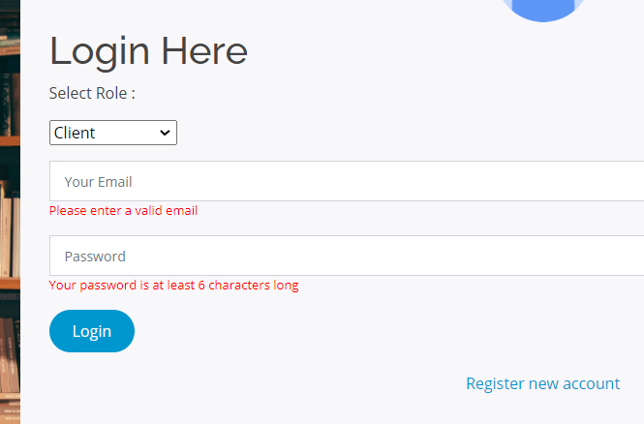

Figure 40: Highlighted texts to warn client of empty input fields

In the event where a client accidentally pressed on “Login” button without inserting anything for the input fields, texts highlighted in red will appear underneath each input fields to warn the client of impossible authorisation without proper inputs. The countermeasure is put in place to prevent unnecessary authorisation attempt with empty credentials which can lead to server overload. The red texts are dismissed when the input fields are inserted with credentials.

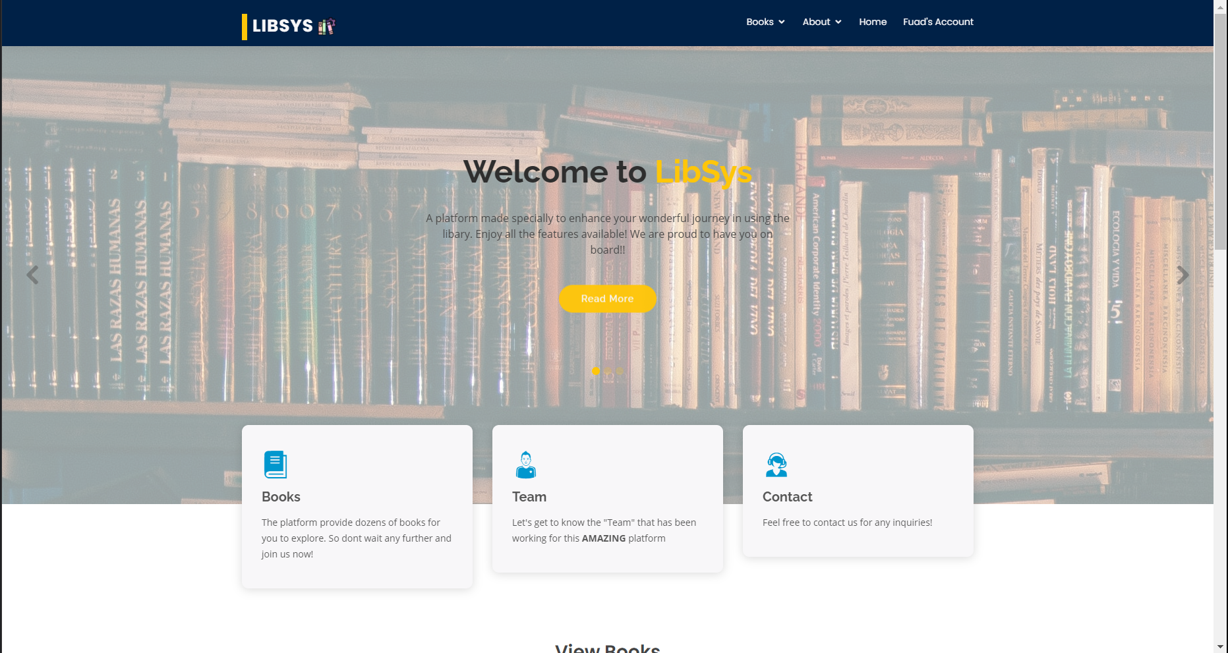

Figure 41: Client redirected to main page after successful login attempt.

Upon successful authorisation, the client will be redirected to the homepage of LibSys with the client having an ongoing session to the system. The client may now borrow books from the catalogue or customize their profile through their account page. Note that the login procedure is valid for librarian and admin user roles as well with only user role to change via the drop-down box.

## Homepage

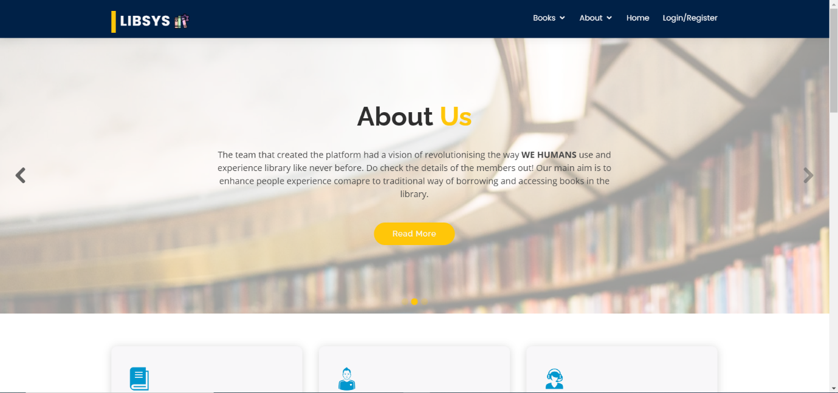

Figure 42: Home Page

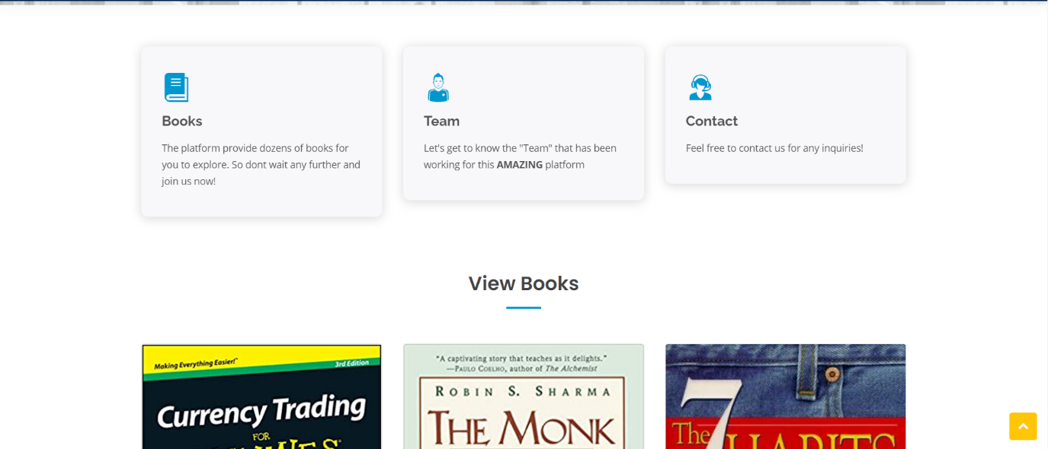

Figure 43: Home Page continued

The Homepage is the main landing page for the website and most of the features of the website are easily accessible from the Homepage. The Homepage features information such as a brief ‘About Us’ message to notify the user on the mission and vision of the website. The Homepage also features several links that direct to the other parts of the website. For example, the user can be redirected to the Book catalogue, Team page and Contact us page by clicking the link provided. The Homepage also displays a few books that are available in the catalogue.

## **Team Page**

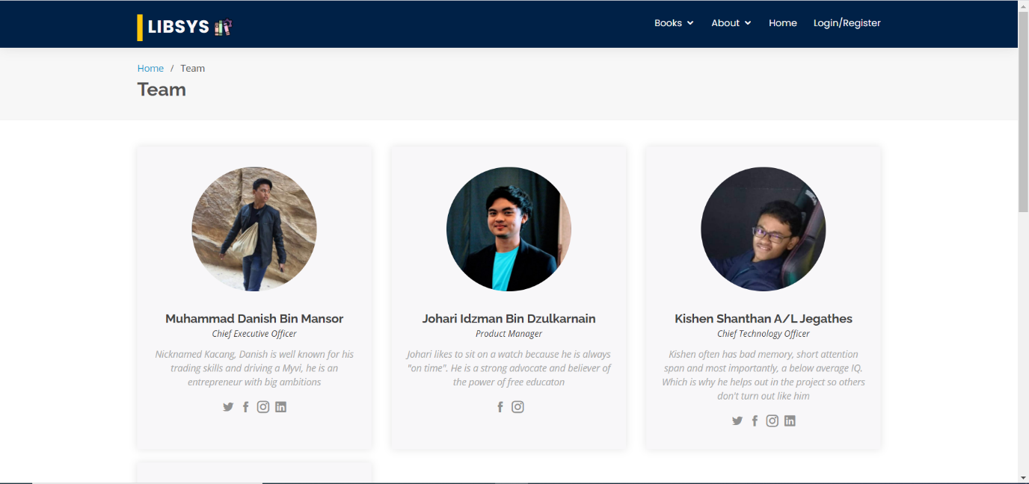



Figure 44: Team about page

The Team Page features brief descriptions and contact information of the developers of the website.

## Catalogue

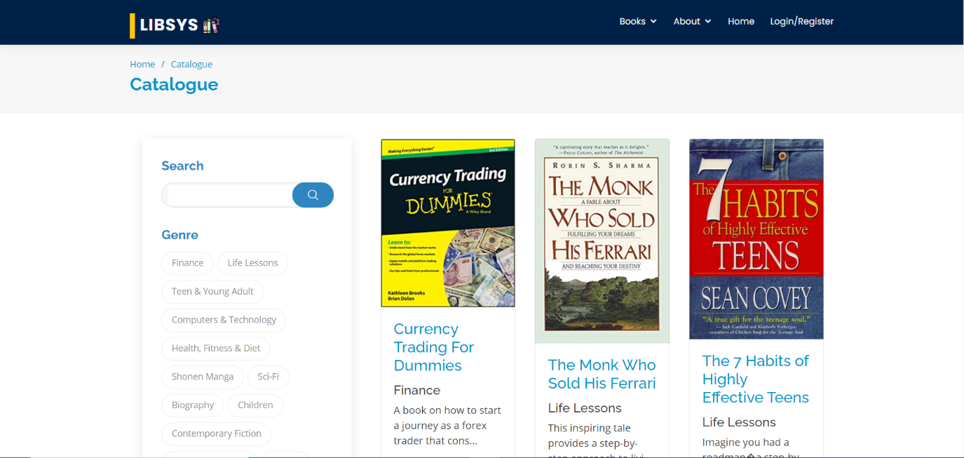

Figure 45: Book Catalogue



Figure 46: Homepage of LibSys

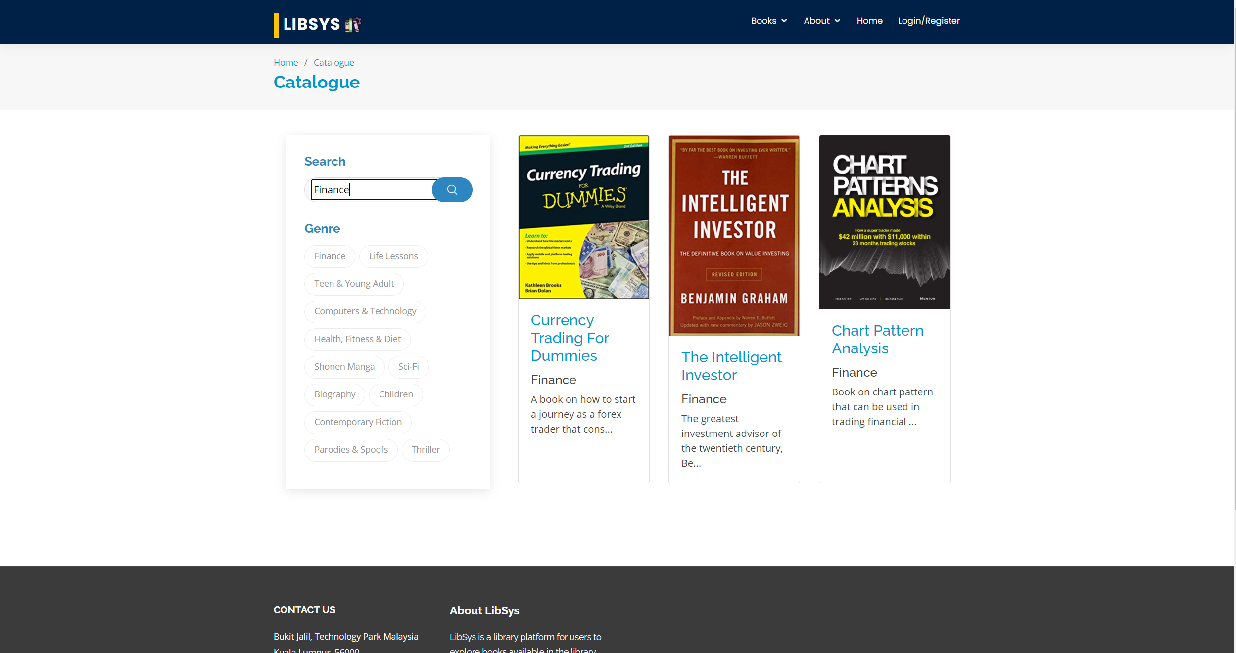

Figure 47: Usage of the search function through the keyword finance



Figure 48: Usage of the filter button based on genre of the book

Figure N.A above is showing the catalogue page for the users to view the list of books available in the library. Users can click on the “Books” to open this page from the Homepage or they can choose from the drop-down the type of books they want to see. Users can also click on the View More Book label inside the Homepage to be directed to this book catalogue page as shown in Figure N. As shown in Figure NAA, user can search for the books by entering the keyword related to the book genre. For example, user can key in the word finance and click on the search icon to filter the books specifically for the finance genre. Apart from that, users can click on one of the genre filter button to show the list of books according to the genre. For example, user can click on the “Life Lessons” genre button and books related to Life Lessons will be displayed.



Figure 49: Quotes of the Day part of the Homepage

Based on the figure above, users can be directed to the Quotes of the Day section of the Homepage by clicking on the arrow located on the right side of the section. Apart from that, users can also view About Us section and Welcome to LibSys section that contains inside the Homepage.

## Edit Profile Details

Each user role is able to edit their profile details when logged in. To do so, the user would need to click on the “Account Settings“ tab in the account page. The system will then display the relevant information about the user. The user can then change their information and click on the “Update“ button which will update the information and display a pop-up message to show the update status.

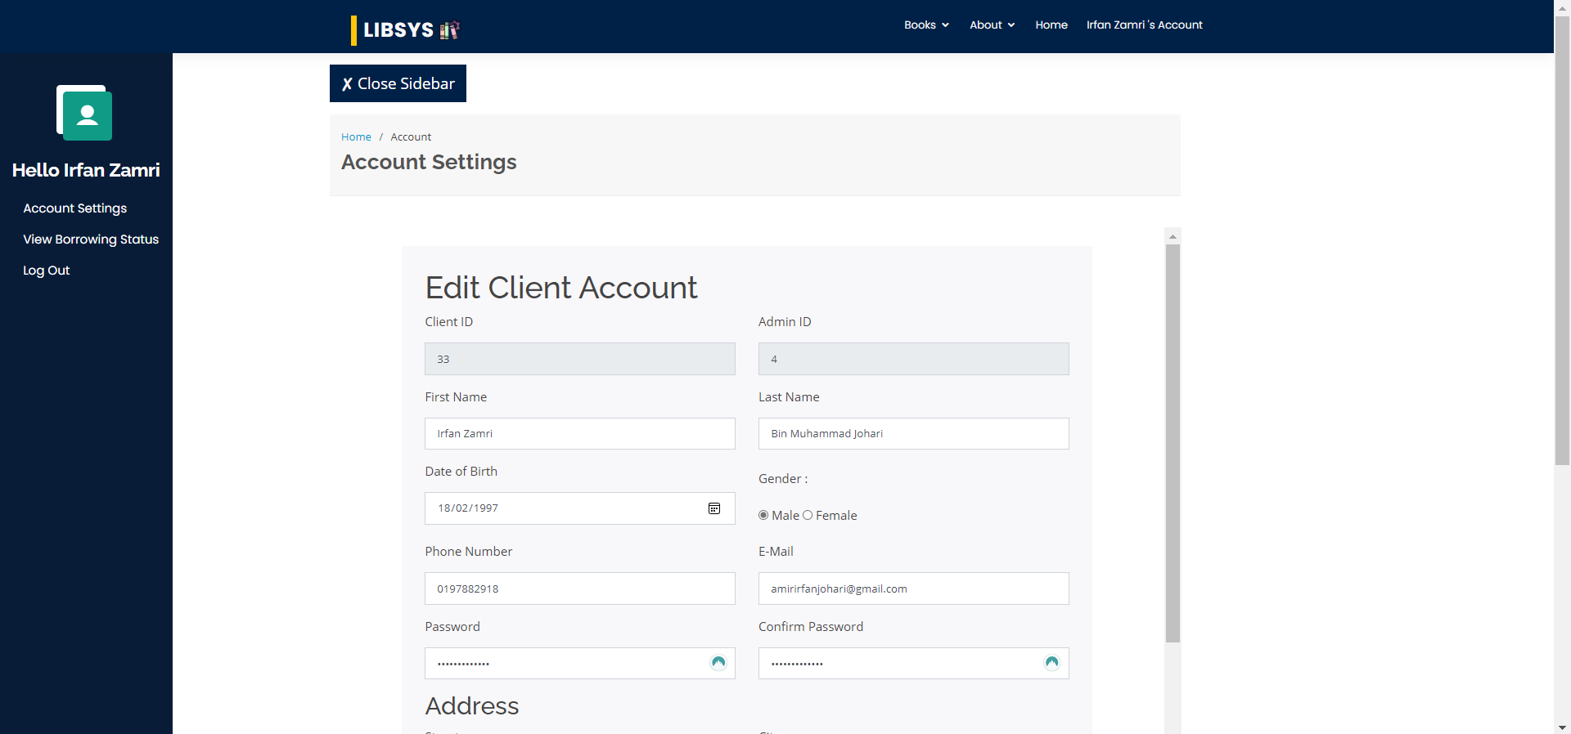

Figure 50: Editing Client Account

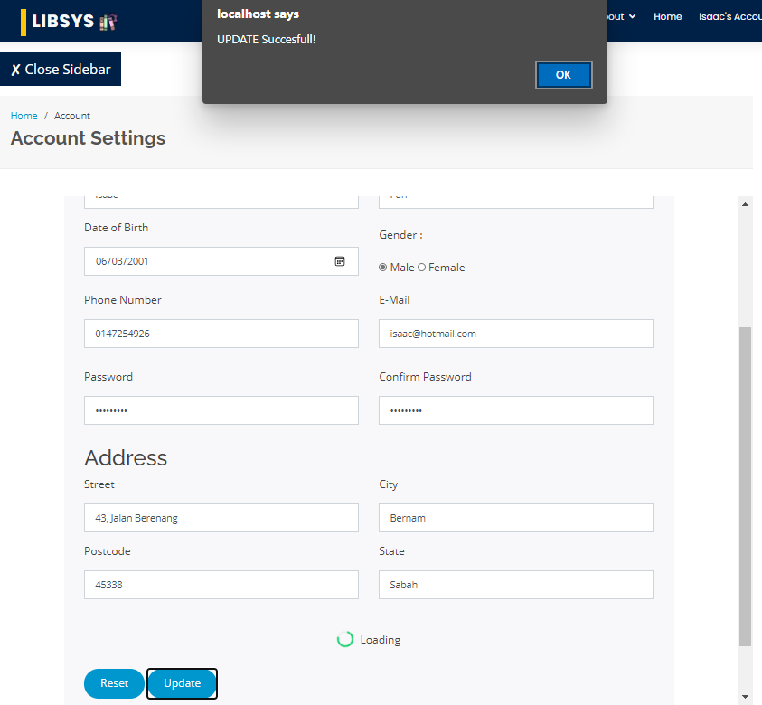

Figure 51: Update Successful

## Client User Role

### View Borrowing Status

To view the borrowing status, the client would need to click on the “View Borrowing Status“ tab on the account page. The system will then display the overdue borrowings of the client, followed by the unreturned books by the client and then list the returned books by the client.

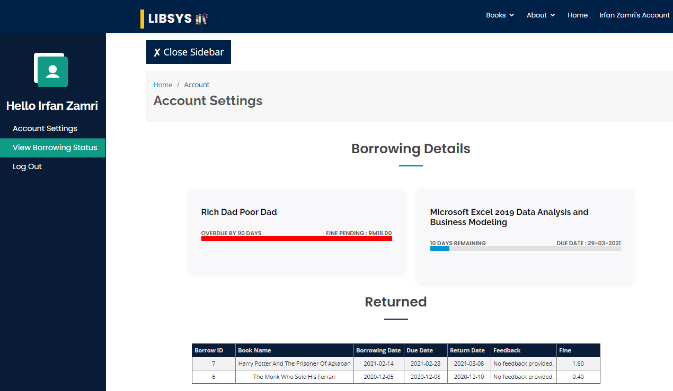

Figure 52: View Borrowing Status Page.

## Librarian User Role

### Add New Book

To add a new book, the librarian has to click on the “Add New Book” button on the catalogue page.



Figure 53: “Add New Book” button on the catalogue page.

The button will then load the Add New Book page. The librarian would have to input information such as the book title, serial number, genre, publisher, priority, publish date, quantity, summary, book cover. In addition, the librarian will also have to add the number of book authors as well as their first and last names. Then the librarian can click on the “Add” button to add the book. In addition, the librarian can also click on the “Return to Catalogue” button on the top left to return to the catalogue page.

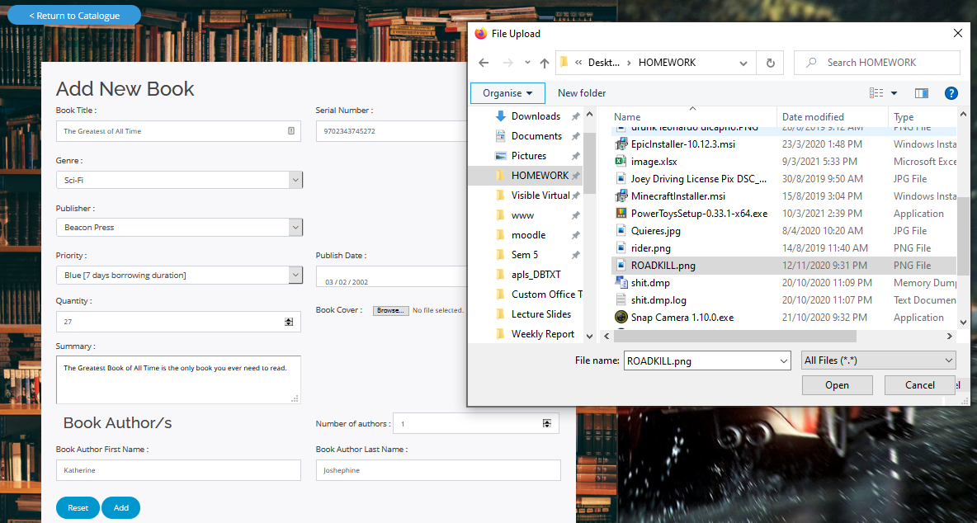

Figure 54: Adding a new book along with selecting an image before clicking “Add”.

Once the “Add” button is clicked and the book has been added, the system will display a prompt to show that the book has been added.

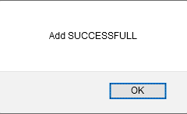

Figure 55: Add Successful Button

### Edit Book

To edit a book, the librarian must first select a book from the catalogue. Then librarian would have to click on the “Edit Book” button on the book details page of the selected book.



Figure 56: “Edit Book” button on the book details page.

The system will then load the Edit Book Details page with the book details of the selected book. The librarian can then make changes to the book details such as changing the name, image, genre and so on and then click on the “Save Changes” button. Upon clicking the button, the system will redirect to the book details page with the updated book information.

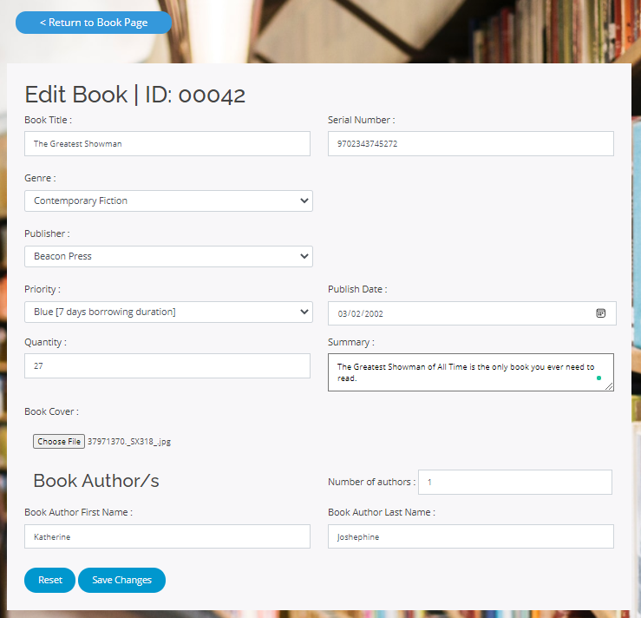

Figure 57: Edit Book Page with name, genre and book image changed.

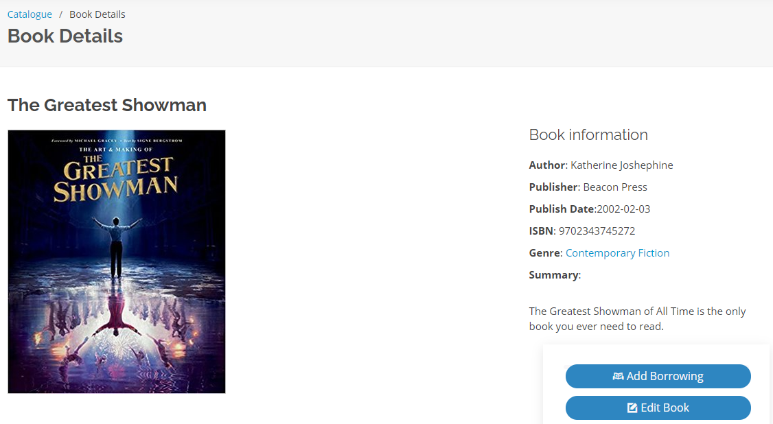

Figure 58: Updated book information.

### Delete Book

To delete a book, the librarian must first select a book from the catalogue. Then librarian would have to click on the “Delete Book” button on the book details page of the desired book. The system will then proceed to delete the book and then redirect to the catalogue page.



Figure 59: “Delete Book” button on book details page.

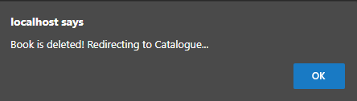

Figure 60: Book deletion message.

### Add New Borrowing

To add a new borrowing the librarian must first select a book from the catalogue. On the book details page, the librarian would then need to select the “Add Borrowing” button.

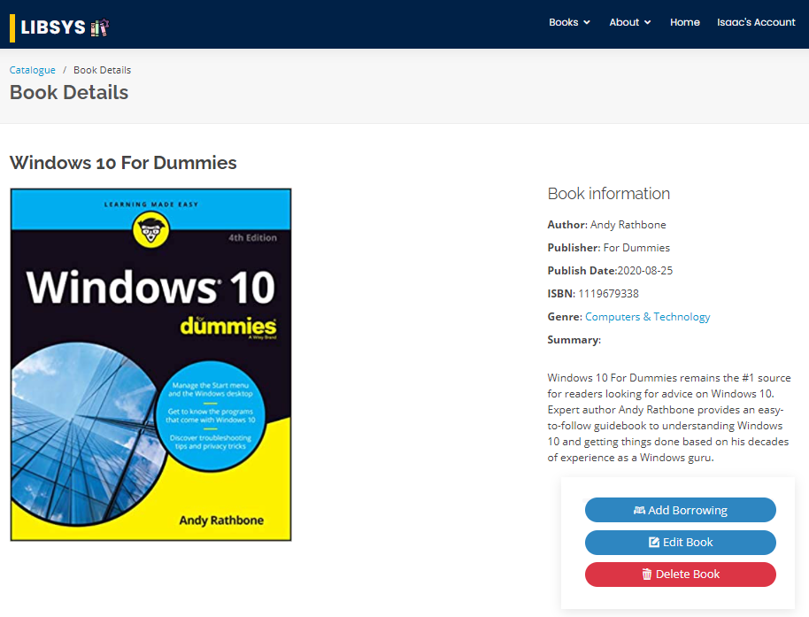

Figure 61: Screenshot of Windows 10 For Dummies Book Details page with Add Borrowing button.

Upon clicking the button, the librarian will be redirected to the add new borrowing page. As the page is loaded, the book id and book name will be displayed based on the book chosen. The date is automatically set based on the current date whereas the due date is set based on the book priority of the selected book which determines the duration for which the book can be borrowed for. The librarian only needs to select the Client from the table by clicking on the “Select” button on the row of the desired client. Once selected, the librarian can then click on the The librarian can also click on the “Return to Book Page” button on the top left to return back to the book details page.

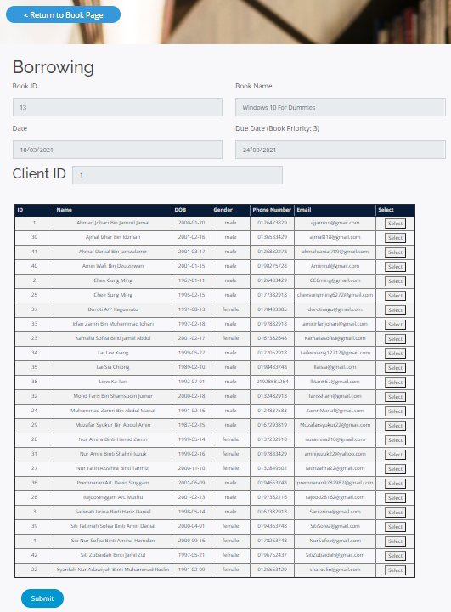

Figure 62: Screenshot of add borrowing page of Windows 10 for Dummies.

Upon successful adding, the system will display a confirmation message.

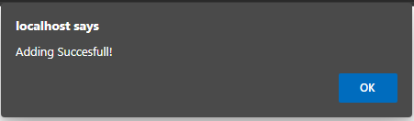

Figure 63: Confirmation message for successful adding.

### View Borrowing Details

To view the list of borrowings, the librarian can select the “View Borrowing” tab on the Account page. The librarian can choose to search the books by all, overdue, returned and then sort by borrowing date, due date or return date by selecting it from the dropdowns. Upon clicking the search button, the system will return the borrowing entries based on the selection. For books that are overdue, the system will also automatically calculate the fine.

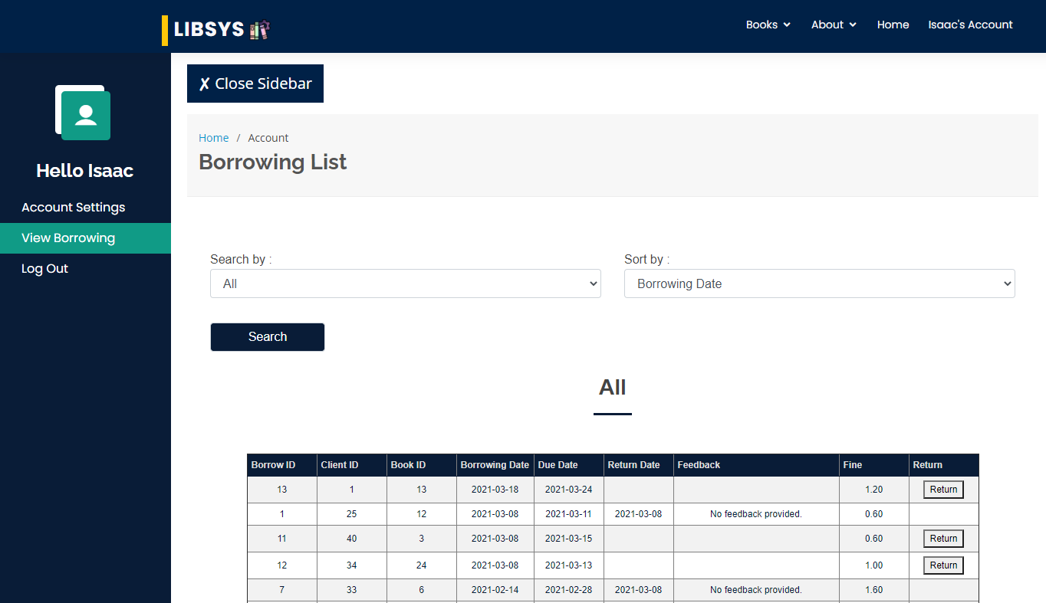

Figure 64: Viewing all borrowing details on the Account Page.

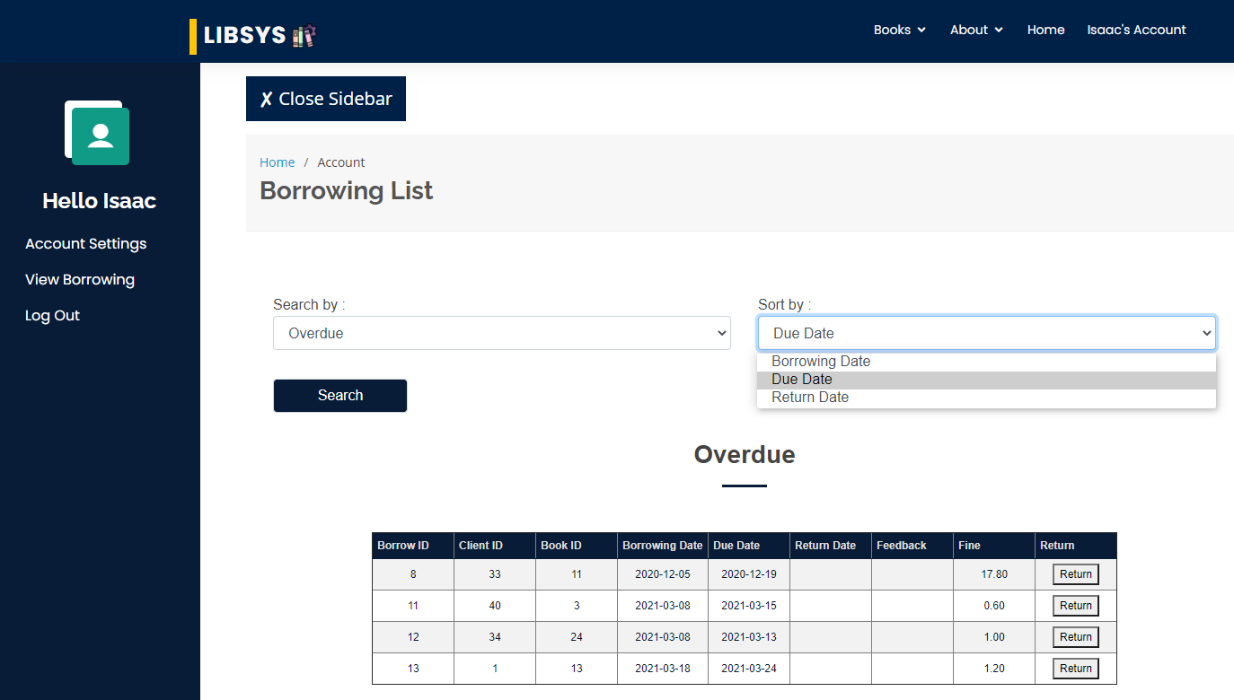

Figure 65: Viewing overdue borrowings sorted by due date.

#### Return Borrowing

To return a borrowing, the user can click on the “Return” button beside the borrowing entry of the View Borrowing Page. The returned button will only be shown beside entries of books that have not been returned.



Figure 66: Clicking on the return button for an overdue borrowing entry.

Upon clicking the return button, the system will then display the feedback form where the librarian would need to enter the feedback given by the client. Then the librarian is required to click on the “Submit” button to continue. If the client does not provide a feedback, the librarian can click the “Submit” button without filling in the field. Upon clicking the “Submit” button, the system will prompt the librarian with a message to confirm that the librarian acknowledges the return of the book and the payment of fees should there be any.

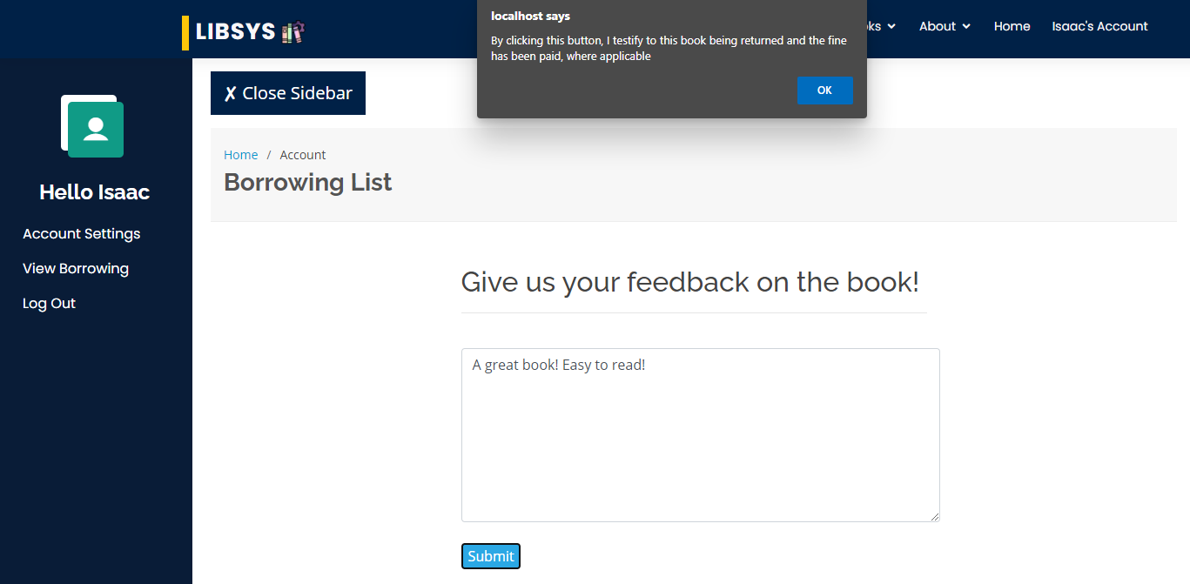

Figure 67: Filling in the feedback field and clicking on the submit button

Upon clicking the “ok” button, the system will display a message box to show that the book has been returned and then load the view borrowing page.

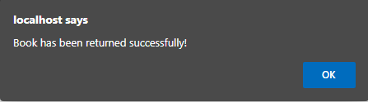

Figure 68: Message box to show that book has been returned.

## Admin User Role

### View User Information

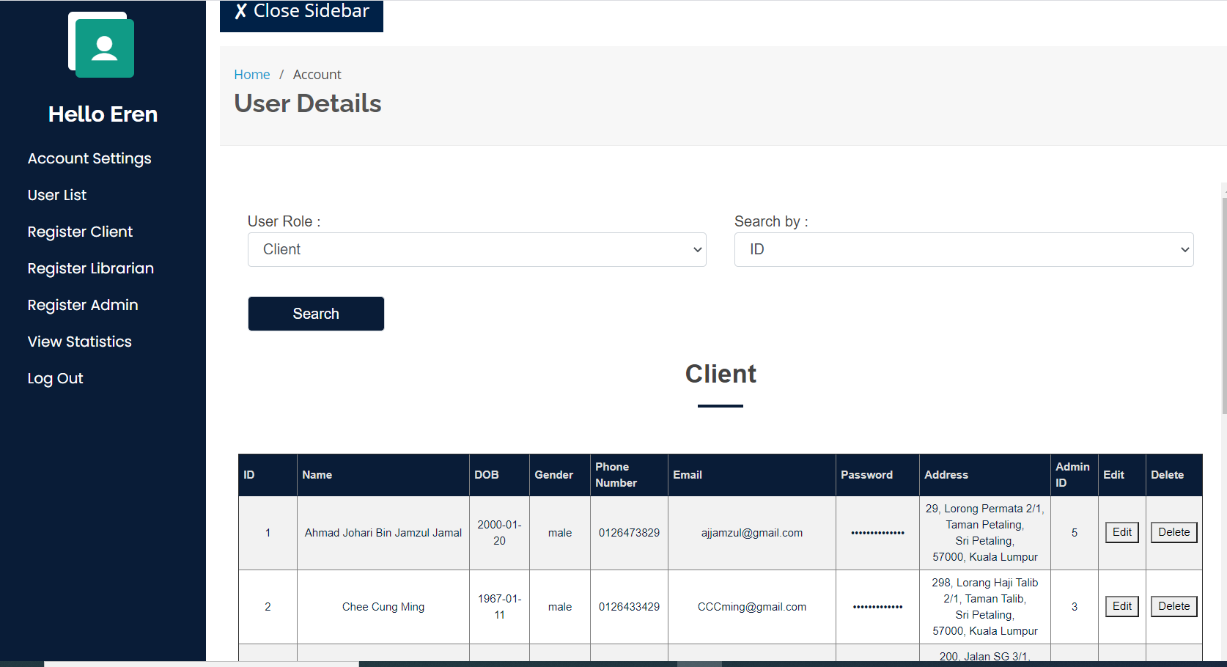

Figure 69: Overall screen design for view user page

The admin user role has access to view the list of users in the system through the View user page. The admin can access this page through the admin account feature. The user can select the user role that he/she wishes to view through the combo box at the top of the page. The user roles available are Client, Librarian and Admin. The user can also select the sorting method to which the information will be displayed. The two sorting options are Name or ID. After selecting the desired user role and sorting type, the user must press the search button and the desired list will appear on the page. Once the lists appear, the user may also proceed to press the edit or delete buttons to proceed to the edit and delete function, respectively.

### Register New User

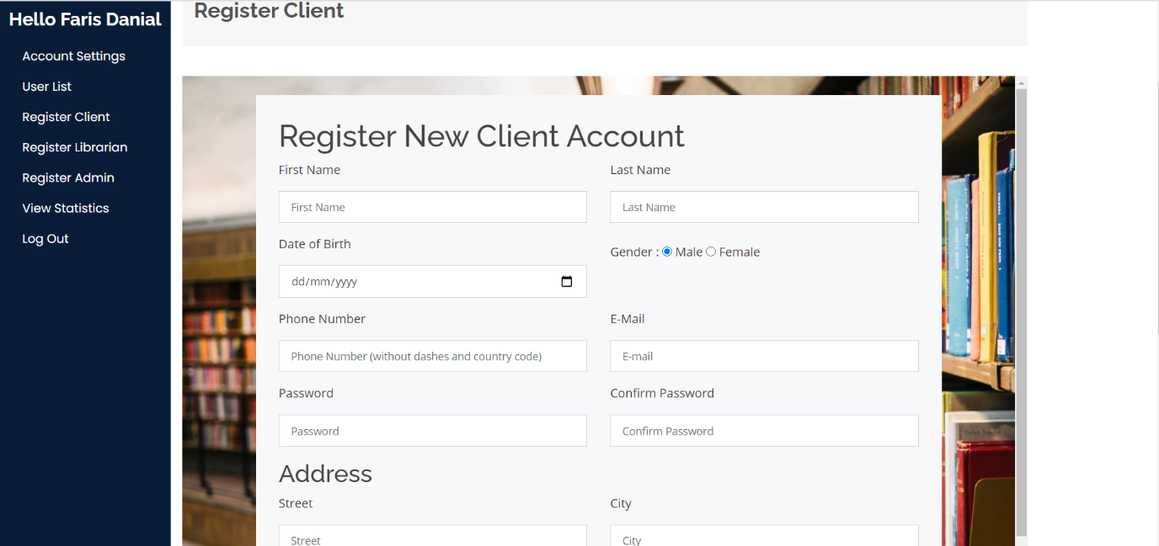

Figure 70: Admin Register new user page

The Admin has the privilege to register new users through the Admin Account page. First, he needs to select which type of user role the new user to register on the side bar at the left of the page. The Admin can Register new Client, Librarian and Admin. After selecting the user role, the Admin needs to fill in all the input fields with the new user information. Once done, the Admin will press the ‘Register’ button to send the new user information into the database hence registering the user into the system. The input fields also include validation to reduce the chances of error or invalid data type inside the database

### Edit User Information

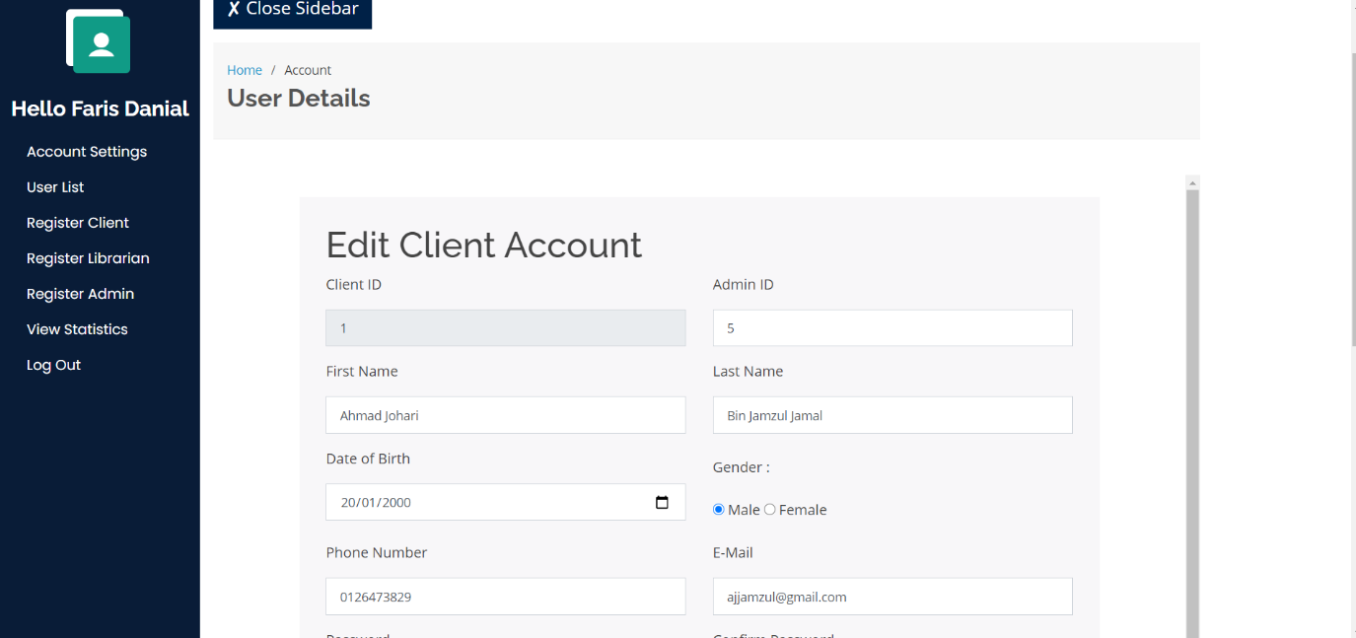

Figure 71: Admin Edit User information page

The Admin will also have access to edit the account information of the users. The interface for editing the user information is similar to the registration page but the details of the user is already filled in. The admin will then make the necessary changes and press the ‘Update’ button to update the data into the database.

### Delete User Information

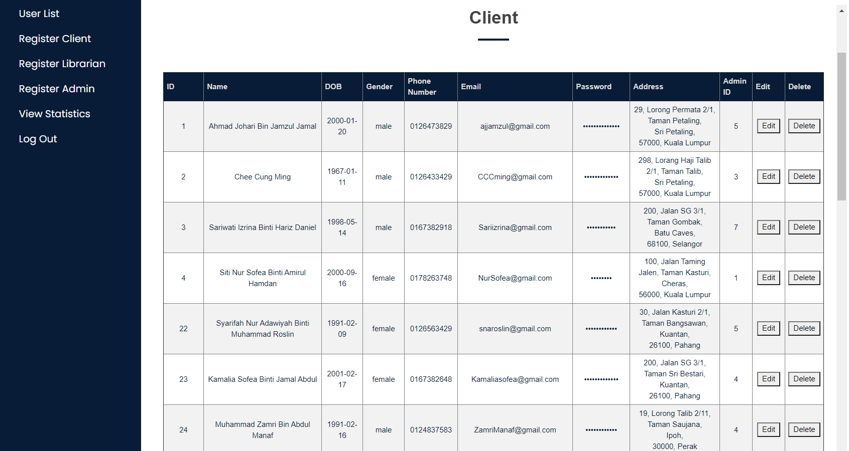

Figure 72: Overall screen design for view user page

The admin can also delete User account information by clicking on the ‘Delete’ button on the View User page.

# Report Design & User Manual

## Report Design

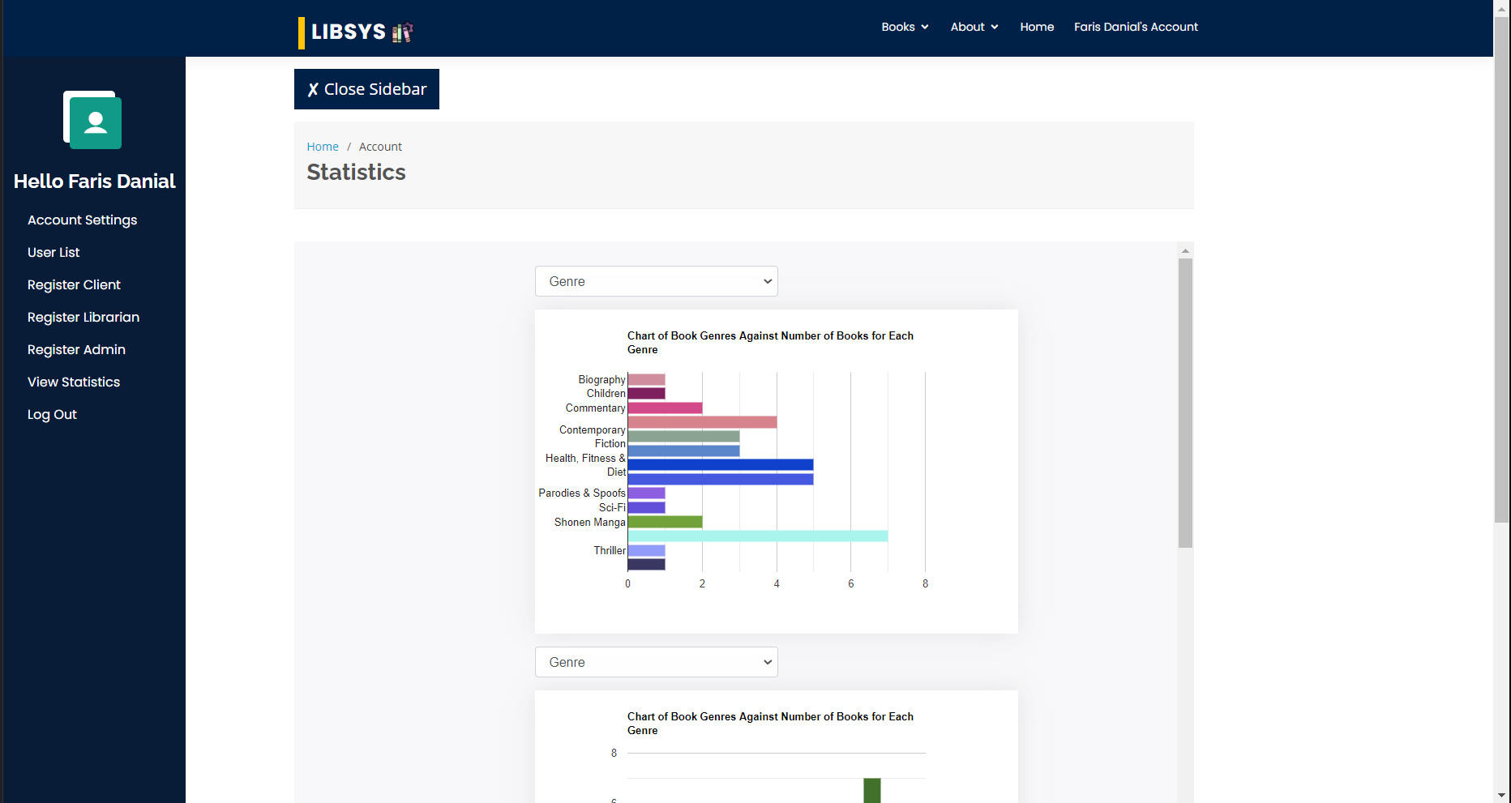

Figure 73: Overview to View Statistics page which is exclusive to Admin user role.

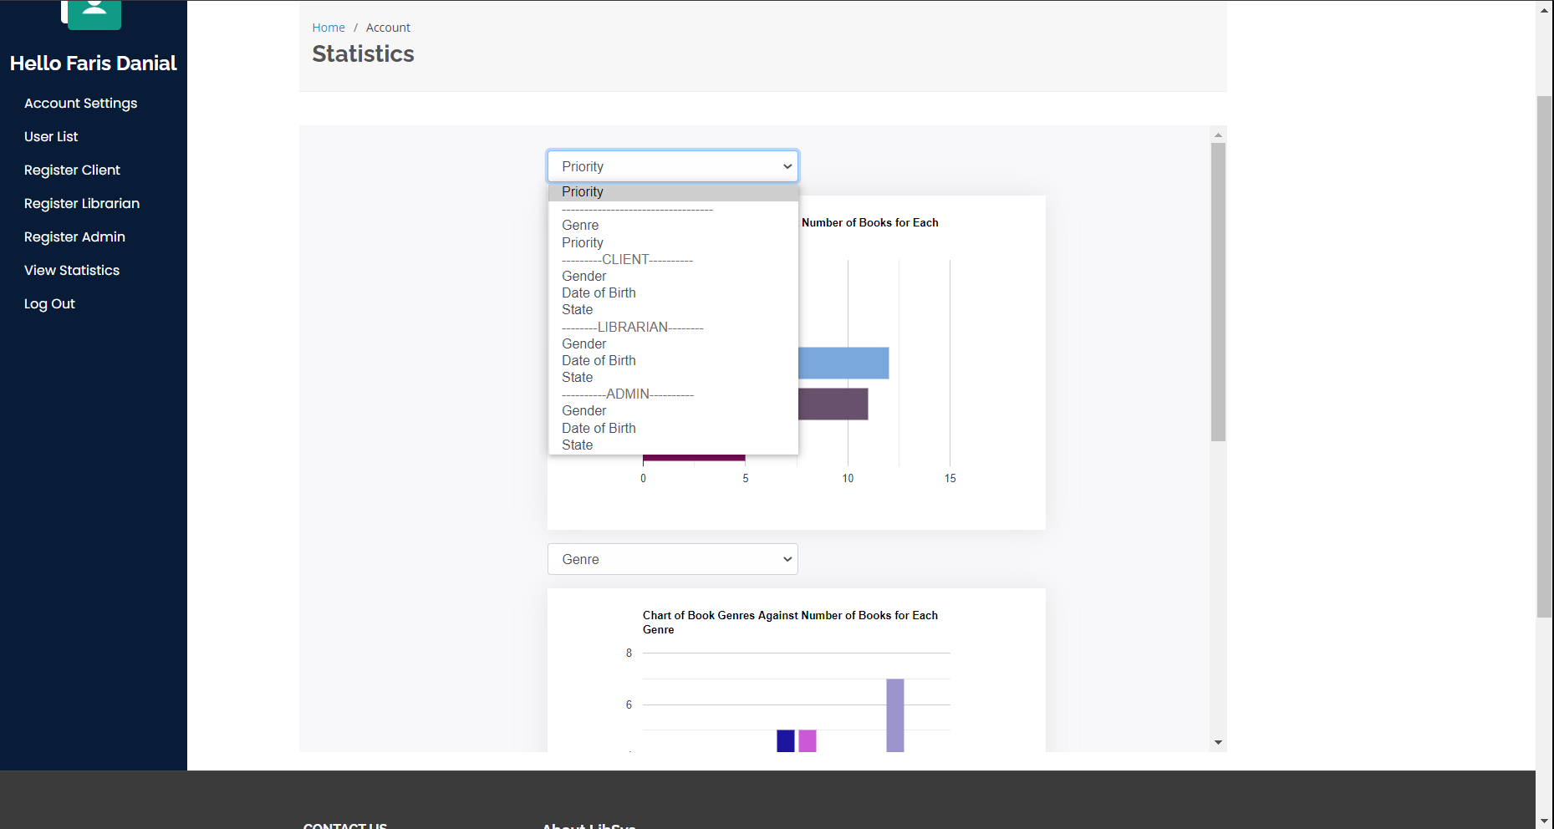Upon clicking “View Statistics” from the sidebar, an admin user will see “Statistics” page loads with 3 independent, colourful, and unique charts as summary which the user can use to understand or extract information about the records available inside the database.

Figure 74: Drop down selection to switch chart parameter.

By using the drop-down selection box, an admin user may switch the view parameters of the chart to which it is attached to. A chart may be able to display book genre and priority, gender, date of birth and state of living for client, librarian, and administrator user roles.

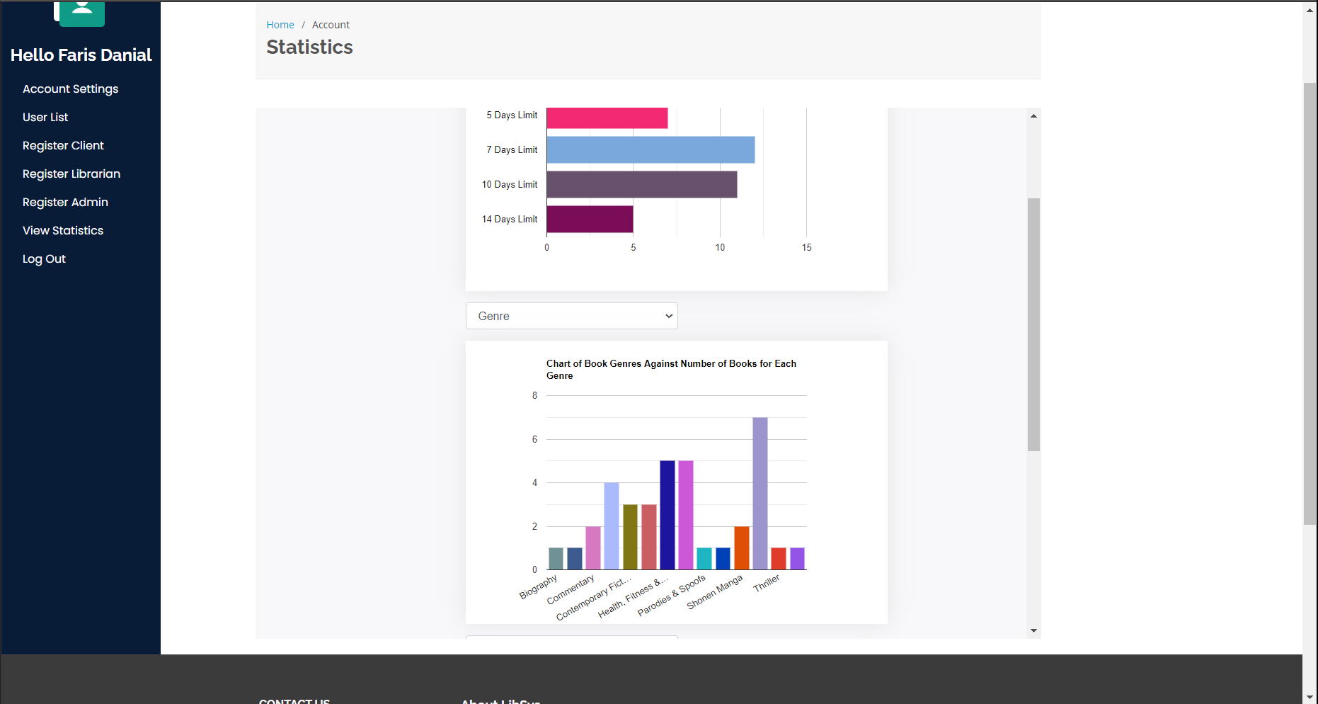

Figure 75: Availability of three charts which is independent and unique from one another.

There are three charts available for the admin user role to view with each having unique display properties. The first chart is displaying data in the form of horizontal bars while the second as vertical bars and lastly the third as pie chart. The charts are independent from one another, meaning that if the first chart has different parameter selected, the other two charts will retain its initial chart parameters.

## User Manual



Figure 76: Default parameter for all three charts is set to “Genre” of books

Admin user role has an exclusive tool which shows the statistics of records available in the database in the form of neat and colourful charts. Operation of the chart is straightforward with the availability of drop-down selection box to let admins define on each chart of what parameter should be fetched from the database and illustrated on the chart. By default, all three charts should display statistics based on “Genre” parameter, which is the genre column found in book table inside the database. If the admin user considers switching the parameter of any chart, they can do so by clicking on the drop-down box above their desired chart and select from one of the parameters available in the list. Note that the charts are different in terms of types so one chart may display better than the other.



Figure 77: Selecting “Priority” as parameter for the first chart to display

As stated before, switching the parameter to a chart is as straightforward as it can be through the use of drop-down selection box. When clicked, a list of selectable parameters appears with different options to choose from. The chart does not only show records for books but also details of registered users in the system. For instance, the admin can select “Genre” to display available book genres and the number of books available for each genre in horizontal bar chart while a “Client Date of Birth” on the second chart to show number of clients born within the specified range of year in a vertical bar chart. The admin may choose to mix and match as many parameters as possible with the charting feature as it helps them interpreting the information shown better.



Figure 78: First chart displays “Priority” for books while the second chart retains “Genre” parameter

From the screenshot above, the first chart that displays in vertical bar chart type is now no longer showing details about book genre but priority of books. Once admin clicks on the new parameter, the page reloads with a new query to the server for the number of books while being grouped by its priority level. Meanwhile, the second chart that illustrates details in the form of vertical bar chart still retains its genre of books information. All in all, the operation of the chart as statistical display is expected to aid admin users in making decision through a simple yet compact report interface. Note that the final chart is a pie type, and the operation is similar to the demonstration conducted to the first chart.

# Test Plan

## Muhammad Danish Bin Mansor [TP055704]

|  |  |
| --- | --- |
| Title: | LibSys Library Management System |
| Tester Name: | MUHAMMAD DANISH BIN MANSOR |
| Date of Creation: | 15-Mar-21 |
| Date of Review: | 18-Mar-21 |

|  |  |  |  |  |  |  |  |
| --- | --- | --- | --- | --- | --- | --- | --- |
| Test Case # | Test Unit | Test Procedures | Test Data | Expected Result | Actual Result | Status | Remarks |
| 1 | Create Feedback | 1. Navigate to Account page 2. Select View Borrowing 3. Press enter or search button 4. Press on return 5. Add Feedback 6. Press on Submit | Correct Input Data  **Feedback: Good Book** | Message saying book has been returned and feedback added | Message saying “Book has been returned successfully” | Success | N/A |
| 2 | View Feedback  & View Statistics Report | 1. Navigate to Account page 2. Click View Borrowing 3. Sort the Borrowing List by Return Date 4. Click on Search | Correct Input Data  N/A | Details of the Borrowing Status with Book Feedback displayed according to Return Date Sort | Details of the Borrowing Status with Book Feedback displayed according to Return Date Sort | Success | N/A |
| 1. Navigate to Account page 2. Click View Borrowing 3. Sort the Borrowing List by Borrowing Date 4. Click on Search | Correct Input Data  N/A | Details of the Borrowing Status with Book Feedback displayed according to Borrowing Date Sort | Details of the Borrowing Status with Book Feedback displayed according to Borrowing Date Sort | Success |  |
| 1. Navigate to Account page 2. Click View Borrowing 3. Sort the Borrowing List by Due Date 4. Click on Search | Correct Input Data  N/A | Details of the Borrowing Status with Book Feedback displayed according to Due Date Sort | Details of the Borrowing Status with Book Feedback displayed according to Due Date Sort | Success |  |

## Kishen Shanthan A/L Jegathes [TP055296]

|  |  |
| --- | --- |
| Title: | LibSys Library Management System |
| Tester Name: | KISHEN SHANTHAN A/L JEGATHES |
| Date of Creation: | 07-Mar-21 |
| Date of Review: | 11-Mar-21 |

|  |  |  |  |  |  |  |  |
| --- | --- | --- | --- | --- | --- | --- | --- |
| Test Case # | Test Unit | Test Procedures | Test Data | Expected Result | Actual Result | Status | Remarks |
| 1 | Add New Borrowing | 1. Select Book 2. Click Add New Borrowing 3. Select Client 4. Click Submit | Input Data  **Client ID**:  33 | System will add the borrowing to the database and display a borrowing added message. | System directs the user to the main page. | Success | N/A |
| 1. Select Book 2. Click Add New Borrowing 3. Click Reset 4. Do not select Client ID 5. Click Submit | Input Data  **Client ID:** | System will add the borrowing to the database and display a borrowing added message. | Error message appears. | Failed | The reset button removes the date value and client ID whichthus breaks data insertion. |
| 2 | Viewing Borrowing Details | 1. Search by “All” 2. Sort by “Due Date” 3. Click on “Search” | Input Data  N/A | System will display all borrowing entries in order of due date. | System displays list of all borrowings in order of due date in a table format. | Success | N/A |
| 1. Search by “Returned” 2. Sort by “Borrow Date” 3. Click on “Search” | Input Data  N/A | System will display returned borrowing entries in order of borrow date. | System displays list of returned borrowings in order of borrow date in a table format. | Success | The SQL statement is also displayed. |
| 3 | View Borrowing History | 1. Click on View Borrowing Status tab | Input Data  N/A | System will first display the borrowings that are overdue with the number of days overdue and the fine. Then the system will show borrowings that have not yet been returned and the remaining days left. Lastly, the system will display data of the client’s returned borrowings in a table format. | System first displays the borrowings that are overdue with the number of days overdue and the fine. Then the system shows borrowings that have not yet been returned and the remaining days left. Lastly, the system displays data of the client’s returned borrowings in a table format. | Success | N/A |
| 4 | Return Borrowing | 1. Press “Return” button 2. Leave feedback form empty 3. Click on Submit | **Feedback:** | System will notify librarian with a pop-up for acknowledgement and then show that the book has been returned by adding the return date and fine (if any). | System notifies librarian with a pop up for acknowledgement and shows that the book has been returned. | Success | On the View Borrowing page, the return date and fine is added to the borrowing entry. |
|  | 1. Press “Return” button 2. Fill in feedback form 3. Click on Submit | **Feedback:**  A good book! Worth the read! | System will notify librarian with a pop-up for acknowledgement and then show that the book has been returned by adding the return date and fine (if any).. | System notifies librarian with a pop up for acknowledgement and shows that the book has been returned. | Success | On the View Borrowing page, the return date, feedback and fine is added to the borrowing entry. |

|  |  |
| --- | --- |
| Title: | LibSys Library Management System |
| Tester Name: | KISHEN SHANTHAN A/L JEGATHES |
| Date of Creation: | 07-Mar-21 |
| Date of Review: | 13-Mar-21 |

|  |  |  |  |  |  |  |  |
| --- | --- | --- | --- | --- | --- | --- | --- |
| Test Case # | Test Unit | Test Procedures | Test Data | Expected Result | Actual Result | Status | Remarks |
| 1 | Add New Borrowing | 1. Select Book 2. Click Add New Borrowing 3. Do not select Client ID 4. Click Submit | Input Data  **Client ID:** | System will add the borrowing to the database and display a borrowing added message. | System adds the borrowing to the database with default value of Client ID (1) and then displayes a borrowing added message. | Success | The reset button was removed |
| 2 | Viewing Borrowing Details | 1. Search by “Returned” 2. Sort by “Borrow Date” 3. Click on “Search” | Input Data  N/A | System will display returned borrowing entries in order of borrow date. | System displays list of returned borrowings in order of borrow date in a table format. | Success | The SQL statement is no longer displayed |

## Muhammad Fuad Bin Abdullah [TP055684]

|  |  |
| --- | --- |
| Title: | LibSys Library Management System |
| Tester Name: | MUHAMMAD FUAD BIN ABDULLAH |
| Date of Creation: | 15-Mar-21 |
| Date of Review: | 18-Mar-21 |

|  |  |  |  |  |  |  |  |
| --- | --- | --- | --- | --- | --- | --- | --- |
| Test Case # | Test Unit | Test Procedures | Test Data | Expected Result | Actual Result | Status | Remarks |
| 1 | Search Book | 1. Navigate to Catalogue page 2. Enter search keyword 3. Press enter or search button | Correct Input Data  Search keyword:  “Currency” | Only books with the keyword “currency” appears, not case sensitive. | A book titled “Currency Trading For Dummies” is displayed as search result. | Success | N/A |
| 1. Navigate to Catalogue page 2. Enter search keyword 3. Press enter or search button | Incorrect Input Data  Search keyword:  “curency” | No books appeared in the list as there are no such books with the keyword, not case sensitive. | No books are displayed. | Success | N/A |
| 2 | Display Book and Author | 1. Navigate to Catalogue page 2. Click on the book titled “Currency Trading For Dummies” | Correct Input Data  N/A | Details of “Currency Trading For Dummies” book such as Kathleen Brook as one of the author is displayed accordingly. | Details of the book is displayed with name Kathleen Brooks as one of the authors. | Success | N/A |
| 3 | Add Book and Author | 1. Insert book title 2. Insert serial number 3. Select existing genre 4. Select existing publisher 5. Select priority 6. Select publish date 7. Insert quantity 8. Upload book cover 9. Insert book summary 10. Insert author quantity 11. Insert author’s first name 12. Insert author’s last name 13. Press on “Add” button | Correct Input Data  **Title**: Dr. Johari and Life – Talks  **Serial number**:  4641125132132  **Genre**:  Life Lessons  **Publisher**:  Pelangi Pembaca Sdn. Bhd.  **Priority**:  Purple  **Publish Date**:  12/02/2020  **Quantity**:  1  **Cover**:  Uploaded  **Summary**:  Join the talk with Dr. Johari on his take about life.  **Author Quantity**:  1  **Author’s First Name**:  Johari Idzman  **Author’s Last Name**:  Bin Dzulkarnain | Notification notifying the librarian of a successful addition is displayed. | Notification “add SUCCESSFUL” is displayed to indicate of successful book addition. | Success | Test is done to test book addition with selection of existing genre and publisher. |
| 1. Insert book title 2. Insert serial number 3. Select other genre 4. Select other publisher 5. Select priority 6. Select publish date 7. Insert quantity 8. Upload book cover 9. Insert book summary 10. Insert author quantity 11. Insert author’s first name 12. Insert author’s last name 13. Press on “Add” button | Correct Input Data  **Title**: Dr. Kishen and Technology – Talks  **Serial number**:  9878787654523  **Genre**:  Commentary  **Publisher**:  Nusantara Brilliant  **Priority**:  Purple  **Publish Date**:  05/01/2021  **Quantity**:  1  **Cover**:  Uploaded  **Summary**:  Join the talk with Dr. Kishen on his take about technology.  **Author Quantity**:  1  **Author’s First Name**:  Kishen Shanthan  **Author’s Last Name**:  Jegathes | Notification notifying the librarian of a successful addition is displayed. | Notification “add SUCCESSFUL” is displayed to indicate of successful book addition. | Success | Test is done to book addition with selection of other genre and publisher. |
| 1. Leave all fields empty 2. Press on “Add” button | Incorrect Input Data  N/A | Notification notifying of empty field appears to ask the librarian to fill in the field before adding the record. | Notification “Please fill in this field” appears under Book Title field and no book addition process is initiated. | Success | N/A |
| 1. Leave book title empty 2. Insert serial number 3. Select other genre 4. Select other publisher 5. Select priority 6. Select publish date 7. Insert quantity 8. Upload book cover 9. Insert book summary 10. Insert author quantity 11. Insert author’s first name 12. Insert author’s last name 13. Press on “Add” button | Incorrect Input Data  **Serial number**:  1216465453123  **Genre**:  Commentary  **Publisher**:  Nusantara Brilliant  **Priority**:  Purple  **Publish Date**:  05/01/2021  **Quantity**:  1  **Cover**:  Uploaded  **Summary**:  Join the talk with Dr. Kishen on his take about technology.  **Author Quantity**:  1  **Author’s First Name**:  Kishen Shanthan  **Author’s Last Name**:  Jegathes | Notification notifying of empty field appears to ask the librarian to fill in the field before adding the record. | Notification “Please fill in this field” appears under Book Title field and no book addition process is initiated. | Success | The notification appears at in sequential order. In this case, book title is empty therefore the notification appears under its field even if there are other empty fields. |
| 4 | Update Book and Author | 1. Insert new book title 2. Insert new serial number 3. Select new existing genre 4. Select new existing publisher 5. Select new priority 6. Select new publish date 7. Insert new quantity 8. Upload new book cover 9. Insert new book summary 10. Insert new author quantity 11. Insert new author’s first name 12. Insert new author’s last name 13. Press on “Save Changes” button | Correct Input Data  **Title**: Dr. Idzman and Warhammer – Talks  **Serial number**:  5646487846846  **Genre**:  Commentary  **Publisher**:  Nusantara Brilliant  **Priority**:  Indigo  **Publish Date**:  13/01/2021  **Quantity**:  2  **Cover**:  Uploaded  **Summary**:  Join the talk with Dr. Idzman on his take about Warhammer.  **Author Quantity**:  1  **Author’s First Name**:  Idzman  **Author’s Last Name**:  Johari | Librarian is redirected back to the book details page with new changes reflected | Similar to expected outcome. | Success | N/A |
| 1. Insert new book title 2. Insert new serial number 3. Select other genre 4. Select other publisher 5. Select new priority 6. Select new publish date 7. Insert new quantity 8. Upload new book cover 9. Insert new book summary 10. Insert new author quantity 11. Insert new author’s first name 12. Insert new author’s last name 13. Press on “Save Changes” button | Correct Input Data  **Title**: Warhammer X Nagatoro Universe  **Serial number**:  1599483241723  **Genre**:  Warhammer Universe  **Publisher**:  Nusantara Fiction  **Priority**:  Blue  **Publish Date**:  14/01/2021  **Quantity**:  3  **Cover**:  Uploaded  **Summary**:  Embark on the journey with Nagatoro as she explores the cinematic universe of Warhammer.  **Author Quantity**:  1  **Author’s First Name**:  Johari  **Author’s Last Name**:  Idzman | Librarian is redirected back to the book details page with new changes reflected | Similar to expected outcome. | Success | Test is done to book update with selection of other genre and publisher. |
| 1. Clear book title 2. Insert new serial number 3. Select new existing genre 4. Select new existing publisher 5. Select new priority 6. Select new publish date 7. Insert new quantity 8. Upload new book cover 9. Insert new book summary 10. Insert new author quantity 11. Insert new author’s first name 12. Insert new author’s last name 13. Press on “Save Changes” button | Incorrect Input Data  **Serial number**:  7687543543468  **Genre**:  Thriller  **Publisher**:  Ebury Australia  **Priority**:  Green  **Publish Date**:  15/01/2021  **Quantity**:  4  **Cover**:  Uploaded  **Summary**:  Embark on the journey with Nagatoro as she explores the cinematic universe of Warhammer.  **Author Quantity**:  1  **Author’s First Name**:  Johari Idzman  **Author’s Last Name**:  Nanaowakari | Notification notifying of empty field appears to ask the librarian to fill in the field before updating the record. | Notification “Please fill in this field” appears under Book Title field and no book update process is initiated. | Success | The notification appears at in sequential order. In this case, book title is empty therefore the notification appears under its field even if there are other empty fields. |

## Johari Idzman Bin Dzulkarnain [TP055683]

|  |  |
| --- | --- |
| Title: | LibSys Library Management System |
| Tester Name: | JOHARI IDZMAN BIN DZULKARNAIN |
| Date of Creation: | 15-Mar-21 |
| Date of Review: | 18-Mar-21 |

|  |  |  |  |  |  |  |  |
| --- | --- | --- | --- | --- | --- | --- | --- |
| Test Case # | Test Unit | Test Procedures | Test Data | Expected Result | Actual Result | Status | Remarks |
| 1 | Login | 1. Select User Role 2. Insert Email 3. Insert Password 4. Press Login button | Correct Input Data  **User Role**:  Admin  **Email**:  Faris@gmail.com  **Password**:  DanialJo22  Incorrect Input Data  **User Role**:  Client  **Email**:  faris@gmail.com  **Password**:  DanialJo | System will direct the user to the main page. | System directs the user to the main page. | Success | The user will need to select the proper User role first to ensure that the proper database is accessed for the matching credentials. |
|  |  | 1. Select User Role 2. Leave Email input field empty. 3. Leave password input field empty. 4. Press Login button | Incorrect Input Data  **User Role**:  Client  **Email**:  **Password**: | Error message will appear to show user which input field is empty. | Error message appears. | Success | N/A |
| 2 | Registration | 1. Insert First name 2. Insert Last name 3. Insert Date of Birth 4. Select Gender 5. Insert Phone Number 6. Insert E-mail 7. Insert Password 8. Insert Confirm Password 9. Insert Street 10. Insert City 11. Insert Postcode 12. Insert State 13. Press Register button | Correct Input Data  **First Name**:  Johari Idzman bin  **Last Name**:  Dzulkarnain  **Date of Birth**:  08/07/2001  **Gender:**  Male  **E-Mail:**  johariidzman@gmail.com  **Password:**  Password123  **Confirm Password:**  Password123  **Street:**  Persiaran Minang 5  **City:**  Kuala Lumpur  **Postcode**:  56000  **State:**  WPKL | System will notify user with a pop-up saying that registration is successful.  The system will notify the user with a pop-up saying that the password and confirm password does not match. | System notifies user with a pop-up saying that registration is successful. | Success | User role cannot be empty as the default value is set to client. |
|  |  | 1. Leave First name empty 2. Leave Last name empty 3. Leave Date of Birth empty 4. Select Gender 5. Insert Phone Number 6. Insert E-mail 7. Insert Password 8. Insert Confirm Password 9. Insert Street 10. Insert City 11. Insert Postcode 12. Insert State 13. Press Register button | Incorrect Input Data  **First Name**:  **Last Name**:  **Date of Birth**:  **Gender:**  **E-Mail:**  **Password:**  **Confirm Password:**  **Street:**  **City:**  **Postcode**:  **State:** | Error message will appear to show user which input field is empty. | Error message appears. | Success | N/A |
|  | Update | 1. Update First name 2. Update Last name 3. Update Date of Birth 4. Update Gender 5. Update Phone Number 6. Update E-mail 7. Update Password 8. Update Confirm Password 9. Update Street 10. Update City 11. Update Postcode 12. Update State 13. Press Register button | Correct Input Data  **First Name**:  Johari Idzman bin  **Last Name**:  Dzulkarnain  **Date of Birth**:  08/07/2001  **Gender:**  Male  **E-Mail:**  johariidzman@gmail.com  **Password:**  Password123  **Confirm Password:**  Password123  **Street:**  Persiaran Minang 5  **City:**  Kuala Lumpur  **Postcode**:  56000  **State:**  WPKL | System will notify user with a pop-up saying that registration is successful.  The system will notify the user with a pop-up saying that the password and confirm password does not match. | System notifies user with a pop-up saying that update is successful. | Success | N/A |
|  |  | 1. Leave First name empty 2. Leave Last name empty 3. Leave Date of Birth empty 4. Select Gender 5. Insert Phone Number 6. Insert E-mail 7. Insert Password 8. Insert Confirm Password 9. Insert Street 10. Insert City 11. Insert Postcode 12. Insert State 13. Press Register button | **First Name**:  **Last Name**:  **Date of Birth**:  **Gender:**  **E-Mail:**  **Password:**  **Confirm Password:**  **Street:**  **City:**  **Postcode**:  **State:** | Error message will appear to show user which input field is empty. | Error message appears. | Success | N/A |
| 4. | Delete | 1. Press delete button | **N/A** | System will notify user with a pop-up saying that the user details have been successfully deleted. | System notifies user with a pop-up saying that the user details have been successfully deleted. | Success | N/A |

# Significant Source Codes

## Displaying data on the home page

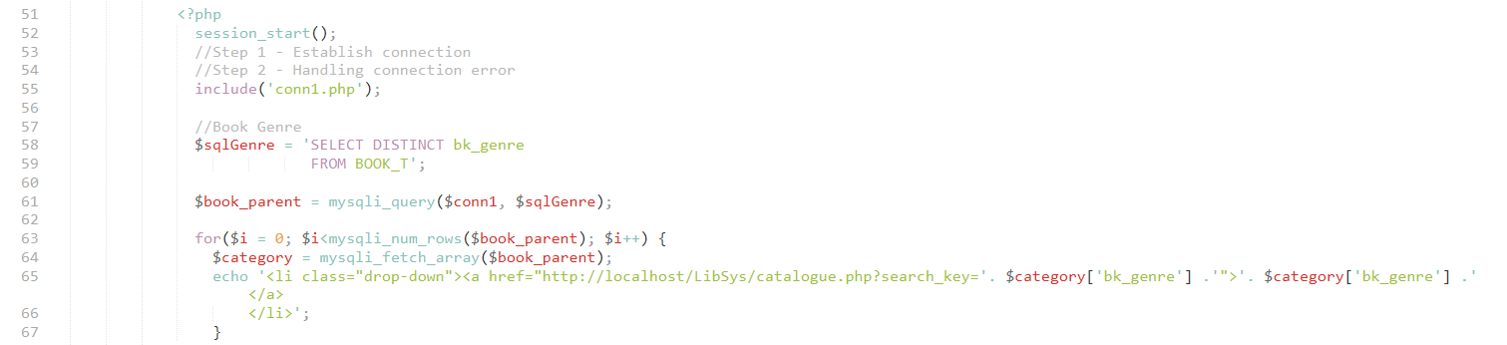

Figure 79 : Code Snippet for PHP code

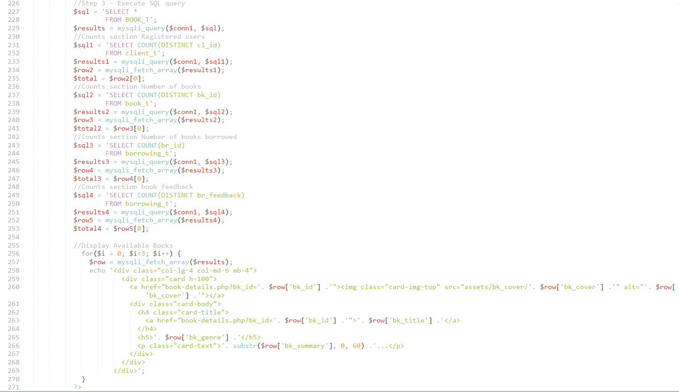

Figure 80: SQL in fetching the data from the Database

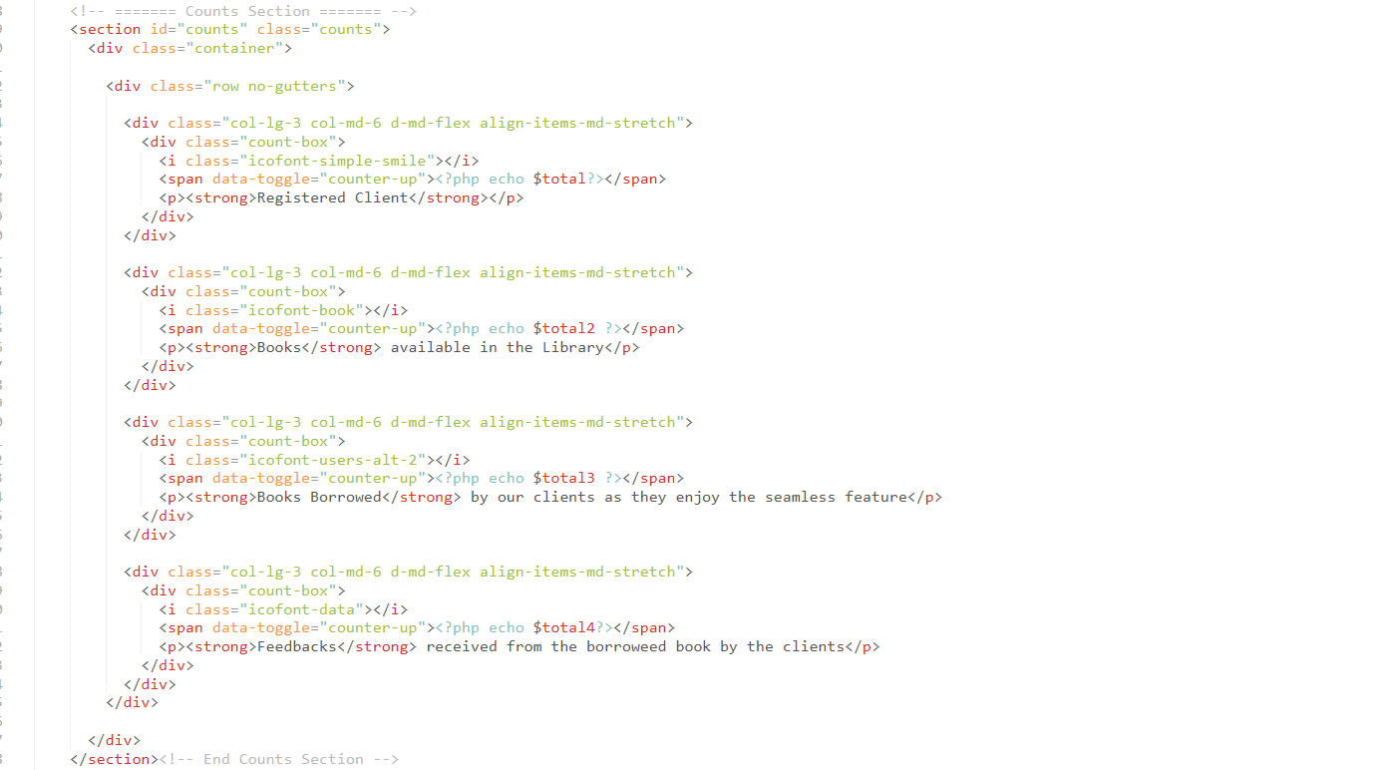

Figure 81: Displaying the data

The snippet code above is taken from index.php. It is used to read the several database tables and display the information from it. For example, the count section is the section where the SQL will read from the tables to fetch required data and display the total amount of registered clients, number of books available in the system, number of books borrowed, and the number of book feedback. Apart from that, the code also read the Book_T table to display the books available in the system in a catalogue form.

## Deleting a Book

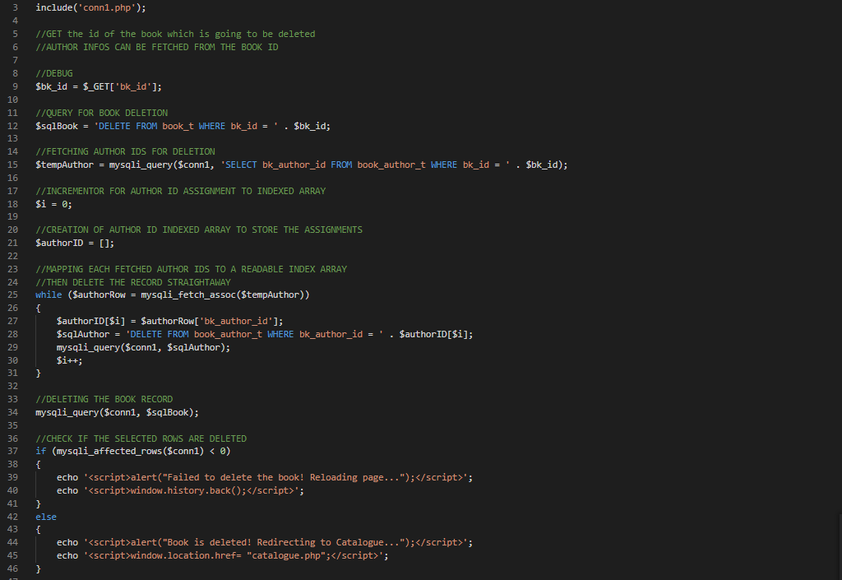

Figure 82: Code Snippet of PHP code to delete book from the database (deleteBook.php).

The above code snippet shows the code that is used to delete a book from the database. The system first creates a connection to the database by importing the code from conn1.php. The librarian would first have to select a book from the catalogue first before deleting it. As such, the system uses the “$_GET[‘bk_id’]” method to obtain the book id of the selected book from the URL. It then runs a while statement to delete each book author of the book from the ”book_author_t” table based on the number of author the book has. Only after all the book authors are deleted, the system deletes the book and displays a message to show if the book has been successfully deleted or not. If the book was not successfully deleted, the system goes back to the previous page. If the book was successfully deleted, the system redirects to the catalogue. The book authors are deleted before the book because the “book_author_t” table has a “bk_id” foreign key which references the book_id in the “book_t” table. As such, if the book is deleted first, it would cause an error in the database due to the “bk_id” foreign key dependency having been deleted first.

## Updating Client Profile Information

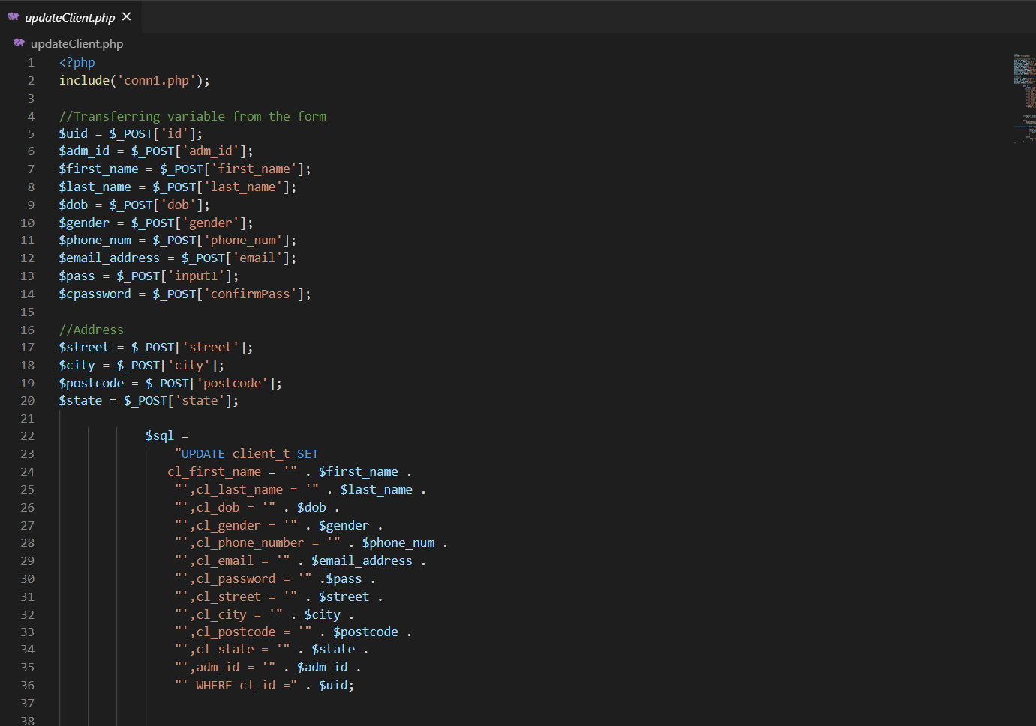

Figure 83: A snippet of PHP code handling the update of client profile into the database.

The figure above shows a snippet of the code which handles the update of client’s details through their profile page that is displayed through ‘editClient.php’ under iframe attribute of a main PHP file named ‘account.php’.

When the client performs an update by pressing on the submit button, the file from the screenshot above is called and have its SQL update queries executed to a table inside the database labelled ‘client_t’ with information from the input fields the client made changes to.

Error handling is set in place to handle user-inflicted errors such as in the event of performing no changes to any of the fields and yet the submit button is pressed, the system will notify the client of failed attempt to update as the SQL statements did not affect any of the records found.

## Creating Client Profile

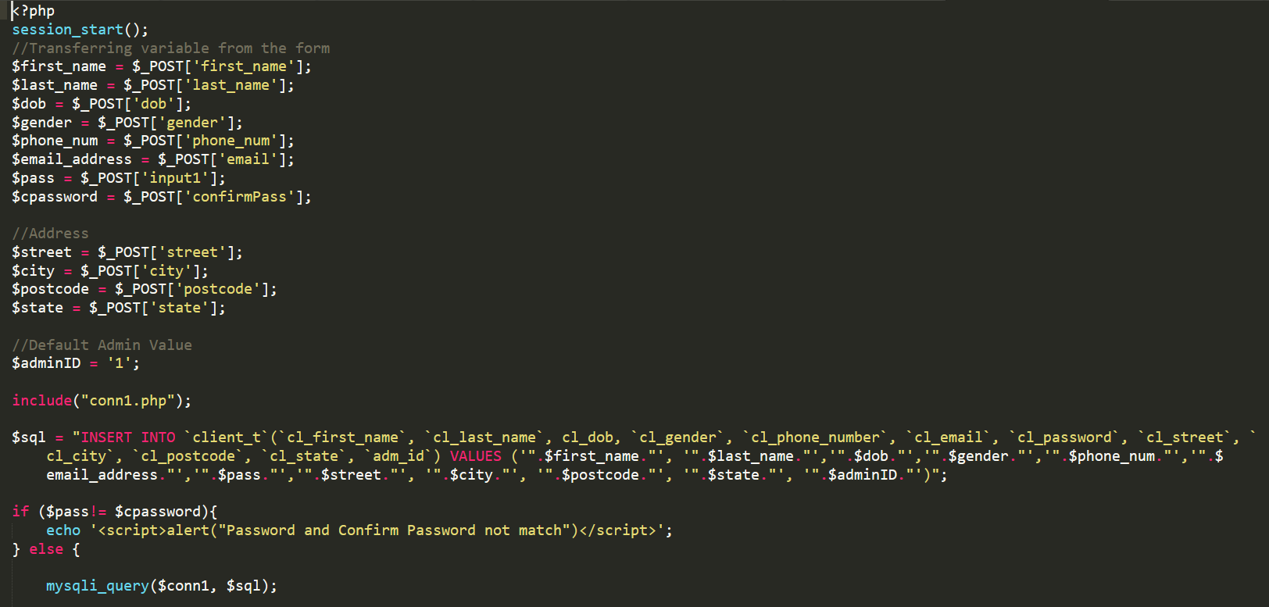

Figure 84: A snippet of PHP code handling the creation of a new client profile into the database.

The sample code above is taken from the registerClient.php file and handles the function of registering new clients. The code is written in PHP programming language and deals with SQL to query the new client information to the database. This particular code is located in registerClient.php which will be executed when the user presses the ‘Register’ button in the editClient.html page. It will get the values from the input field in the editClient.html filled in by the user and it will then be stored in a PHP variable. The PHP variables are then used in conjunction with SQL to Insert a new entry into the database.

# Conclusion

The library – Victoria Institution Public Library – has been around for a long time and the size for both the building along with its contents had grown so large that the traditional file-based approach it has been using since is considered as a method of the past and seen as unfit for current time. Our team, who is in charge of this tender, is determined to start a project to introduce the use of Information System into the library’s management procedure. The project would foresee it as a tool that could increase the efficiency of the major setback in the library environment which are logging and inventory management. Alongside that, the project will also improve the waiting time of a visitor with a virtual catalogue system accessible via computers. The project can be summarised into simpler terms: a tender to **develop a computerised system** for Victoria Institution Public Library that enables for local librarians to oversee and track the status of books in the library’s inventory as well as the inclusion of additional features such as catalogue viewer and database administration role with the assistance of Information System.

There are several problem contexts which were voiced out by the team members during the project meetings. The **first problem** is the inability to view borrowing status easily mainly because the records of related statuses are found in files which may have been scattered around in the shelves or countertops of the library. The next problem is manual process of managing information about books and clients that not only cause resource issues but also privacy threat as the action of viewing classified client information is unmonitored. The third one is the struggle a librarian must face particularly when answering questions about books by clients while having to complete other managerial tasks. The last problem is with the file-based approach itself as data redundancy tends to happen frequently as duplicates of record entries are found within the files primarily because routine to keep track of each update is complicated and tiresome.

The team members have proposed some possible solutions to address the aforementioned problems and the team also had agreed to keep some as features to the proposed management system. The **first solution** is to create a module for the system that enables for both librarian and client user roles to check on the book status virtually without the need for resource intensive actions. The next solution is digitising the processes of managing books and clients’ information which will save the library extra spaces for other beneficial uses such as server cluster or bookshelves. The third solution allows the client user role to search for their desired book through a self-service way that is the book catalogue viewer module which is a part of the proposed system. Last solution provided is the most important of all as it introduces the usage of Database Management Software (DBMS) into the overall system in the effort to eliminate duplications or invalid data submissions by the librarian.

There are four main objectives to this project, and these were carefully thought of by the team members in an effort to specially address and solve the issues Victoria Institution Public Library has been facing. The **first** **objective** is to make the management routine more accurate and easier for both client and librarian by having a simplified method to check borrowing status. The second objective is to improve the quality of work life of the librarians in their job to add, retrieve, delete, and update information about available books in the library’s inventory. The third objective is to reduce workload of a librarian by introducing a computerised book catalogue. The last objective is to reduce the probability of data repetition and increase the strength to data integrity.

This project is expected to have a **rigid scope** that is assumed to reduce the effect of project creep over time as there are four core feature ideas that are solid and can be expanded through modular method implementation during the actual development phase. The four main features cover the book catalogue viewer, borrowing and returning information handler, account registration and system login sequence, and lastly book inventory management. The system will have three distinct user roles comprising of Librarian, Administrator and Client with all being able to interact with the same web client interface but with different accessibilities. Although some parts of the scope may contain ambiguous characteristics, discussions among team members will be held if need be to prevent unnecessary or digressing interpretations.

During the discussion on project’s suitable **development methodology**, the team agreed to continue with the standard waterfall model. The waterfall model, often associated with the introduction to System Development Life Cycle (SDLC), is the simplest methodology in the industry that is flexible in its requirements. The activities found in a project can be visualised through the conventional phases this model provides. As the methodology is not strict in terms of framework, the team is able to amend some part to fit the situation and, in this case, an extra phase labelled “Testing” is included to monitor the progress of system integration tests. Previously stated, the phases will be visualised along with its activities and allocated period of time. In the project’s case, the easiest way to display its timeline would be through Gantt Chart.

The project is accompanied with a detailed **Gantt Chart** foreseeing the timeline of events in which the team members must keep track of in order to deliver a completely functional system by the deadline date. The Gantt Chart is planned to start on 7th December 2020 and ends around mid-week February 2021. The columns of the chart are grouped in a way it displays the requirements’ duration by week and day combination. This approach allows for each-day progress tracking while keeping the weekly view intact. There is a colour scheme that the bar of the Gantt Chart must abide by in order to reflect the progress in a more uniform manner. The colours can be interpreted accordingly by looking at the legend section while viewing the chart. The project Gantt Chart follows the standard System Development Life Cycle (SDLC) progression phases but with several modifications to fit events that can enhance the development of this library management system.

A series of **system hierarchy charts** were drawn to serve as an outline and guidance to the system development. The charts were drawn based on two fundamental categories – Feature List and User Role. Feature List is the overview to every feature available and accessible to the project while User Role defines the type of user and its functionalities or restrictions. As the chart is based off these two categories separately, Feature Hierarchy Chart displays all features accessible through the main web interface with some exception to user-specific options. Meanwhile, Admin to Client Hierarchy Chart all focuses to User Role functionalities only. Briefly put, Feature Hierarchy Chart is an overview of features and pages available from the main LibSys web interface while User Role Hierarchy Chart narrows to each user’s features when certain hyperlink or button found in LibSys pages is clicked.

All in all, this project is a good way to expose team building experiences among the team members as there will be role assignments with each role possessing certain authority or privilege where its potentials can only be seen or evaluated when the members are in united spirit. Other than that, there are brain-storming sessions that seek to undo unclear matters alongside the search for a simple but doable solution. In these sessions, the members should be able to see necessary benefits which include the strengthening of bond between them and the opportunity to analyse each member’s field specialism. Last but not least, the creation of proposal in this case is the simplest way and yet it is compact with information required to ensure a stable start to any kind of project.

## Assumptions

To ensure smooth progress is achieved throughout the project, the team came up with **three major assumptions** that could help alleviate ambiguous parts of the project’s expectation. Firstly, the team assumed that the premise, in this case the library, and users at one time have access to a web browser and are connected to the internet. Next, the team also believed that every target user involved in the system including librarians, clients and administrators have IT proficiency of at least novice level. Lastly, the team supposed that an unrestricted authorisation is granted to every member to explore and record physical or digital documents found within the boundary of the library for data basing purposes.

## Limitations

For the duration of the project, there are **four major limitations** with the last one identified after the completion of the system and these limitations have disrupted the linear timeline of the system development. The first limitation is heavy restriction in terms of social-distancing and safety precaution protocols imposed to address the pandemic situation. The restriction causes the team’s research at the library to become severely delayed with less information extracted and analysed for designing and constructing the system. The second limitation is that the team has no physical barcode scanner tool that is used to scan barcodes stuck at book covers. However, the team proposed to not use barcode but QR-code as it is commonly found in mobile phones and more user-friendly. The third limitation is regarding extensive research to be made to properly integrate QR-code system into the proposed solution’s environment. The extension is required as none of the project team members had worked with QR-code nor barcode previously. The final limitation focuses a lot on trust and security issues of the completed system as librarian user role is able to tamper with clients’ feedback as they are the one writing down their feedbacks on the borrowed books.

## Enhancements

During the execution of the project, the team has reached a consensus that the outcome is satisfactory but with few possible enhancements to be made in future projects. In essence, there are **four major enhancement** could be done to this project which theme focuses on website development for library management system. At the beginning of the project, the team agreed that a QR code can be implemented as a Quality of Life (QoL) enrichment to the system as it can remove the need to manually key-in ISBN serial numbers. Thus, it would be a wonderful addition to similar system in the future if QR code is implemented. The next possible enhancement is to introduce book reservation feature into the system. A book that is limited in quantity and frequently borrowed by clients should have this type of feature to let the clients place their booking on the book in advance. Ultimately, reservation feature creates a linear queueing system for clients before they are given the chance to borrow the limited book. Besides reservation, a better filtration for book lookup system can also be considered as a fantastic enhancement to the system. Currently, the search function is rudimentary as it can only search for keywords found in book titles and genres. By comparing the search function with websites available online today, most can look up for entries with better accuracy through the use of filtration settings. The setting is customisable to a certain extent where the user of the site can specify a search with extreme granularity. Lastly, an enhancement could be implemented for admin user role who are able to view and generate statistics of details found inside the database. As of now, the charting system is rigid because of the fixed number of viewable charts and admin user role can interact with. Plus, the charts’ type cannot be customised. Hence, a better charting options such as swappable chart types and dynamic chart insertion should be provided the admin user role to allow for a more accurate interpretation as well as becoming a reliable tool for decision-making.

# **References**

Brick, B., 2018. *The Disadvantages of a Manual Operating System in a Library.* [Online]   
Available at: https://bizfluent.com/12746087/the-disadvantages-of-a-manual-operating-system-in-a-library  
[Accessed 14 December 2020].

Cambridge Dictionary, 2020. *Meaning of library in English.* [Online]   
Available at: https://dictionary.cambridge.org/dictionary/english/library  
[Accessed 14 Dcember 2020].

IONOS, 2019. *Waterfall methodology.* [Online]   
Available at: https://www.ionos.co.uk/digitalguide/websites/web-development/waterfall-methodology/  
[Accessed 24 December 2020].

# Appendix

## Installation Guide

### Prerequisite

This is the installation guide to hosting LibSys Library Management System through localhost. The steps provided is accompanied by screenshots if available and the installation will not take long if the user is already familiar with the basics of utilising a computer. There are several prerequisites before the installation can begin. Some of the prerequisites are included in the steps to install here however, there are some that we assume is already installed and available in the user’s system which no assistance will be provided. The prequisites are as follows: -

* A browser compatible of browsing localhost (127.0.0.1) (installation guide is not covered)
* An operating system which supports feedback loop through localhost (installation guide is not covered)
* Firewall rule to open port locally for web server and database management interface (installation guide is not covered)
* A .RAR or .ZIP file extractor (installation guide is not covered)
* A text editor which supports .PHP file (installation guide is not covered)
* WAMP Server (installation guide is covered)
* LibSys Server files (installation guide is covered)

The installation requires browser which can allow for the website to load and appear properly through localhost, an operating system that permits feedback loop through localhost, a firewall rule to open port for web server and database management web interface, an application to extract a .RAR or .ZIP files, a text editor to read and write into .PHP file, an all-in-one web management application called WAMP server which manage and host websites and databases locally, and finally the LibSys server files itself to host the website via WAMP service. The installation guide will only cover the download and install for WAMP Server and LibSys files while if the user’s system has already installed the prerequisites before continuing.

### Downloading and Installing WAMP

This step requires the user to have met all the prerequisites except WAMP Server and LibSys Server files. If the user has not, please fulfil the prerequisites first before resuming with this step. To begin, go to the link <https://www.wampserver.com/en/> and follow through the steps below.

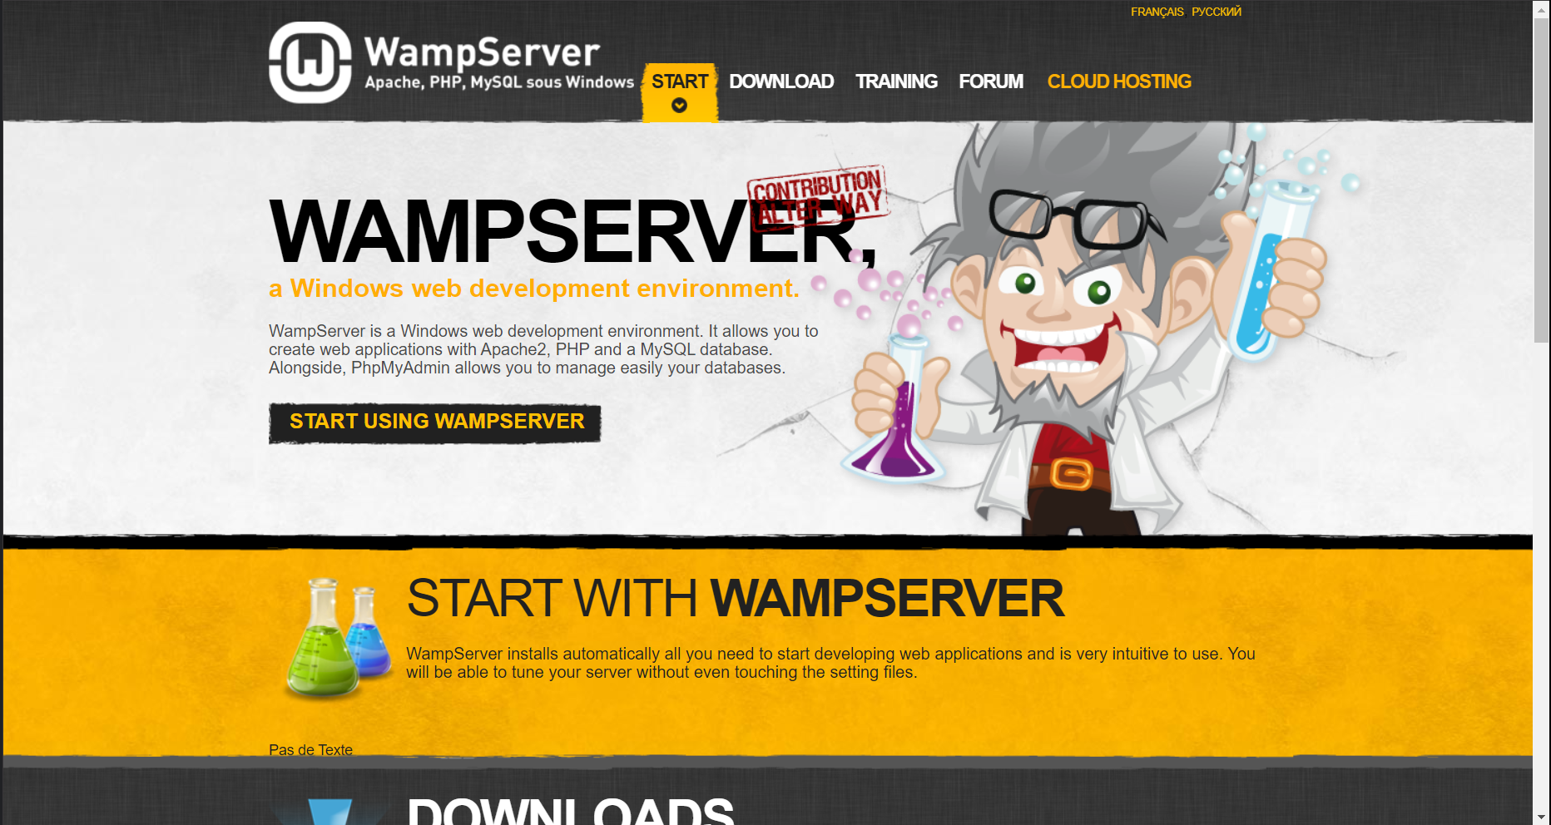

Figure 85: WAMP Server Official Website.

This is the main website of WAMP Server. Here, the user wants to click on the word “START USING WAMPSERVER” and the user will be redirected to the download page. Once the user is at the page, click on one of the suitable links depending on the operating system and architecture of the user’s system. This tutorial is based on a Windows 10 x64-bit system and the x64 bit Windows link is clicked.

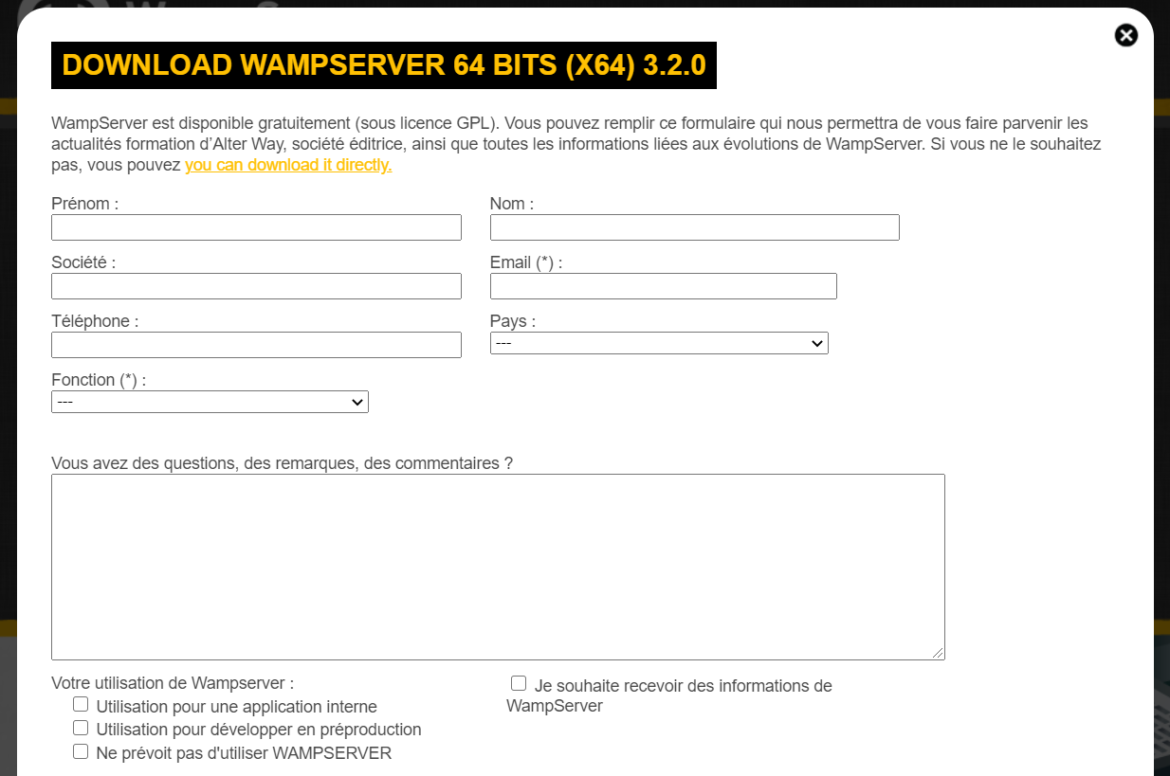

Figure 86: Download link for the application highlighted in yellow.

Once pressed, an overlay page pops up requesting for the user to fill in the form. Do not worry about this, skip ahead and just press on the link in yellow to be redirected to SourceForge.net for the installer.

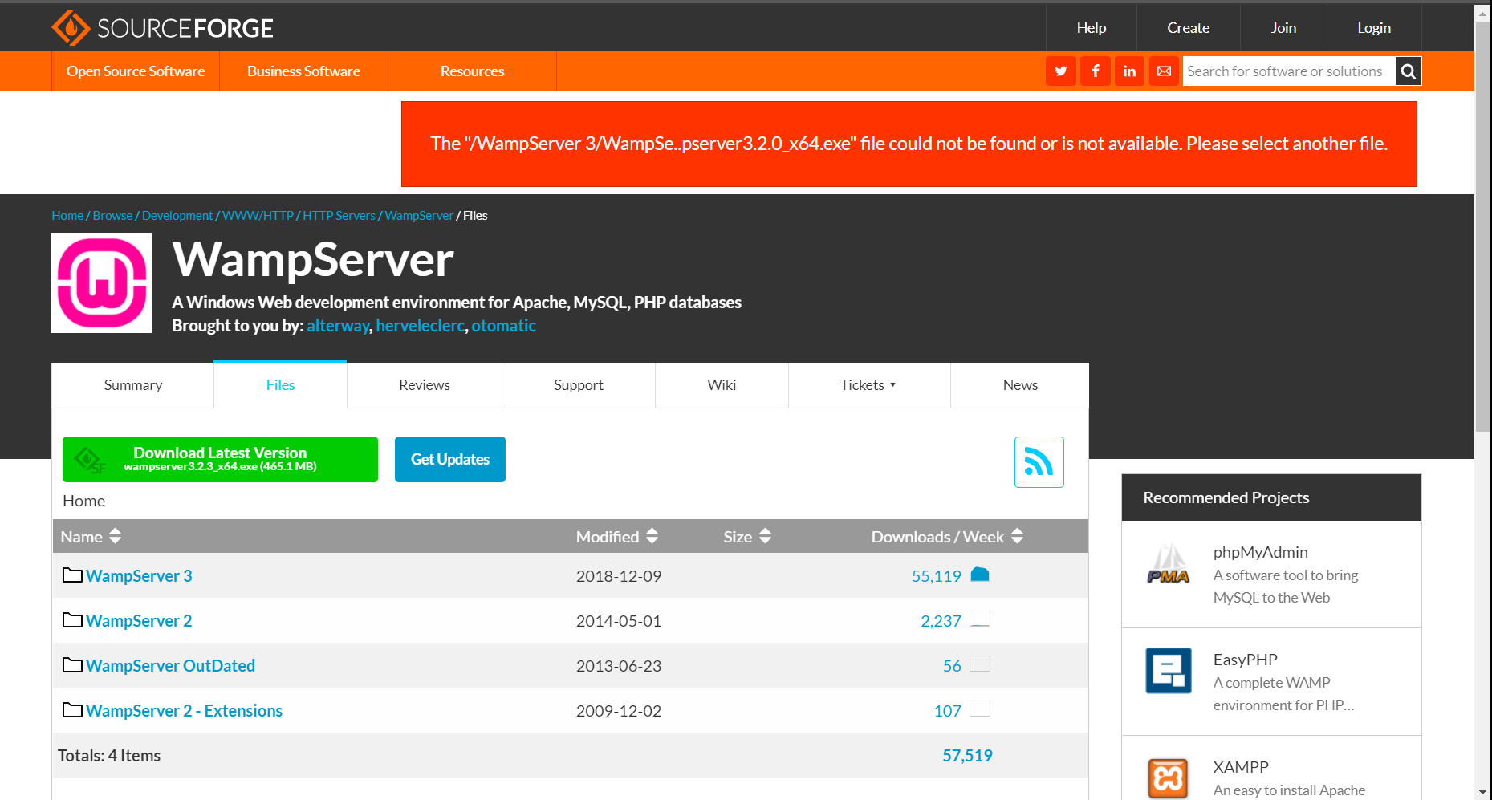

Figure 87: SourceForge.net hosting the installer.

Once the user sees this page, the user will want to click on the button with label “Download Latest Version” written on it. This button will download the latest version of WAMP Server.

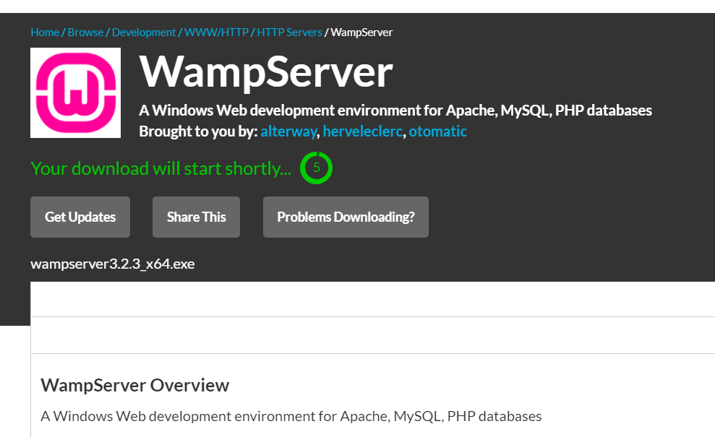

Figure 88: Timer after clicking on download.

After clicking on the button, the user will be redirected to this page where a timer countdown is present before the download starts. Once the timer countdown ends, the user browser will automatically fetch the link and starts downloading the installer.

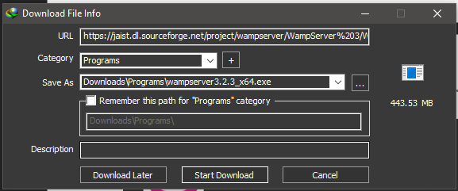

Figure 89: Download confirmation popup.

This tutorial is using a different downloader application called Internet Download Manager (IDM). No matter the application used to fetch the download link, the user will need to accept the prompt if there is any in order to continue with the download process. Note that the file for the installer is almost 450MB in total. A gentle reminder if the user is connected to a quota-limited network as the download may consume a lot of bandwidth.

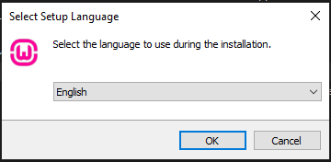

Figure 90: First window after executing the installer.

Once the download is complete, the user will want to execute the installer. Depending on the user permission level, a User Account Control (UAC) prompt may appear to request for administrative authorization to the user’s execution. Then, the window as in the figure above is displayed for user to select their installation language. If the user wants to change language, they can do so by selecting another language from the drop-down selection box. Press ‘OK’ to continue to the next window.

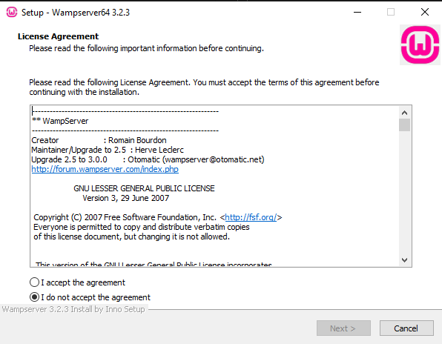

Figure 91: Terms and Condition window of the installer.

This window displays terms and condition which the user must accept before installing and using the application. Read through the agreement if the user wants to and select “I accept the agreement” radio button to enable the “Next” button. Press on “Next” once enabled to proceed to the next window.

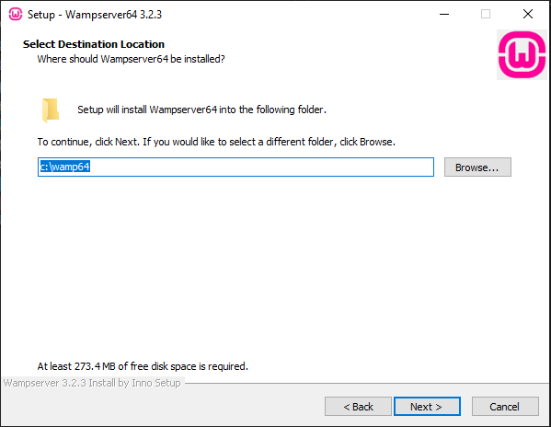

Figure 92: Selecting installation directory.

On this window, the user is given options to either use the default directory or look for another for WAMP Server installation directory. Perform either of the options and click on “Next” to continue.

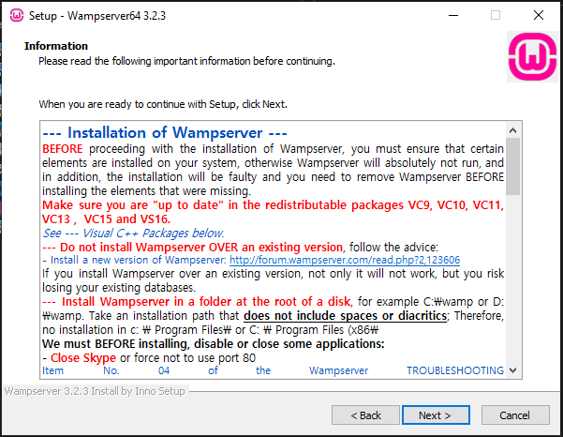

Figure 93: Installation information for user to read.

This page displays the installation disclaimer for the user to read and understand that the installation of the application is at their own risk. Once the user complete reading, press on “Next” to continue.

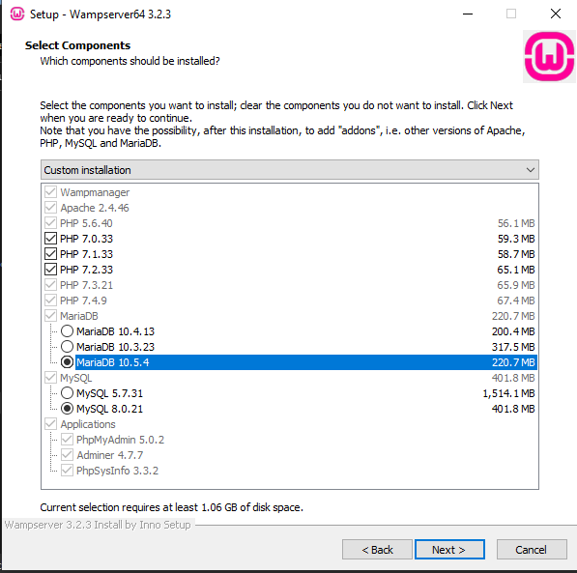

Figure 94: Components to select for the installation.

At this window, the user will need to select components exactly as shown in the screenshot. These selections are required in order to properly host the website later on. Once the selection is done based on the screenshot, press on “Next” to continue to the next page.

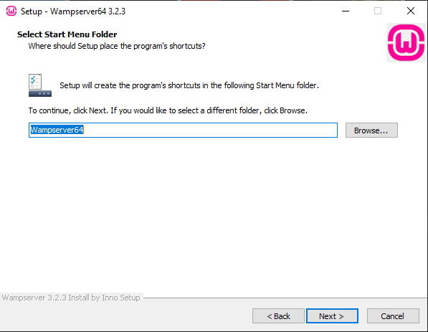

Figure 95: Start menu folder directory selection.

For this window, the user is also given options to either let the start menu folder to be set to default or select their own directory. Once the user has done either of the options, press “Next” to continue.

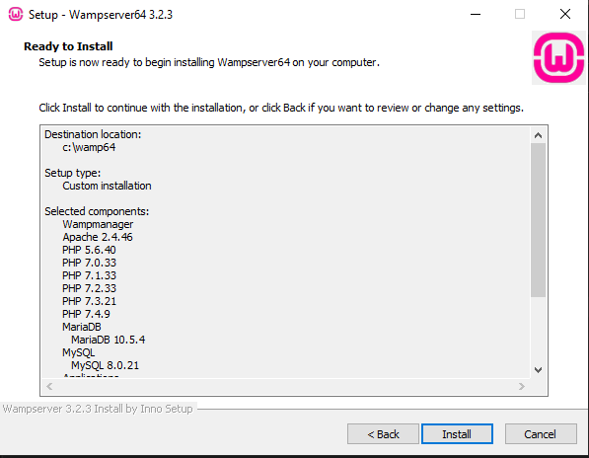

Figure 96: Installation summary for user to perform double checking.

Finally, the user is shown the summary of the installation setting which will commence once the user presses on “Install”. The user may read through the text to double check for any wrong selections and press “Install” to proceed.

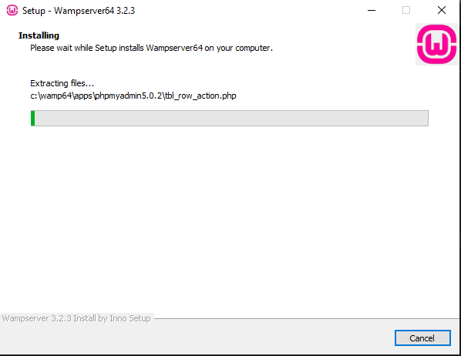

Figure 97: Installation in progress.

The user will have to wait until the installation is complete at this time. While waiting for the extraction and installation to finish, the user should play The Sims 4 on another screen if they have multiple screens.

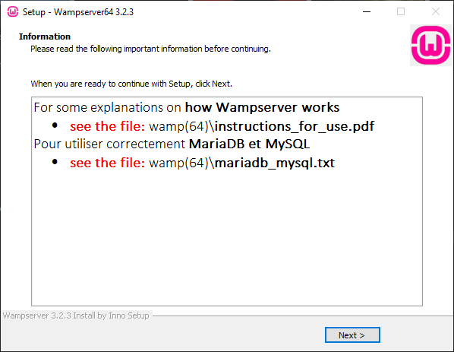

Figure 98: Post-installation summary for user to take note of.

Once done with the installation, the user is greeted with post-installation summary and direction to get the instructions on how to use WAMP Server. Press on “Next” to continue.

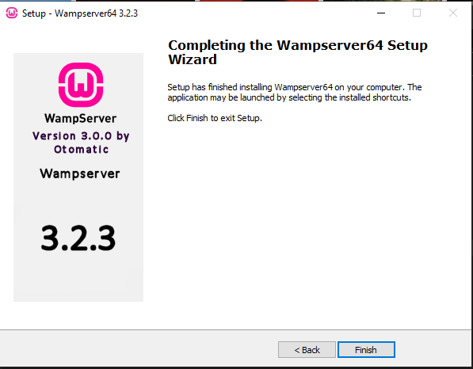

Figure 99: Final window of the installer.

This is the last window the user will have to go through for the installation process. Press on “Finish” to complete the installation.

### Downloading and Extracting LibSys Files

This step requires the user to have met all the prerequisites except LibSys Server files. If the user has not, please fulfil the prerequisites first before resuming with this step. To begin, go to the link  [https://github.com/FuadAbdullah/libsys/](https://www.wampserver.com/en/) and follow through the steps below.

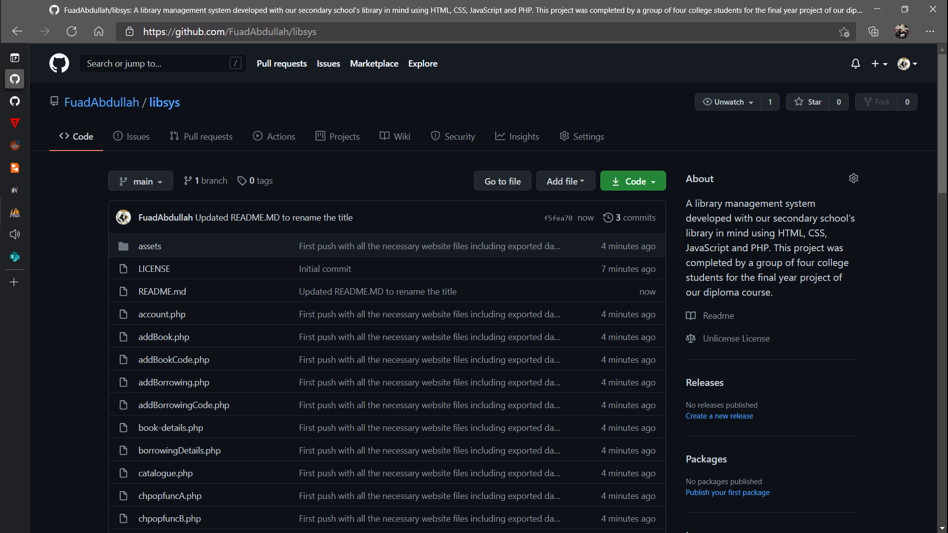

Figure 100: LibSys server files hosted on GitHub.com.

LibSys server files are hosted on GitHub.com in the repository accessible via the link provided. The user may view the content of the website through this website or just skip ahead to download the files.

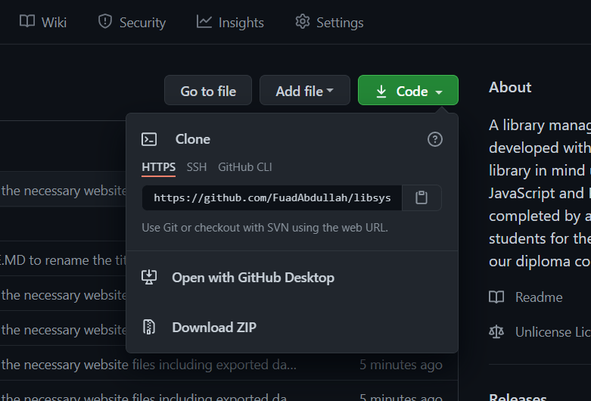

Figure 101: Downloading the server files as .ZIP file.

The user will want to press on the button with label “Code” one so it could display a context menu with “Download ZIP” button. Click on the button to download the files.

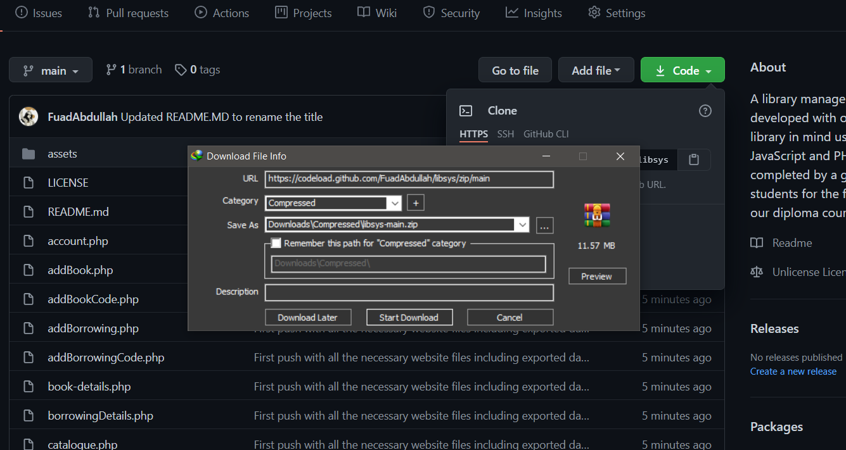

Figure 102: Another download confirmation dialog.

Similar to WAMP Server download, a prompt may appear to ask the user for download confirmation. Confirm the prompt to start downloading the files.

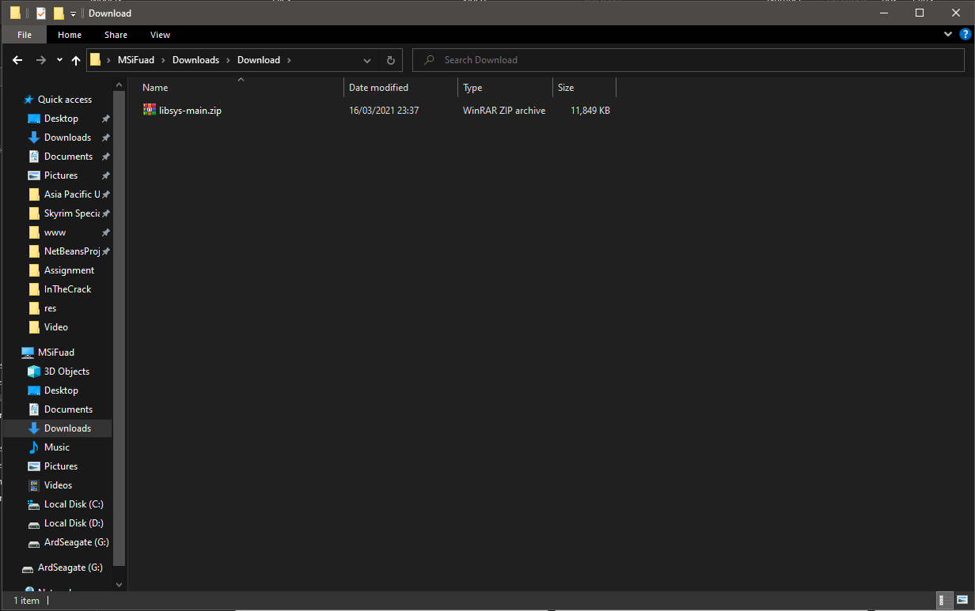

Figure 103: The downloaded file appears in download folder.

Depending on the user’s browser setting, the downloaded files in the form of .ZIP should appear in the download folder as seen here in the screenshot. Double click on the file to view the content of the .ZIP file using the user’s preferred .ZIP handler.

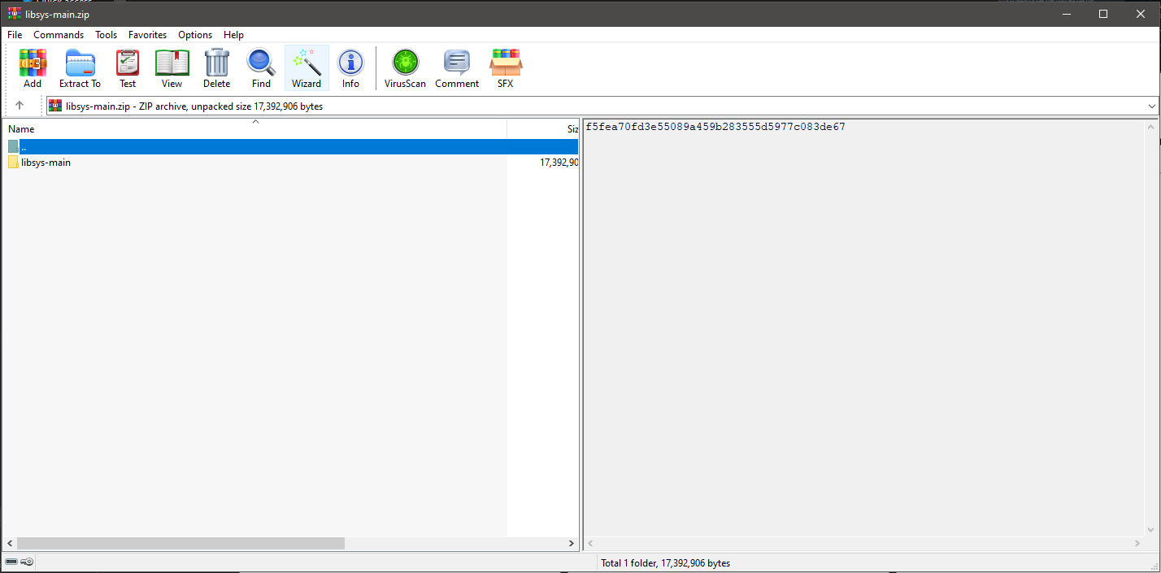

Figure 104: .ZIP file opened using WinRAR.

In the screenshot above, WinRAR was used to open the .ZIP file and here a folder is shown. Double click on the folder to go inside it.

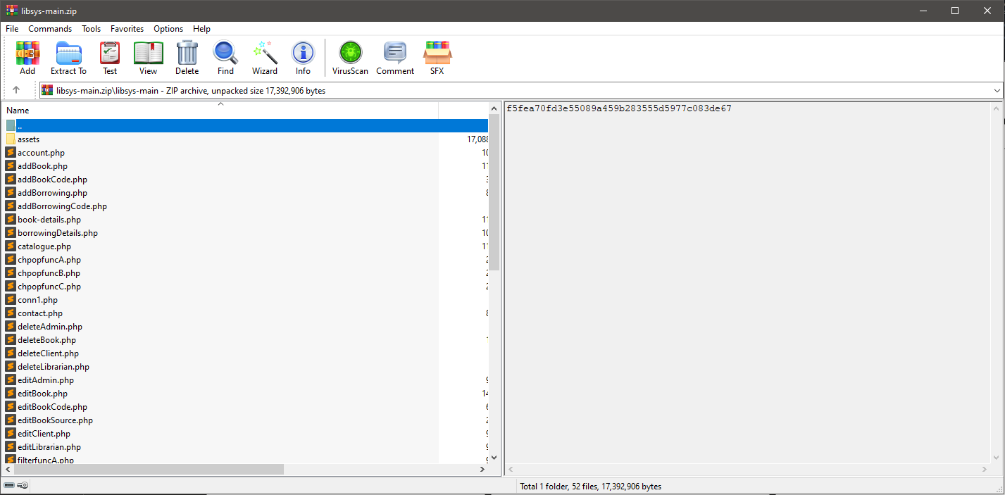

Figure 105: Content of the folder ‘libsys-main’.

Once inside the folder, the user may see a number of files in which all belongs to LibSys website. This folder will need to be extracted before anything can be done with it. Now, extract the folder into the user’s download directory.

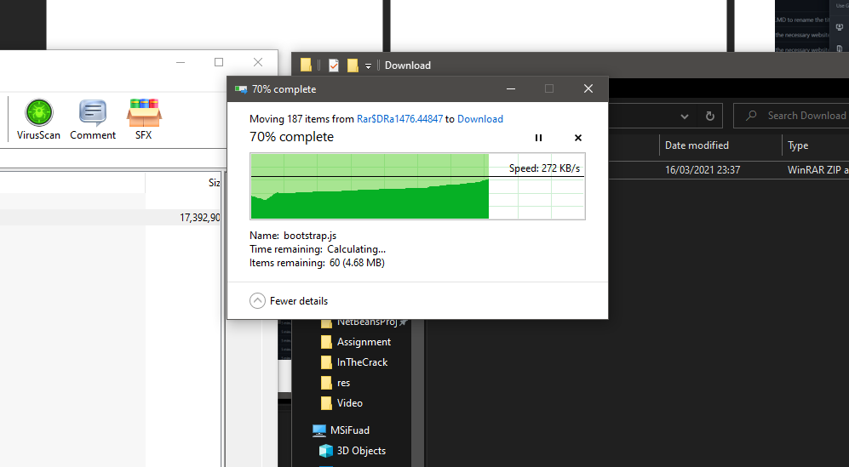

Figure 106: Extracting the files into download folder.

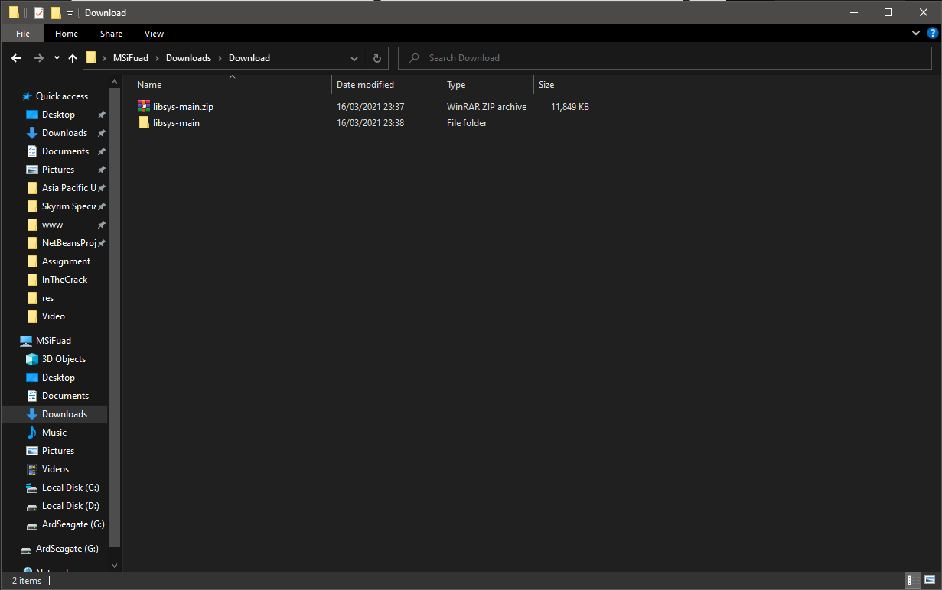 The user may see a similar window while extracting the files out into the download folder.

Figure 107: The folder ‘libsys-main’ after extraction inside download folder.

Once extracted, a new folder of the same name as the .ZIP file will appear in the download folder. Now the user has acquired the files necessary to set up the website.

### Setting up LibSys in WAMP Directory

This step requires the user to have met all the prerequisites. If the user has not, please fulfil the prerequisites first before resuming with this step. To begin, follow through the steps below.

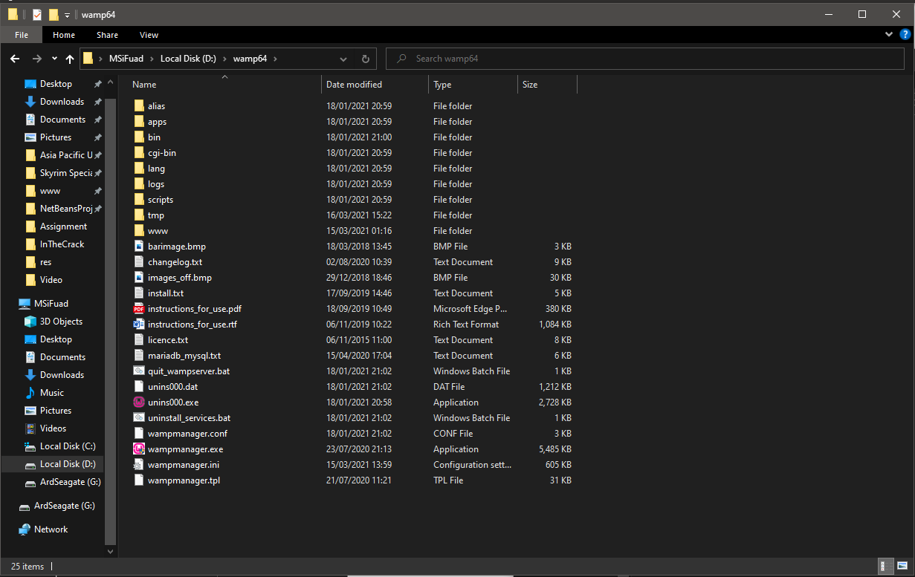

Figure 108: WAMP main installation directory.

The user needs to navigate to their WAMP Server installation directory. If the user forgot the directory of their WAMP Server, the user may look for the shortcut and perform directory tracing.

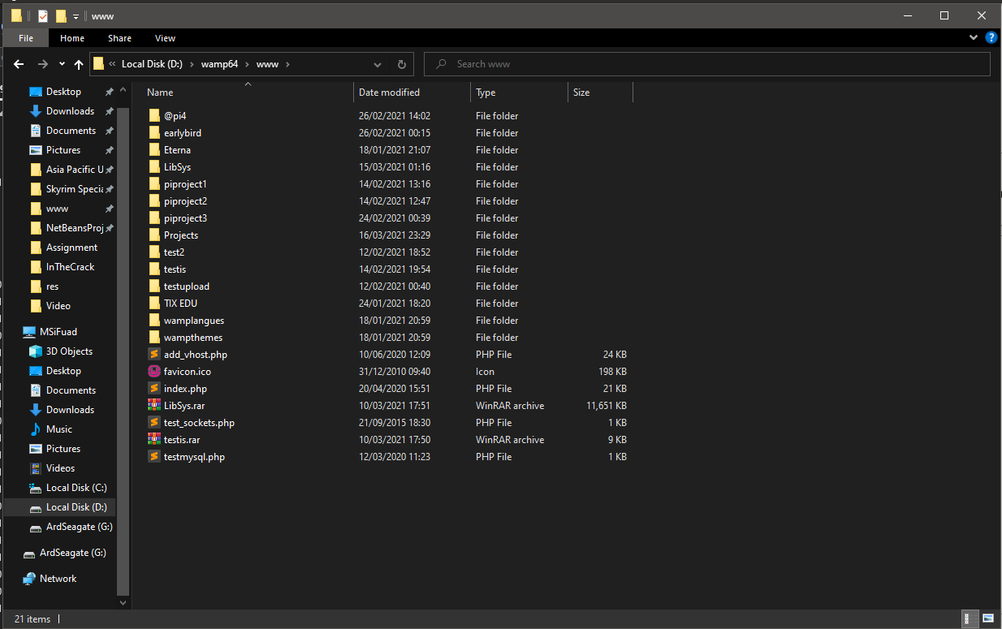

Figure 109: Navigate to ‘www’ folder.

Once the user is inside the main directory of WAMP Server, the user will want to go into the ‘www’ folder. This folder is where all website folders are located in.

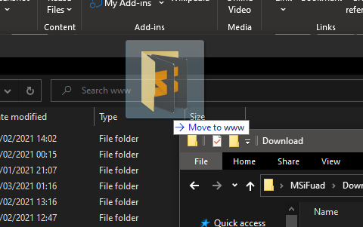

Figure 110: Moving ‘libsys-main’ folder into ‘www’ folder.

Assuming the user still has the download folder open, drag and drop the ‘libsys-main’ folder from the download folder into ‘www’ folder.

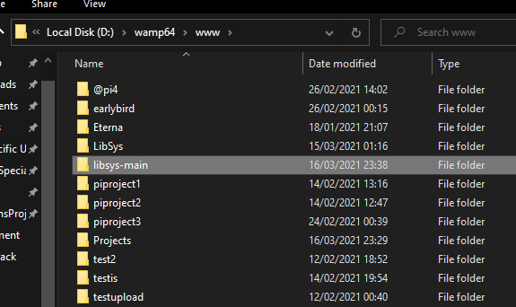

Figure 111: ‘libsys-main’ folder in ‘www’ directory after move.

Here is the ‘libsys-main’ relocated from download to ‘www’ folder.

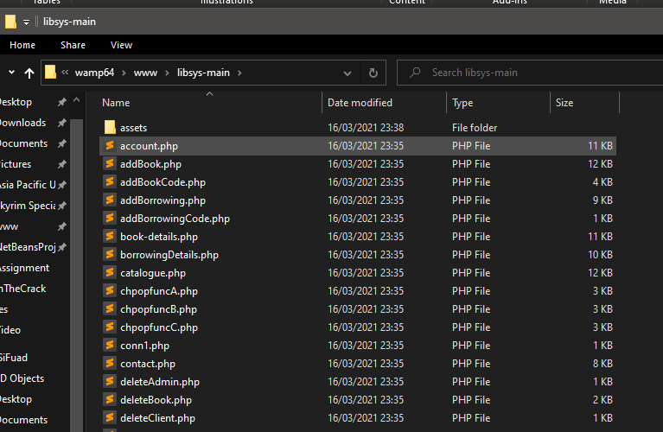

Figure 112: Inside of ‘libsys-main’ folder.

The user can go into ‘libsys-main’ folder to explore the contents of the website. The next section will teach on how to set up the database and finally host the website locally.

### Setting up Database and Testing the Website

This step requires the user to have met all the prerequisites and have moved all the necessary folders into WAMP Server directory. If the user has not, please fulfil the prerequisites and previous section first before resuming with this step. To begin, follow through the steps below.

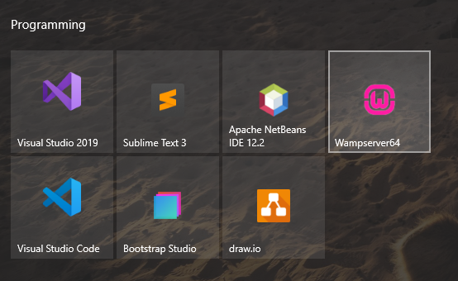

Figure 113: Clicking on WAMP Server shortcut to run the application.

After ‘libsys-main’ folder is in WAMP Server ‘www’ directory, the user may now run the WAMP Server application. Some users may have its User Account Control (UAC) prompting them for administrator authorization.

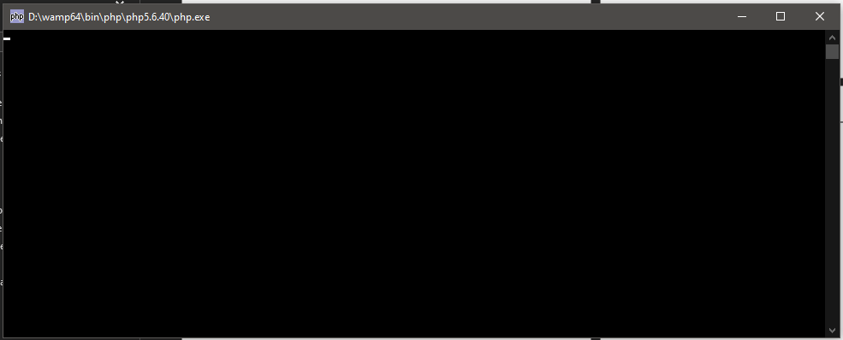

Figure 114: Multiple command prompts appearing after running the shortcut.

During the execution, there will be several windows of command prompts popping up and then immediately disappear. This is part of the run and nothing should be worried about.

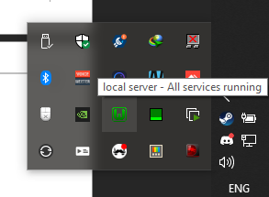

Figure 115: WAMP Server running in tray after finalisation.

Once the command prompts stop appearing, the user may find WAMP Server running in the background via tray. The user must be wary of the colour of the icon as the services are functioning properly if the icon is green and the otherwise if it is red. If the icon is red, restart the application and see if that fixes the problem.

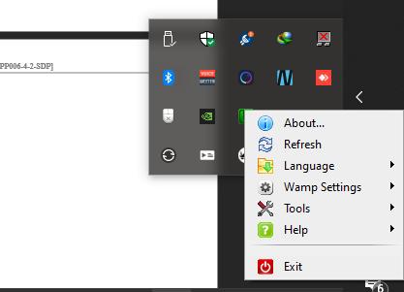

Figure 116: Context menu of WAMP Server tray icon.

The user may right click on the icon to show context menu to manage the application. This guide will not cover the functionalities of the context menu.

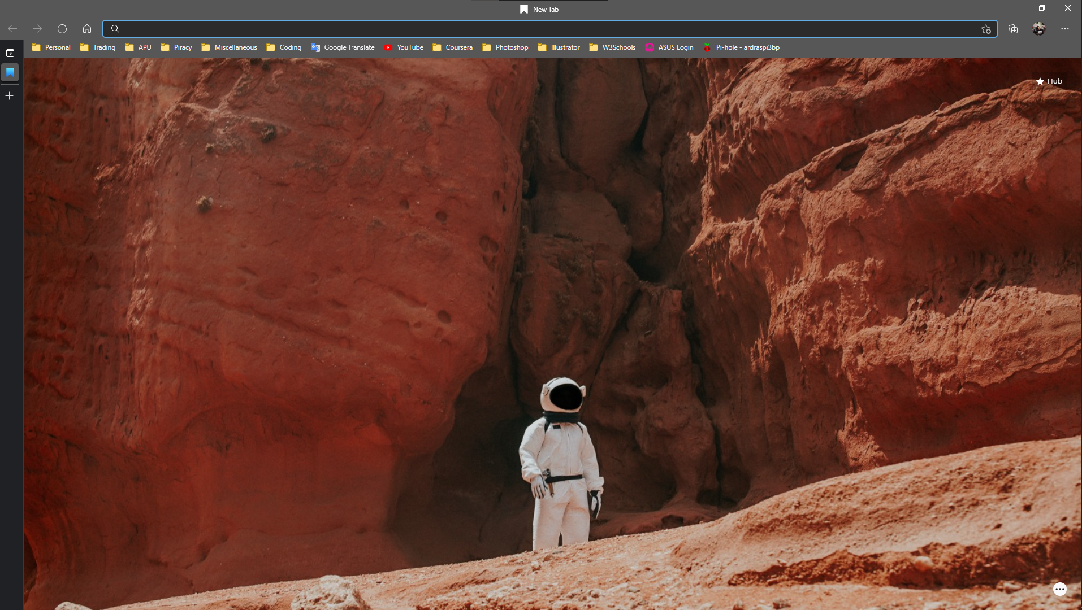

Figure 117: Browser opened in new tab.

Now, the user is required to open a browser of their own choice. Here, Microsoft Edge is used and the current window is showing new tab.

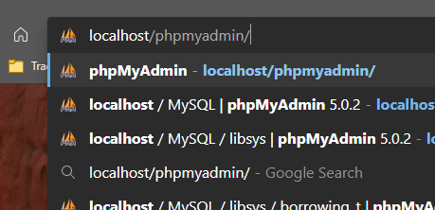

Figure 118: Localhost address directing to phpMyAdmin Web Client.

The user will want to insert the address of localhost/phpMyAdmin/ into the address bar and press the enter key to go to phpMyAdmin web client.

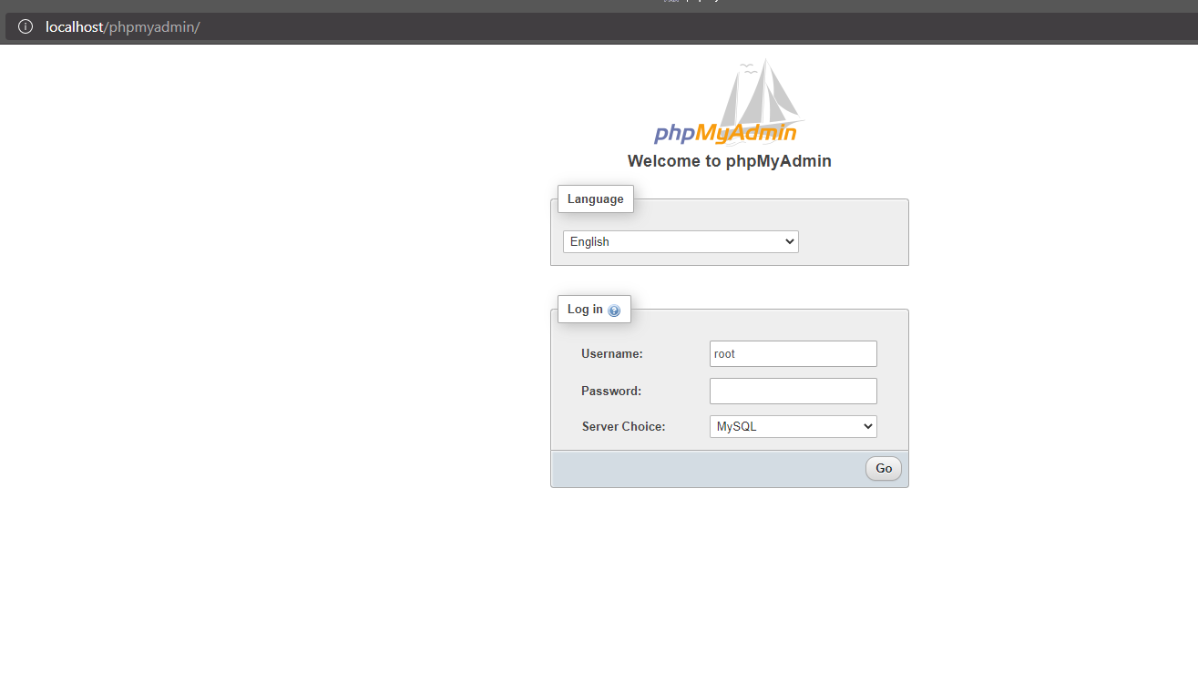

Figure 119: phpMyAdmin Web Client login page.

Once the user presses enter, the login page of phpMyAdmin will appear where the user will be required to key in root credentials in order to proceed. Root credentials comprises of ‘root’ as username and empty blank string as password. Make sure “Server Choice” is set to MySQL and press on “Go” to continue.

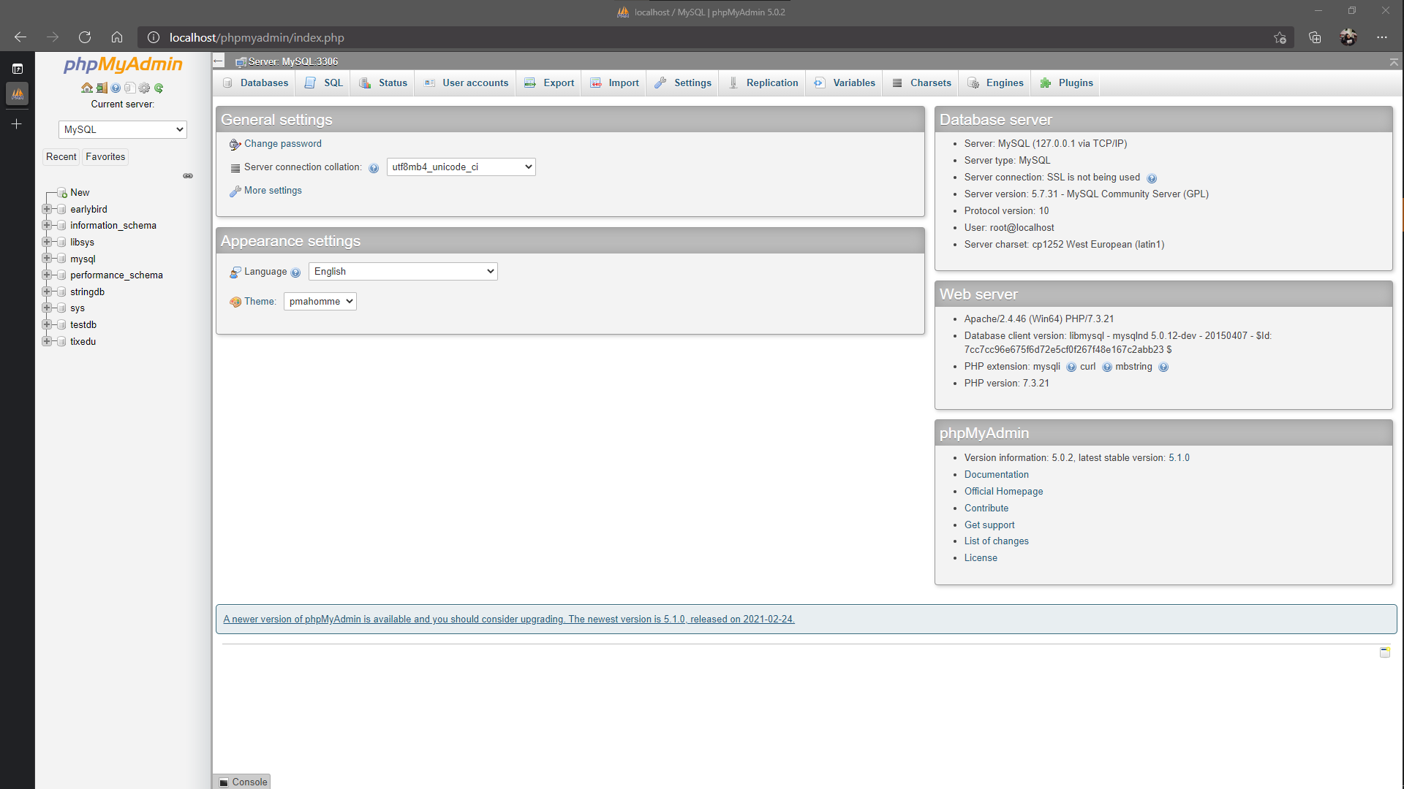

Figure 120: Main page after logging in using root credentials.

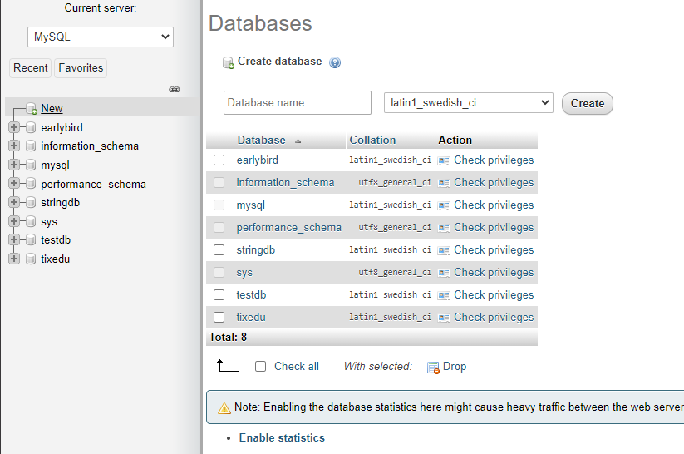 After logging in, the user will be redirected to this page. The user will want to press on “New” link found in the sidebar located to the left side of the screen.

Figure 121: Creation of new database to store LibSys information.

Once pressed, the page will refresh with database creation section on the right side.

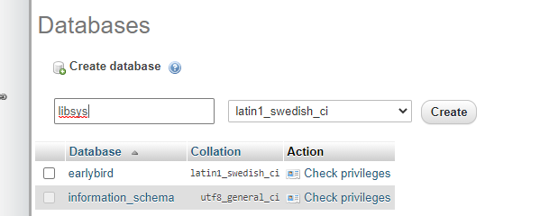

Figure 122: Database name must be ‘libsys’ in all small letters.

This part is important as the website is configured to work with a case-sensitive database name. The user will need to key in the database name as ‘libsys’ exactly in small letters and then press on “Create” to create the database.

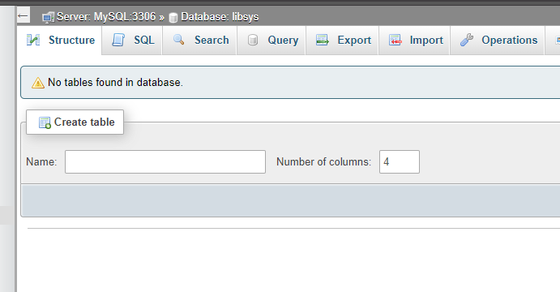

Figure 123: Post-creation ‘Structure’ of the database page.

After the database is created, there will be no table found under the ‘Structure’ tab. Now the user will want to switch to the ‘Import’ tab found near the top right corner to import the existing database in the form of .sql file.

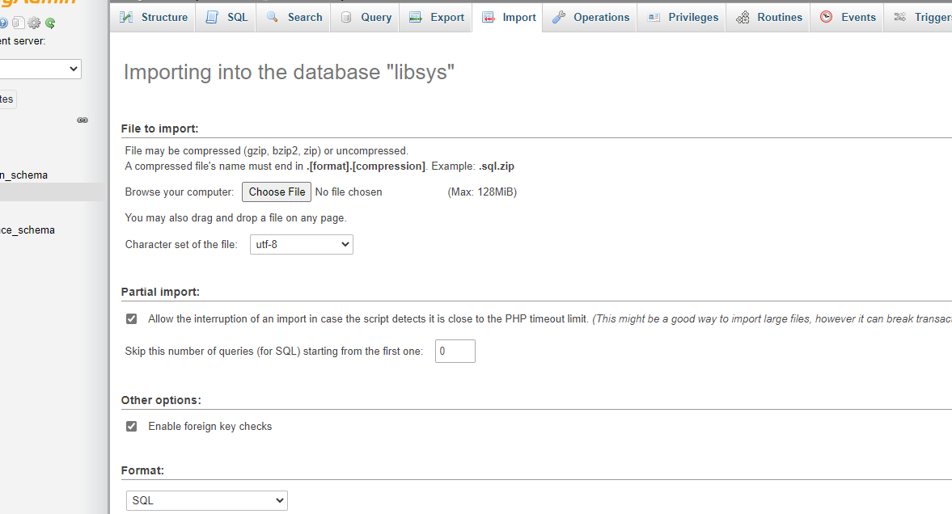

Figure 124: Import tab of the database.

Once the import page is loaded, the user will see a button labelled “Choose File” in the middle of the screen. However, there are some changes to be made to the .sql file before the user can import it. Assuming that the user has ‘libsys-main’ folder open, go to the directory and look for ‘libsys.sql’.

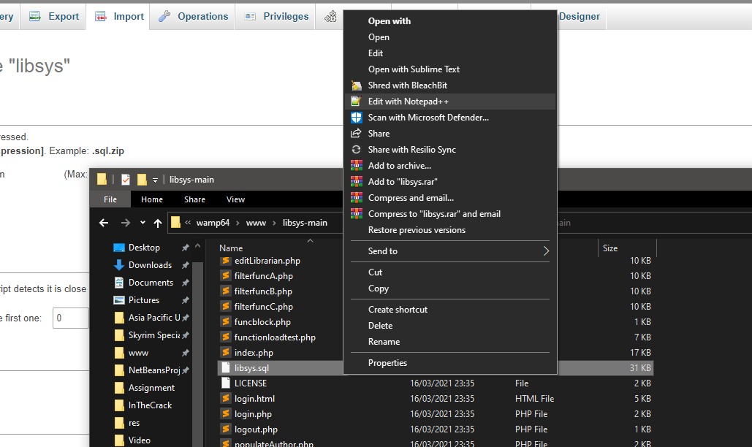

Figure 125: Context menu of ‘libsys.sql’ file.

The file will require some editing to be done and the .sql file can be edited with any text editor application. This guide will be using a text editor called Notepad++ to edit the file. Now inside the folder, the user will want to right click and select “Edit with Notepad++” or other similar option to start the text editor.

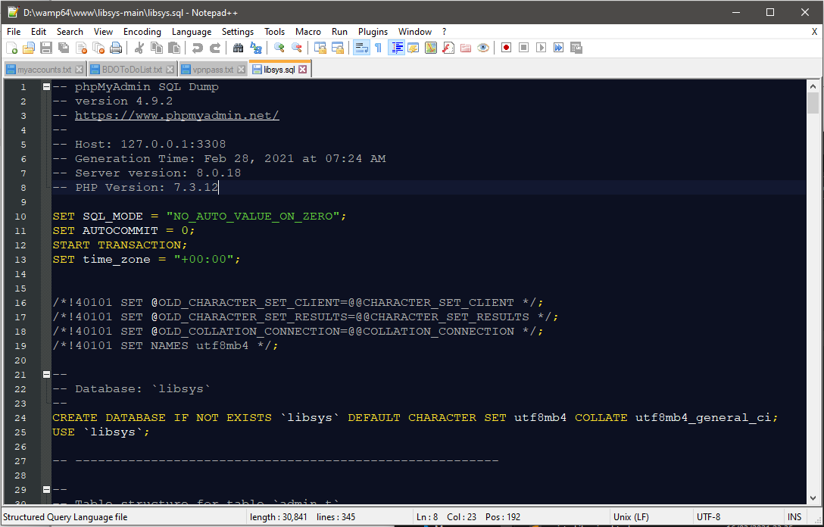

Figure 126: Editing the .sql file in Notepad++.

Once inside the text editor, the user can see lines of SQL commands which, when imported into the database later, will create all the tables along with records from previous database. For now, the user will need to perform a search and replace process to remove a specific keyword from the command.

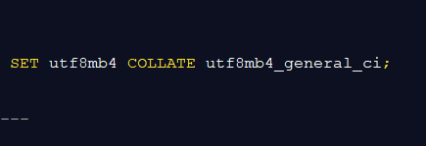

Figure 127: Exact keyword to search and remove.

In the screenshot above, the user is required to search for “COLLATE utf8mb4_general_ci” keyword and remove them entirely from the command list. After doing so, make sure to double check for any leftovers and save the file. Now the file is ready to be imported into the database.

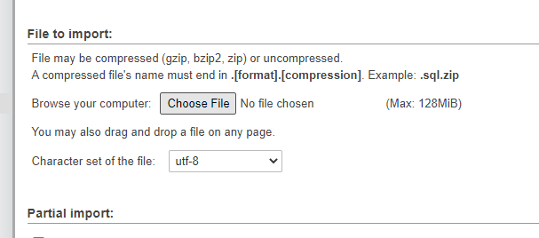

Figure 128: Clicking on ‘Choose File’ button to open file browser.

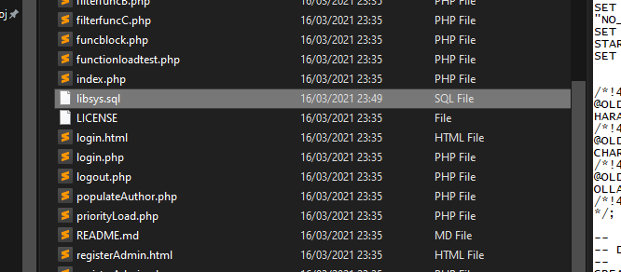 The user will want to press on “Choose File” to open the file explorer here.

Figure 129: Selecting ‘libsys.sql’ as the database import file.

Once the file explorer is open, navigate to the ‘libsys-main’ file located in WAMP Server’s ‘www’ folder and select the .sql file.

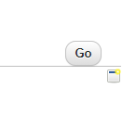

Figure 130: Click on ‘Go’ button to continue with the import.

Once the file is loaded into the page, press on “Go” on the bottom right corner of the page to let the system execute the SQL commands.

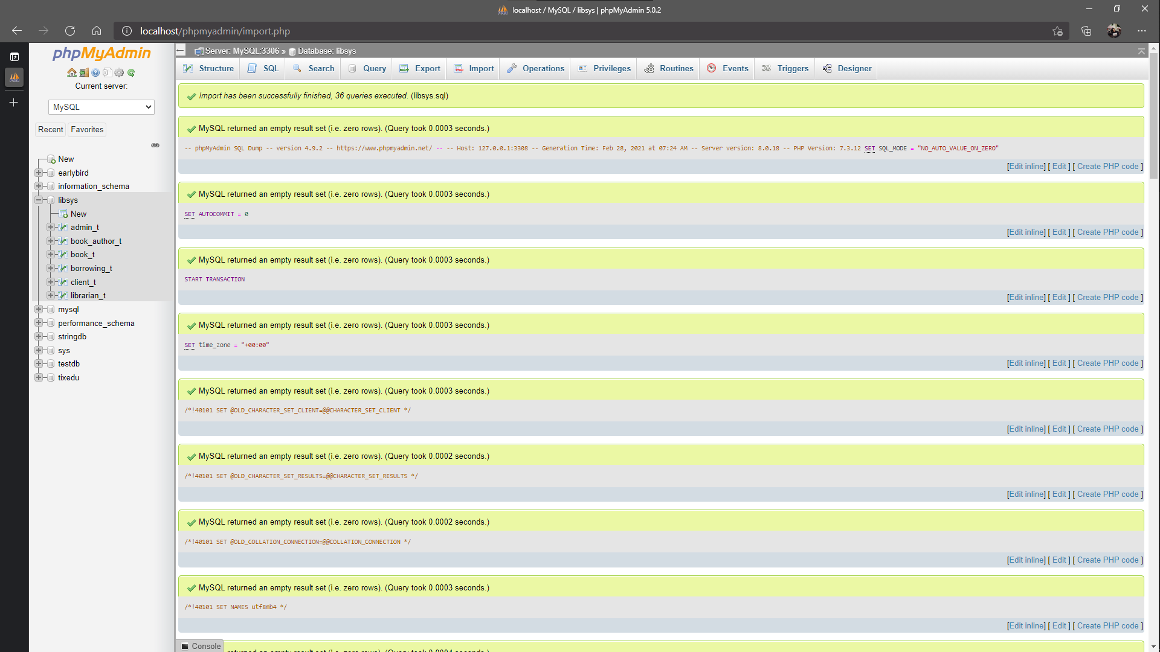

Figure 131: Display of successful import.

If the text editing part is performed correctly, the outcome to the SQL command execution should display output similar to this. If not, check the file again and delete the keyword mentioned previously.

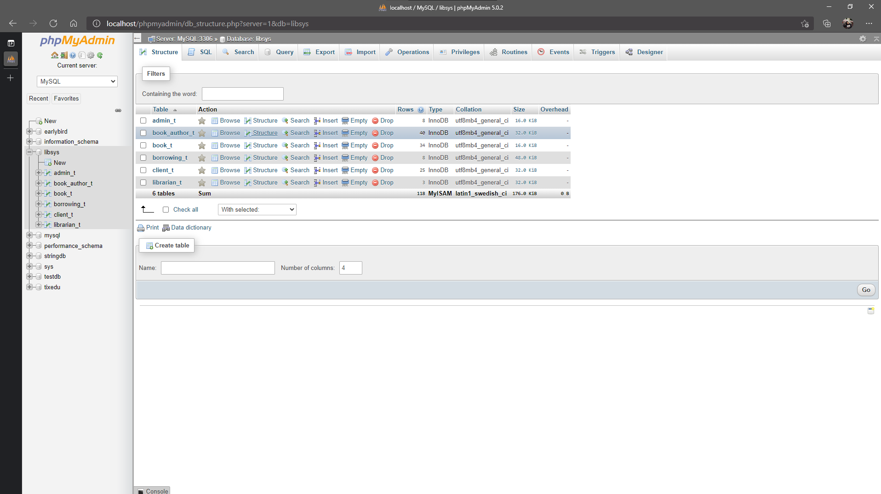

Figure 132: View of the ‘Structure’ of the database after import.

Here is the ‘Structure’ tab after the import went successfully with all the tables required by LibSys loaded into the database.

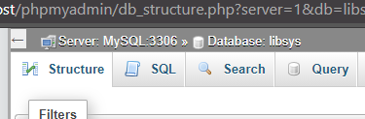

Figure 133: Note the port number for the MySQL database.

Before the website can access the database, another adjustment will need to be made inside another text file. Though this time the file is a .PHP file which is a connection file used by the website to establish connection to the database. The user will need to take note of the MySQL port written in the top part of the page as it will be used for later.

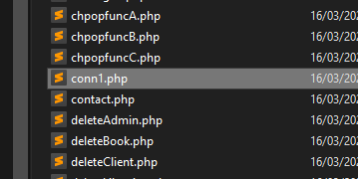

Figure 134: ‘conn1.php’ file which needs to be updated.

Assuming the user still has ‘libsys-main’ folder active, look for a file called ‘conn1.php’.

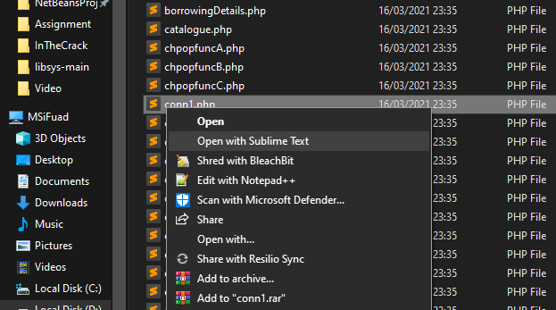

Figure 135: Context menu of ‘conn1.php’ file.

Once the file is found, right click on the file to open context menu and select the user’s preferred text editor. This time, Sublime Text 3 text editor is used instead of Notepad++ but there is no difference in using either.

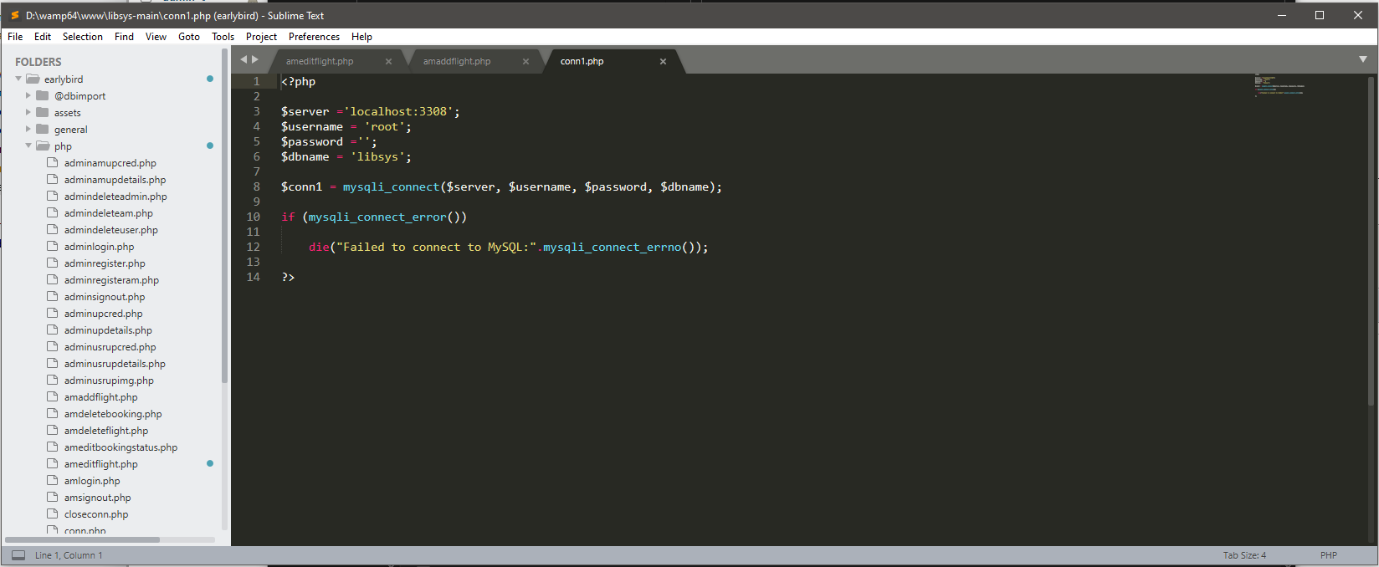

Figure 136: Editing ‘conn1.php’ using Sublime Text 3.

Here, the text editor is running with the .PHP file loaded in.

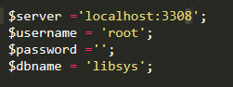

Figure 137: Changing the ‘8’ of the port number to ‘6’

The user needs to look for this particular block of code and change the port number from ‘3308’ to ‘3306’ based on the port number from the screenshot. The user may have a different port number so they must we aware of that.

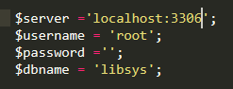

Figure 138: Port number changed successfully to match the one from PHPMyAdmin.

Once the port number is changed, the user may save the file and navigate back to the browser to test out the website.

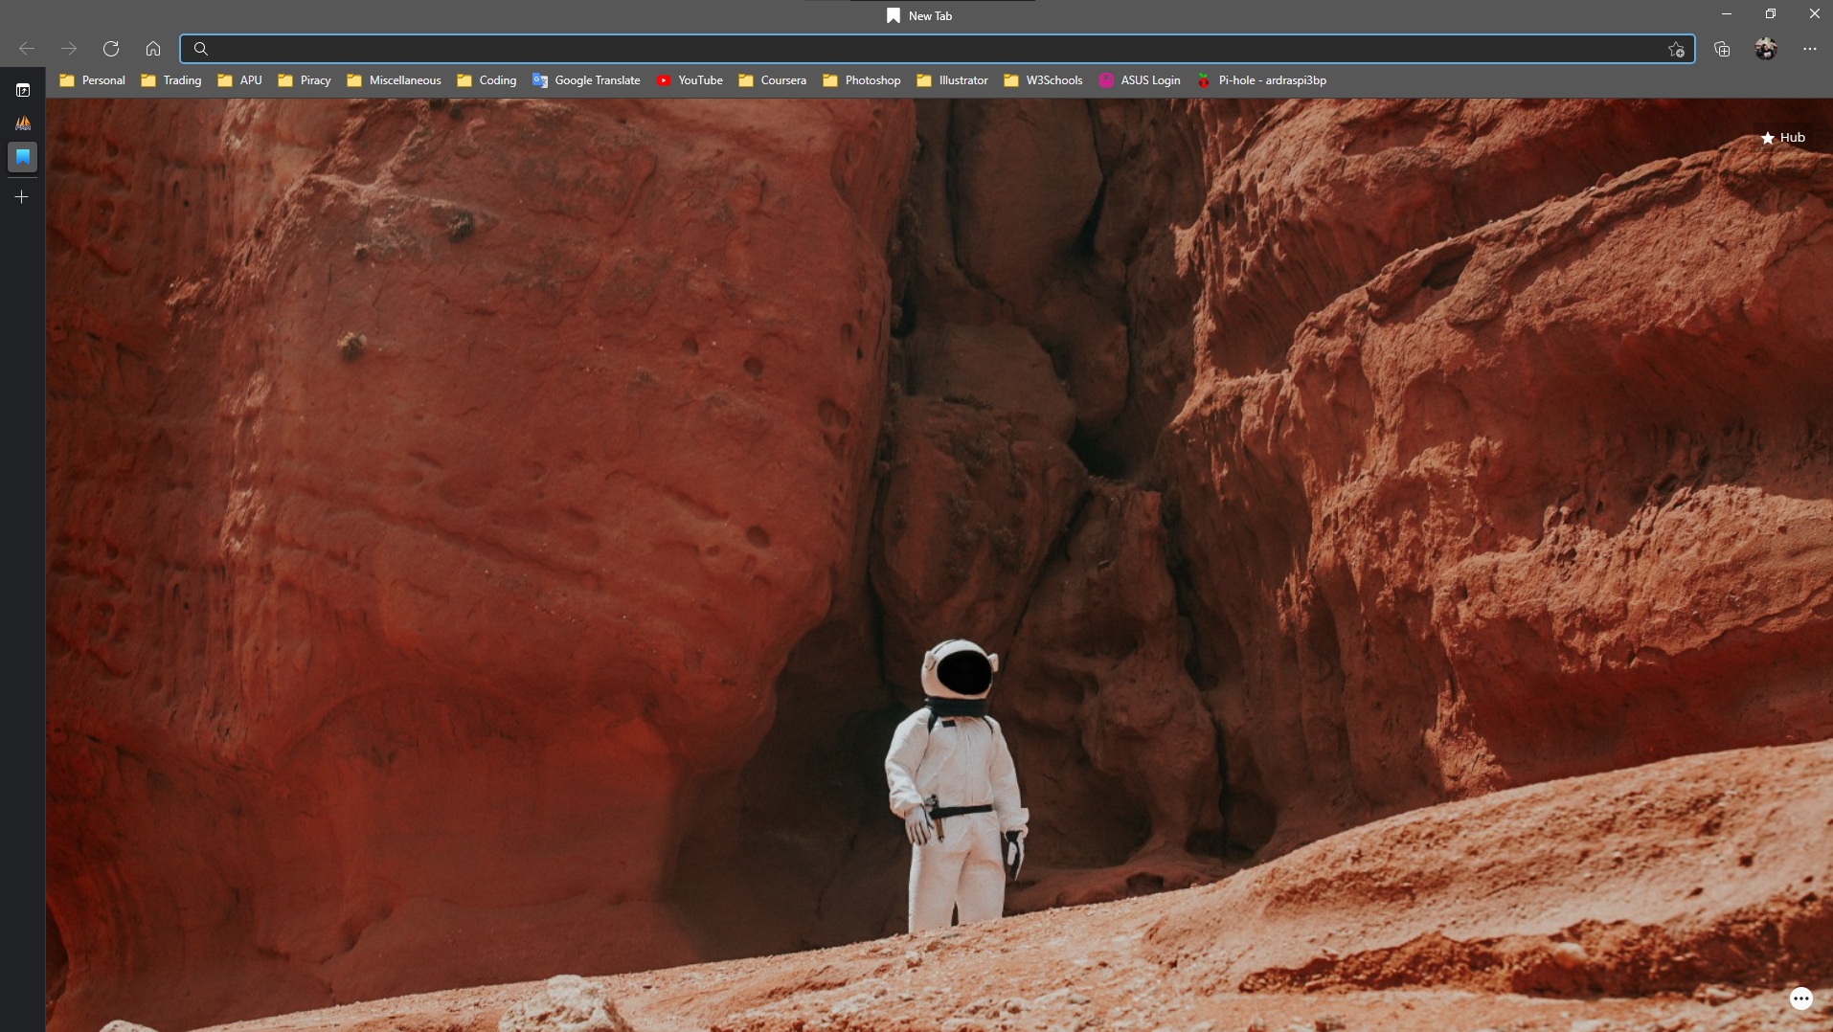

Figure 139: Another tab opened in browser.

In the browser, create another tab and focus at the address bar.

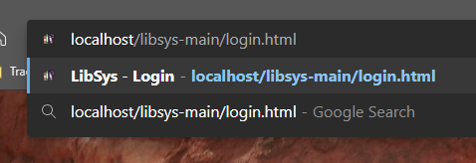

Figure 140: Address to the website’s login page.

Here, the user will need to insert the address of the website. The address localhost/libsys-main/login.html is similar to the one found in file explorer’s directory and then press enter on the keyboard.

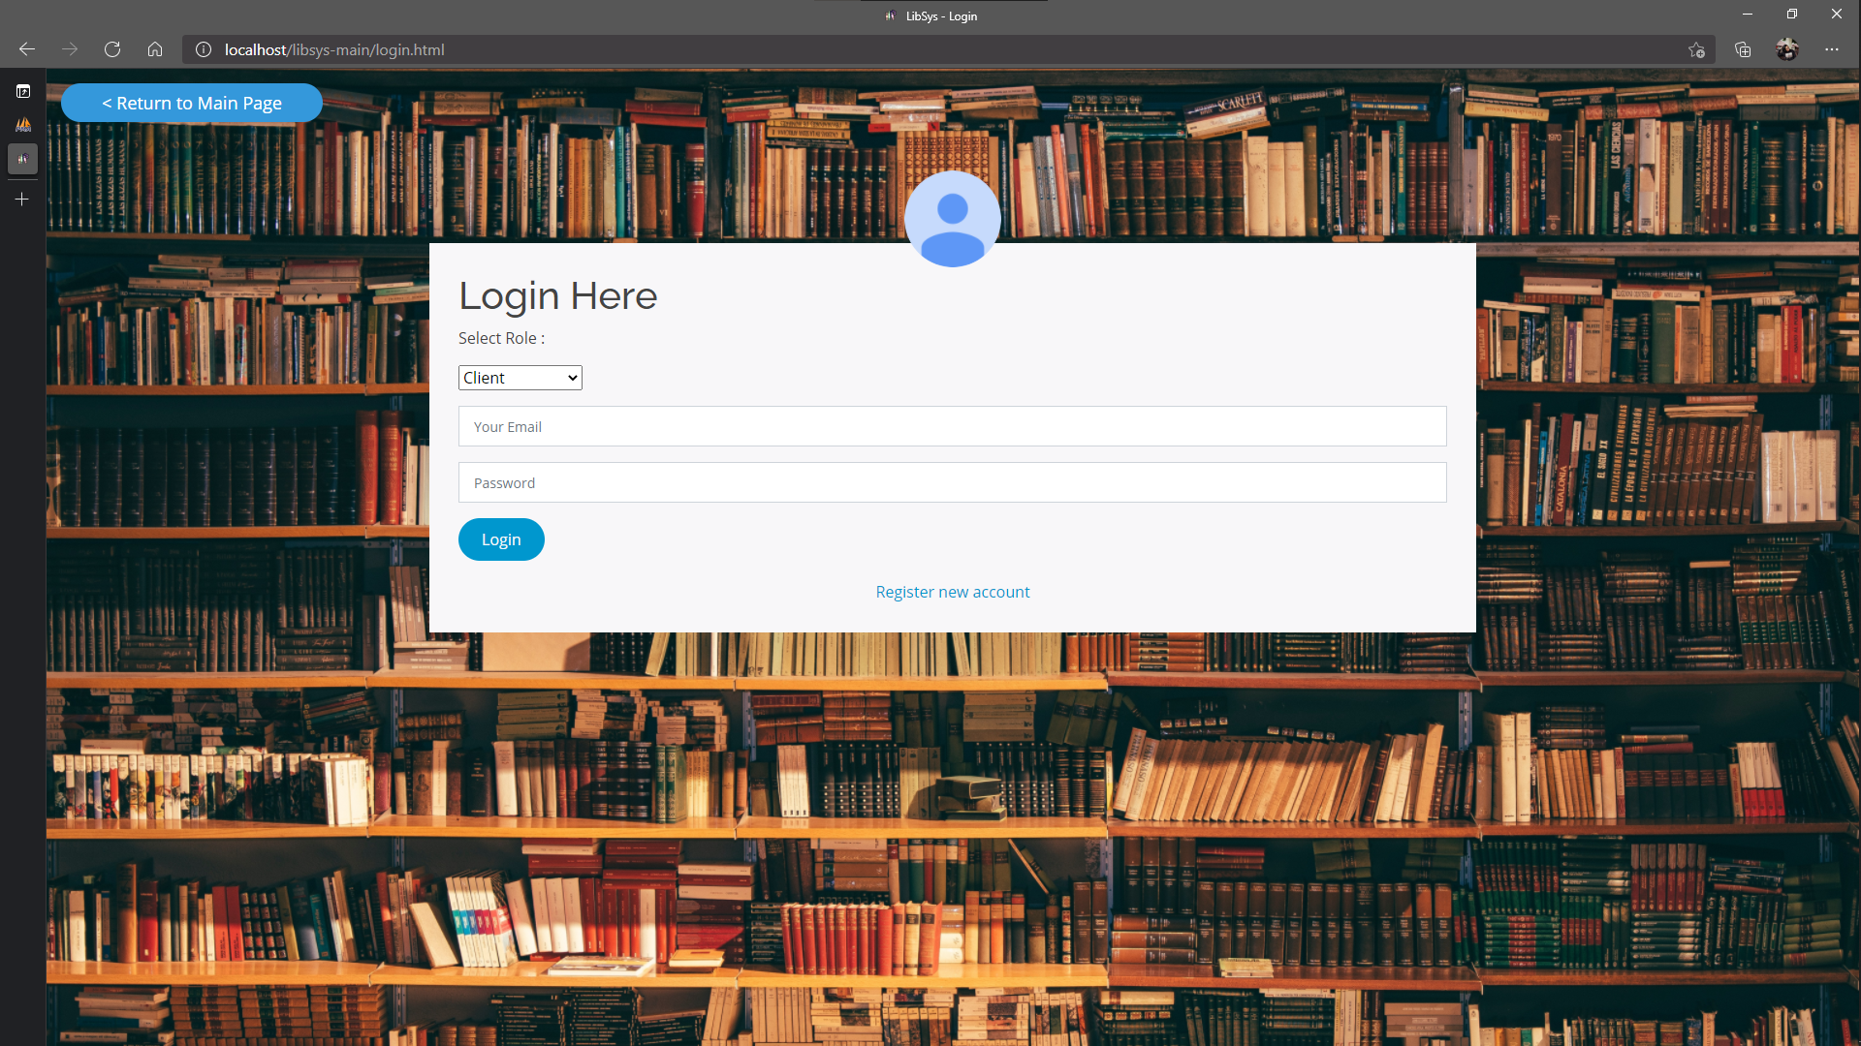

Figure 141: Login page of LibSys Library Management System loads.

From the screenshot, the page loaded perfectly with all the HTML and CSS files displaying the website in the way it was intended to be. However, the user needs to confirm whether or not the database can connect to the website. For this, the user can try logging in as one of the existing user. Navigate back to phpMyAdmin web client and enter the ‘Structure’ tab of ‘libsys’ database.

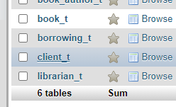

Figure 142: Getting an existing client’s credentials to test login sequence.

In the ‘Structure’ tab of the database, click on ‘client_t’ to load records of registered clients.

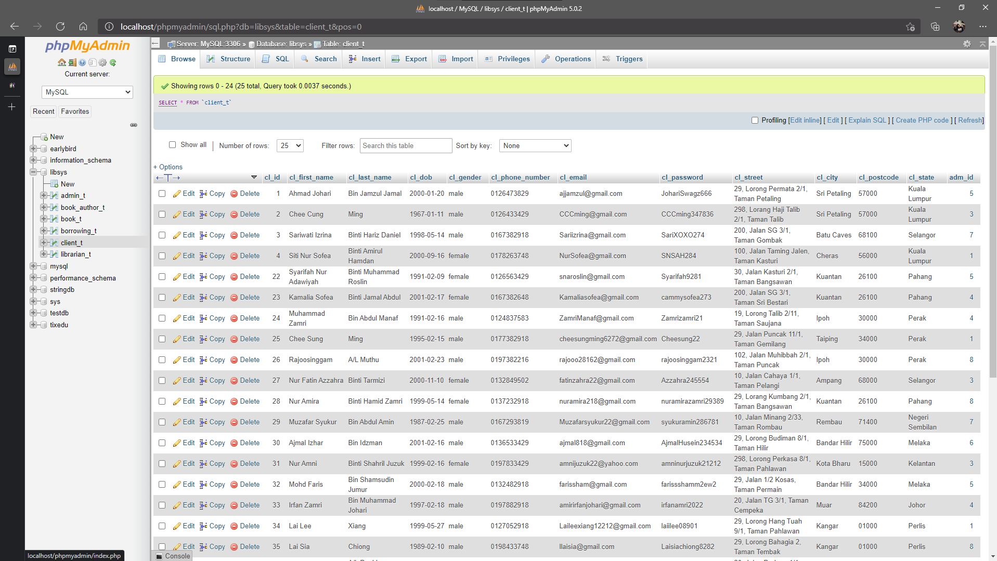

Figure 143: Client table with registered client’s records.

This page displays all the registered clients for the library system. Do not worry about this being a privacy issue as all these records are dummy data that are not related to anyone who are living nor dead. Zoom in to see better of the records and choose any of their email address and password as sample credentials.

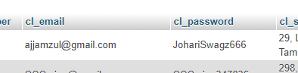

Figure 144: First client email and password for login.

In this guide, the user can use this particular combination of email address and password for login attempt, or the user can scroll down and look for their own combination.

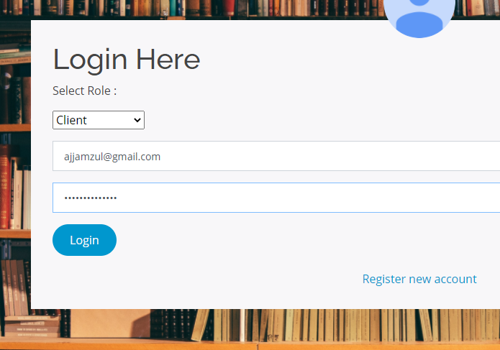

Figure 145: Inserting the client’s credentials to test the login sequence.

After getting the credentials, go back to the login page and insert the credentials according to their input field. Once that is done, press on “Login” to begin the authorization process where the website will establish contact with the database.

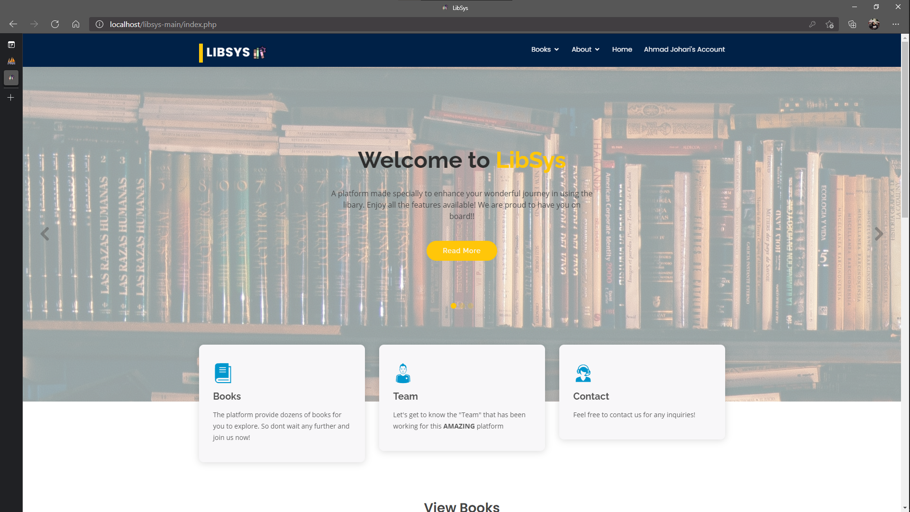

Figure 146: User is redirected to the homepage after successful login.

If the user is redirected to this page, then congratulations as the website has been successfully hosted locally. However, if there is SQL or PHP error appearing on the page then something went wrong while following the installation steps. The user may want to retrace their steps and correct it until the login sequence is working as it determines that the website can communicate with the database locally. With that ends the installation guide of installing LibSys Library Management System locally.

### Conclusion

During the installation, users may face problems such as dead links or inaccessible files. However, alternatives to the applications used in this guide can be found although the compatibility may be an issue. The system was developed with localhost environment in consideration and if the system were to be made online, the installation of this system might need some changes in the steps at the user’s own risk. Guides to make it available online are available online where the user will be required to port-forward or demilitarize their server’s port, have a domain name to conceal IP address, a server to constantly run the website all the time and a web server to handle requests to and from the clients. This installation guide is hoped to make the installation procedure simple and intuitive by allowing the user to compare the steps to the screenshots which serve as aid to when the description is difficult to understand.